Refugee Trivia and Answer Key

Global Displacement (see power point presentation slides 3 and 4)

Refugees in the Middle East

- In addition to the 6.6 million refugees displaced outside of Syria’s borders in 2018, an additional 6 million Syrians are considered to be internally displaced within Syria.
True.

- All refugees live in refugee camps.
False. Of all registered Syrian refugees in Egypt, Iraq, Jordan, Lebanon, Turkey and North African countries, for example, only 6 percent lived in refugee camps in 2018. In Jordan, 16 percent of Syrians lived in camps in 2018, while in Lebanon the government has banned the construction of formal camps.

- Turkey currently hosts the largest number of refugees of all countries around the world. True. Turkey hosted over 3.6 million refugees in 2018.

- Lebanon is currently the country with the largest number of refugees per capita.
True. In 2018, Lebanon hosted close to 1.5 million refugees, including Syrians, Palestinians displaced from Syria, Iraqis, Sudanese and others.

- All Syrian refugees have the right to work while living in another country, such as Jordan or Turkey.
False. Each host country determines the legal rights and benefits that refugees obtain. For example, although Jordan hosts over 660,000 Syrian refugees, the Jordanian government had only issued 125,000 work permits between 2016 and the end of 2018.

U.S. Refugee Resettlement

- Last year, refugees resettled in the United States came from more than 70 countries – most from the Global South.
True. In 2018, the top 10 origin countries for refugees admitted to the United States were as follows:
      - The Democratic Republic of Congo (7,878)
      - Burma (3,555)
      - Ukraine (2,635)
      - Bhutan (2,228)
      - Eritrea (1,269)
      - Afghanistan (805)
      - El Salvador (725)
      - Pakistan (441)
      - Russia (437)
      - Ethiopia (376)

- Congress determines the number of refugees that will be resettled in the United States each year.
False. The president sets a ‘refugee ceiling’, or maximum number of refugees to be resettled in the United States each year. This refugee ceiling does not have to be fulfilled.

- Refugees are not required to pass any medical examinations prior to being resettled in the United States.
False. Refugees receive a health screening before and after arrival to the United States.

- Refugees are the most thoroughly vetted individuals entering the United States.
True.

- Refugees in the United States cost the government more in social services than they pay in taxes.
False. Most refugees resettled in the United States are employed within six months of arrival and they pay taxes like U.S. citizens. A recent working paper by Evans and Fitzgerald (2017) found that: “the U.S. spends on average $15,148 in relocation costs and $92,217 in benefits from social programs over a refugee’s first 20 years in the U.S., but refugees pay a total of $128,689 in taxes over this time period. Over their first 20 years in the U.S., refugees that arrived in the U.S. aged 18-45 pay about $21,324 more in taxes than they take home in benefits.”

- The United States government pays for refugees’ transportation to the United States.
False. Refugees pay for their own travel to the U.S. (or other resettlement countries) through a no-interest loan.

Notes: I have used similar immigration trivia questions for the first day of class for a 400-level undergraduate course on Contemporary Immigration in the United States. The aim of this exercise is to have students reconsider the information they have heard about immigration and raise additional interest for the course topic.
Forced Migration Exercise

Is migration a choice or is it forced? Select a few of the migrants or migrant groups from the list below. Where would you place these migrants in a continuum which runs from economic migrants (those choosing to migrate) to refugees (those forced to migrate)? In 1-2 sentences justify your placement. Remember that your justification has implications for how national governments assign legal status and protections to migrants.

- An Egyptian man who migrates to Jordan to work in a sandwich shop, because he cannot find work in Egypt. He sends most of the money he earns back to his parents in Cairo.

- A Syrian family who flees Aleppo to live in Istanbul, because of fear of chemical attacks and bombings.

- An Iraqi woman and her two children who flee ISIS control of Mosul in 2015 and go to Turkey.

- An Iranian teenager who is gay decides to study in Turkey and try to get a job there, because he fears being penalized for his sexuality under the Iranian regime.

- A Lebanese woman who moves to the United States to attend university and join her father who is living here.

- An Afghani man who worked as a translator with the U.S. military during the War in Afghanistan and moves to Pakistan, because he fears being killed for his connections with the U.S. military.

- An Egyptian science teacher who lives and works in Doha, Qatar, because she prefers the lifestyle and political freedom there.

- An Afghani woman who moves to Iran with her family because of a lack of social services, a lack of rights, and violence and general insecurity in Afghanistan.

Notes: This exercise is adapted from an activity used in a 400-level undergraduate Sociology course on Contemporary Immigration in the United States. In pairs, I have students draw a continuum, and pick a few migrants to place along the continuum. After students have done this, I draw a continuum on the board and ask different students to come up to the board, place a migrant on the continuum and justify their placement. Students with different perspectives are asked to respond and debate the positioning of these migrants along the continuum. The exercise aims to complicate conceptions of whether migration is forced or it is a choice.

Migration Profile or Fact Sheet Exercise

Policy institutes and international organizations often publish reports or fact sheets about specific countries, topics or groups. In this exercise, you will learn to access data, make graphs and graphics and write your own profile report or fact sheet about a specific migrant group. This assignment could be completed independently or in groups.

United States Refugee Profile:
- Choose a refugee group in the United States or in your state.
- Using data from the Refugee Processing Center (http://ireports.wrapsnet.org), learn about the history of this refugee group’s migration to the United States to answer the questions:
  - How many refugees from this country have been resettled in the United States? In what states do they live? Use ‘Map – Arrivals by State and Nationality’ for a map of where refugees from this country have been resettled in the United States. Once your map is visible, save it as a pdf.
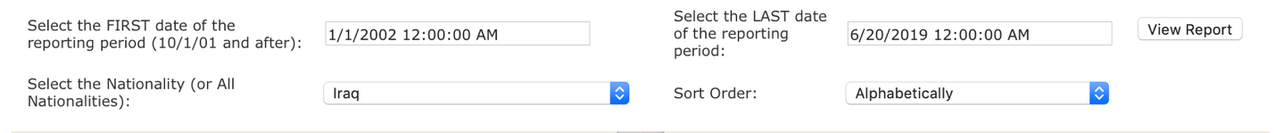
  - How many refugees from this country have been resettled in you state and in a nearby city?
Use ‘MX-Arrivals by Destination and Nationality’ for the number of refugee arrivals from this country each year. Export this data as an excel spreadsheet. Use this data to create a line graph of refugee resettlement for your state in excel.
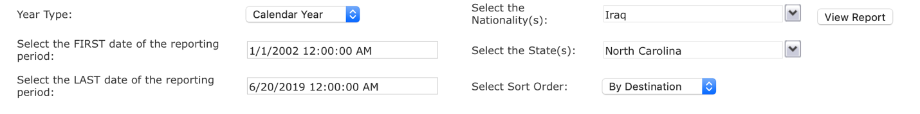
  - What religious group do these individuals belong to?
Use MX-Arrivals by Nationality and Religion to find the religion of the refugees from this country. Export this data as an excel spreadsheet. Use this data to create a pie chart of religion.
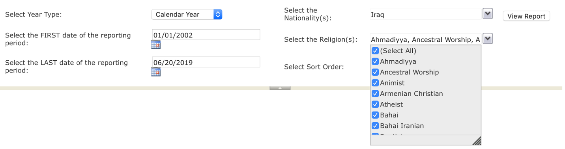
  - Pick one of the following categories you are interested in learning more about: Age, Ethnicity, Education, Gender or Language. What have you learned about this category for this group?
Use MX-Arrivals for a Demographic Profile to learn about these categories. Export this data as an excel spreadsheet. Use this data to create a pie chart or other graph for this category.

An example fact sheet for Iraq is included, beginning on page 6.

Adaptations: This exercise could be adapted to focus on:
- Refugees and refugee camps in the Middle East using information and graphics from UNHCR Global Focus: http://reporting.unhcr.org/node/36.
- Syrian refugees in Egypt, Iraq, Jordan, Lebanon and Turkey using information and graphics from UNHCR 3RP Regional Refugee and Resilience Plan: https://data2.unhcr.org/en/situations/syria.
- Refugees in the Mediterranean using information and graphics from UNHCR: https://data2.unhcr.org/en/situations/mediterranean.
- Refugees in Iraq using information and graphics from UNHCR: https://data2.unhcr.org/en/situations/iraq_cccm.
- Yemeni refugees in Djibouti, Ethiopia, Oman, Saudi Arabia, Somalia and Sudan using information and graphics from UNHCR: http://data.unhcr.org/yemen/regional.php.

Notes: This exercise is adapted from an activity used in a 400-level undergraduate Sociology course on Contemporary Immigration in the United States. In this project, each student in the class is responsible for learning about an immigrant group in the United States from a specific country using Department of Homeland Security and Census data. The students work together in regional groups during two in-class workshops to provide feedback on group members’ graphs and figures and later provide feedback on group members’ first draft of their written profile. Each student submits a ten-page profile for their country that includes that immigrant group’s migration history and related policies and programs, predominant means of entry and demographic characteristics. At the end of the semester, each regional group gives a 10-minute group presentation highlighting the history of migration from their region to the U.S., relevant policies and programs, predominant means of entry and demographic characteristics.
Iraqi Refugee Fact Sheet Example

Since January 1, 2002, 144,213 Iraqi refugees have been resettled in the United States. California, Michigan, Texas, Arizona and Illinois are the top five states resettling Iraqi refugees. Since 2005, 2,145 Iraqis have been resettled in North Carolina. 653 of them have been resettled in Raleigh and 389 have been resettled in Durham. Annual resettlement in North Carolina was the highest in 2014. The majority of Iraqi refugees resettled in the United States identify as Muslim, but approximately one-third are Christian (Catholic, Protestant, Evangelical or Orthodox). Slightly more resettled Iraqi refugees are male (52 percent) than female (48 percent).

Map of Iraqi Refugees Resettled in the United States, from January 2002 to June 2019
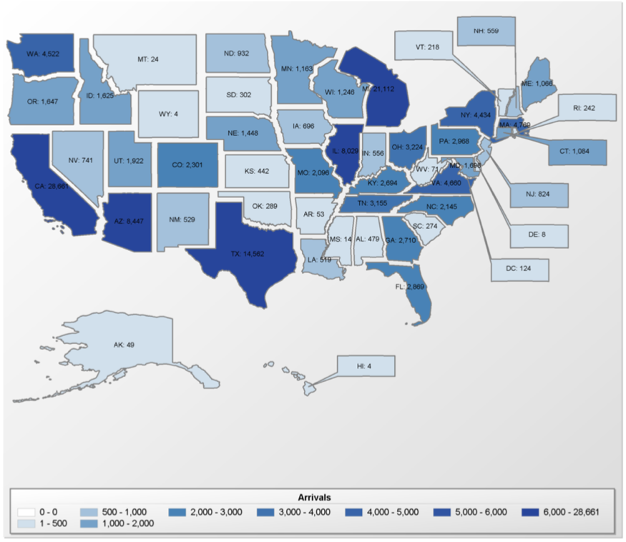
Source: Refugee Processing Center.

Iraqi Annual Resettlement in North Carolina, from 2005 to 2019

Source: Refugee Processing Center.
Religion of Iraqi Refugees Resettled in the United States, from 2005 to 2019

Source: Refugee Processing Center.

Gender of Iraqi Refugees Resettled in the United States, from 2005 to 2019

Source: Refugee Processing Center.

Resource List

Books for Middle or High School Students:
The Best We Could Do by Thi But
The Map of Salt and Stars, by Jennifer Zeynab Joukhadar
Escaping Wars and Waves by Oliver Kugler
A Hand Full of Stars, by Rafik Schami
The Newcomers, by Helen Thorpe

Films:
Welcome (2009): A French film about immigrants living in Calais, France and attempting to cross the British Channel to the United Kingdom

News:
Middleeasteye.net
Google Alert: ‘Refugees’

Policy Institutes and International Organizations:
Migration Policy Institute http://www.migrationpolicy.org/
National Immigration Forum https://immigrationforum.org/resources/?type=fact-sheet
Refugee Processing Center http://ireports.wrapsnet.org
UNHCR Middle East Reporting http://reporting.unhcr.org/node/36
UNHCR Syria Regional Response https://data2.unhcr.org/en/situations/syria
UNRWA (for Palestine refugees) Reports https://www.unrwa.org/resources/reports

Refugee Resettlement Organizations working locally across the United States:
Church World Service (CWS) http://www.churchworldservice.org/
Ethiopian Community Development Council (ECDC) http://www.ecdcus.org/
Episcopal Migration Ministries (EMM) http://www.episcopalchurch.org/emm/
Hebrew Immigrant Aid Society (HIAS) http://www.hias.org/
International Rescue Committee (IRC) http://www.rescue.org/
US Committee for Refugees and Immigrants (USCRI) http://www.refugees.org/
Lutheran Immigration and Refugee Services (LIRS)http://www.lirs.org/
United States Conference of Catholic Bishops (USCCB) http://www.usccb.org/
World Relief Corporation (WR) http://worldrelief.org/

Resource for:
- Information
- Learning More about Local Refugee Populations
- Possible Speakers
- Getting Involved (Fundraising/Volunteering)

Statements and answer key are adapted from resources from Church World Service (www.greateras1.org), National Immigration Forum (https://immigrationforum.org/) and academic sources.
Evans, William and Daniel Fitzgerald. 2017. The Economic and Social Outcomes of Refugees in the United States: Evidence from the ACS. w23498. Cambridge, MA: National Bureau of Economic Research, p. 30.

