The “Brexit Dividend” in effect?

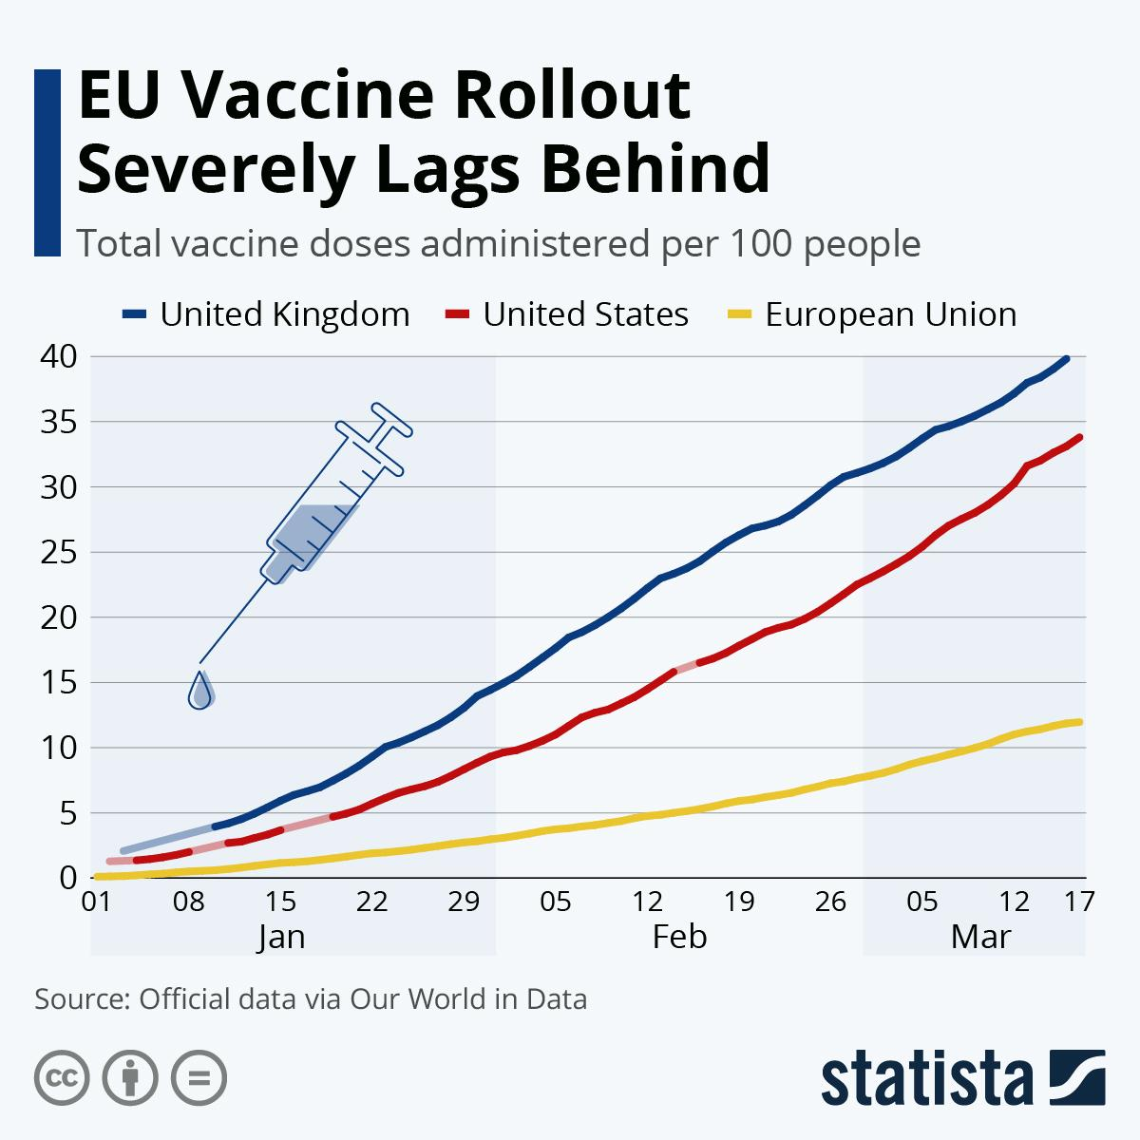

Wrapping up group work on expanding human rights

In breakout rooms, with new group members, share and discuss your responses to the last question:

What inferences can you make or conclusions can you arrive at about the nature of international human rights treaties and documents from the work you and your partners have shared? This is an open ended question but see what you come up with. Try to avoid repeating anything that was said in the previous two questions.

Notes (take note of anything new/interesting):

Human Rights can exist and be enforced at many different levels of government

Level | Example
International | Geneva conventions, UNDRIP, etc. (any example from your group assignment)
Regional | European Convention on Human Rights (47 members in and around Europe).  “The European Convention on Human Rights (ECHR) is an international human rights treaty between the 47 states that are members of the Council of Europe (CoE) - not to be confused with the European Union.  “Governments signed up to the ECHR have made a legal commitment to abide by certain standards of behaviour and to protect the basic rights and freedoms of ordinary people. It is a treaty to protect the rule of law and promote democracy in European countries.”  “Parties undertake to secure these rights and freedoms to everyone within their jurisdiction.The Convention also establishes an international enforcement machinery. To ensure the observance of the engagements undertaken by the Parties, the European Court of Human Rights in Strasbourg has been set up. It deals with individual and inter-State petitions. At the request of the Committee of Ministers of the Council of Europe, the Court may also give advisory opinions concerning the interpretation of the Conventions and the protocols thereto. The Committee of Ministers has also a power to ask the Court for an interpretation of a judgment.  “The parties to a case must abide by the judgments of the Court and take all necessary measures to comply with them. The Committee of Ministers supervises the execution of judgments. The Secretary General may request Parties to provide explanations on the manner in which their domestic law ensures the effective implementation of the Convention.”  https://www.coe.int/en/web/conventions/full-list/-/conventions/treaty/005
National | Human rights ideas and concepts can be embedded in national constitutions.  Ex. Many of the American Bill of Rights overlap with articles from the UDHR though there is no explicit reference to human rights in the US Constitution.  South Africa’s Constitution explicitly includes human rights.
Local | Ex. New York City Commission on Human Rights  The New York City Human Rights Law is one of the most comprehensive civil rights laws in the nation. The Law prohibits discrimination in employment, housing, and public accommodations based on race, color, religion/creed, age, national origin, immigration or citizenship status, gender (including sexual harassment), gender identity, sexual orientation, disability, pregnancy, marital status, and partnership status. Interns, whether paid or not, are considered employees under the Law.  You can read more about it here: https://www1.nyc.gov/site/cchr/about/inside-cchr.page

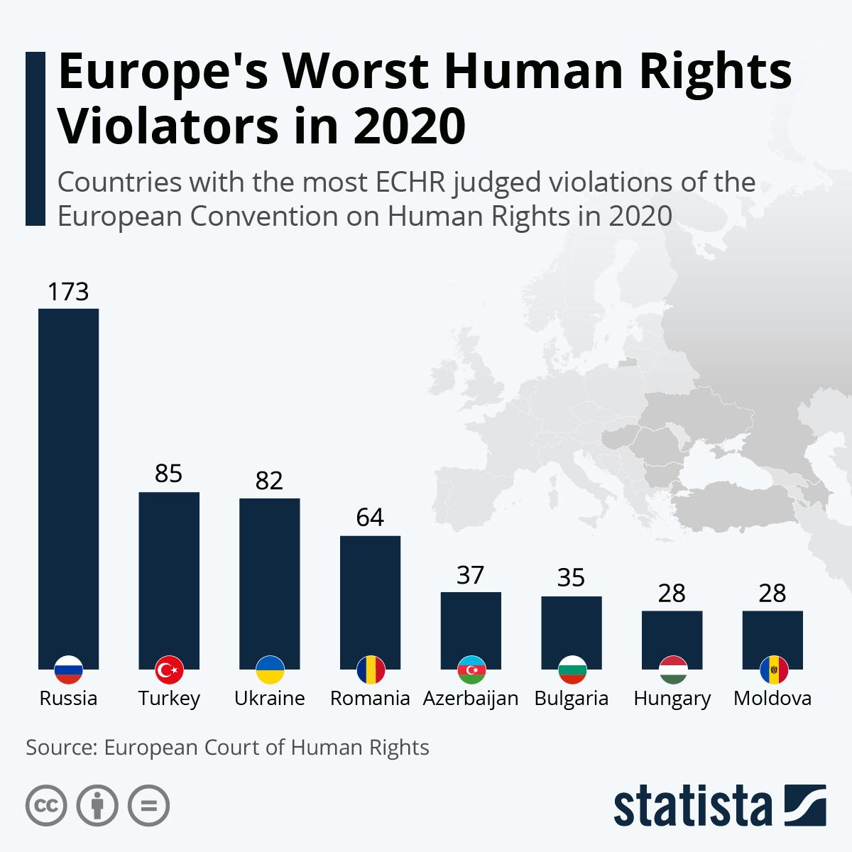

From your project, remember there are four key elements to meaningful human rights laws: Codification (creating laws), enforcement, monitoring, promotion.

European Convention on Human Rights

The ECHR attempts to accomplish all four of the above and is considered the most advanced and sophisticated regional human rights organization in the world. How effective and successful has it been?

Let’s look at what the court has done in a specific country like Turkey.

https://www.coe.int/en/web/impact-convention-human-rights/turkey

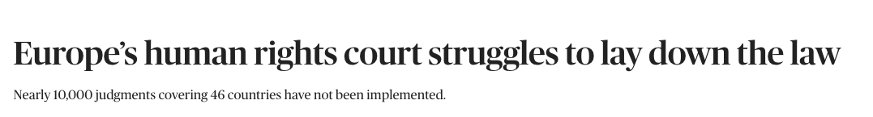

BY GINGER HERVEY
September 20, 2017

The most sophisticated system in the world for defending human rights is facing a test. So far, it’s failing.

Nearly 10,000 judgments of the European Court of Human Rights have not been put into effect by national governments. Some of those cases were ruled on as far back as 1992, and they cover all but one of the 47 member countries of the Strasbourg-based Council of Europe, the court’s parent body and the Continent’s leading human rights organization.

The failure to implement these judgments — detailed in a Council of Europe database — means that practices have continued across Europe, in many cases for years, after being ruled violations of human rights. These range from segregating HIV-positive prisoners in Greece, to police brutality in Bulgaria, to not properly investigating deaths of prisoners in Romania.

Perhaps the committee’s biggest flaw is that if a country doesn’t implement a judgment, there’s not much it can do. The Council of Europe’s commissioner for human rights, Nils Muižnieks, said that as some European countries backslide on democratic standards, the court and the committee are at a loss on how to enforce judgments.

“Our work is based on cooperation and good faith,” Muižnieks said. “When you don’t have that, it’s very difficult to have an impact. We kind of lack the tools to help countries that don’t want to be helped.”

https://www.politico.eu/article/human-rights-court-ilgar-mammadov-azerbaijan-struggles-to-lay-down-the-law/

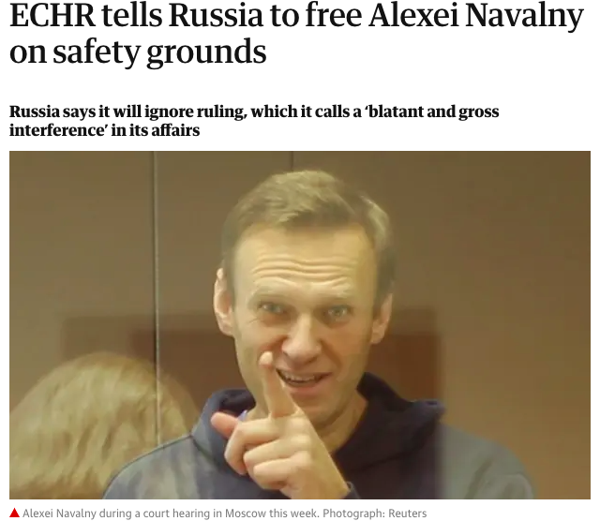
The European court of human rights has told Russia to free Alexei Navalny, prompting a new standoff between Europe and Moscow over the fate of Vladimir Putin’s staunchest critic.

Russia has said it will ignore the ruling despite a requirement to comply as a member of the Council of Europe, calling the court’s decision “blatant and gross interference in the judicial affairs of a sovereign state”.

In a ruling published on Wednesday, the Strasbourg-based court granted Navalny a temporary release from jail because it said the government “could not provide sufficient safeguards for his life and health”.
…

Russia adopted new constitutional amendments last year that said Moscow had the right to ignore international legal decisions that violate its sovereignty.

It has ignored key ECHR decisions in the past, including a July 2014 order to pay €1.9bn in compensation to shareholders of the Yukos oil empire assembled by the oligarch Mikhail Khodorkovsky. Khodorkovsky was jailed for nearly a decade on tax evasion and fraud charges and the company was broken up and sold to state-controlled firms.

Russia joined the Council of Europe in 1996. Under Putin it has increasingly clashed with the body and threatened to leave. Moscow lost its voting rights in the plenary assembly of the council in 2014 over its invasion of Ukraine, and regained them, controversially, in 2019.

https://www.theguardian.com/world/2021/feb/17/echr-tells-russia-to-free-alexei-navalny-on-safety-grounds

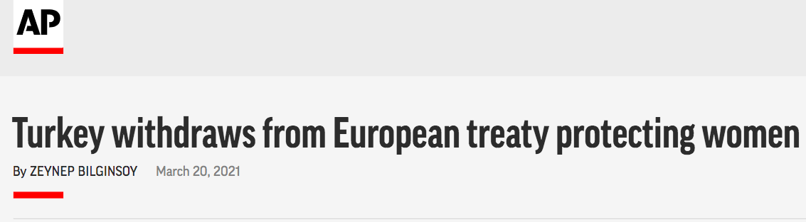

Turkey withdrew early Saturday from a landmark European treaty protecting women from violence that it was the first country to sign 10 years ago and that bears the name of its largest city.

President Recep Tayyip Erdogan’s overnight decree annulling Turkey’s ratification of the Istanbul Convention is a blow to women’s rights advocates, who say the agreement is crucial to combating domestic violence. Hundreds of women gathered in Istanbul to protests against the move on Saturday.

The Council of Europe’s Secretary General, Marija Pejčinović Burić, called the decision “devastating.”

“This move is a huge setback to these efforts and all the more deplorable because it compromises the protection of women in Turkey, across Europe and beyond,” she said.

The Istanbul Convention states that men and women have equal rights and obliges state authorities to take steps to prevent gender-based violence against women, protect victims and prosecute perpetrators.

https://apnews.com/article/world-news-turkey-europe-istanbul-violence-f096c185314cde20dce2504a70ee6889

Respond:

What inferences or conclusions can you draw from the examples and stories above about the effectiveness of human rights treaties?

We have discussed various problems in the international enforcement of human rights law. What is the value of these treaties, laws, and institutions if they have all of these problems?

