Realism and Liberalism on Human Rights

Directions: Please read the following explanations on the views of liberalism and realism on the concept of human rights. At the end, please complete a brief summary contrasting each of these theoretical perspectives.

Realism

According to realists, the landscape of world politics seems inhospitable to human rights. The realist world is one where rules are regularly broken, and agreements last only as long as they benefit the contracting parties. As Hobbes put the problem with characteristic clarity, treaties that are not imposed by force ‘are but words’. Today’s realists continue to believe that, for the most part, the diplomacy of human rights is just talk. They understand that human rights are part of the vocabulary of modern international society: after all, no state leader openly challenges the principles underpinning the human rights regime. The realist contention is that, when push comes to shove, human rights are very low on the list of national policy goals. This explains the prevalence of double standards in international diplomacy, whereby political leaders pay lip service to protecting human rights while at the same time allowing these principles to be undermined by the pursuit of other goals. In other words, in the final analysis, unless the promotion of human rights is in the national interest why would it be rational for states to pursue such goals?

The condition of international anarchy [a world in which there is no strong structure or order imposed on nation states] and the pursuit of the national interest are two significant reasons why realists are skeptical about human rights. A third reason is an ethical objection to the assumption of a universal morality that is in many ways the bedrock of the existing human rights regime. As the great realists of the early part of the twentieth century argued (Carr, 1946; Morgenthau, 1948), urging others to obey the universal moral law are simply techniques to hide the pursuit of narrow selfish interests. All great powers in history have articulated universal claims: we should not be surprised if such measures benefited the dominant power. Such a convenient linkage between universal morality and the national interest was evident in the justifications for colonial possessions made by the European imperial powers in the nineteenth century, just as democracy promotion consolidated US hegemony [dominance] in the modern era. Likewise, those living outside the ‘greater West’ today often complain that human rights are a tool wielded by the powerful to secure various goals such as favourable terms of trade or even a change of regime.

Liberalism

Liberalism is historically the main challenger to realism in international relations. At the level of ideas, liberalism develops out of a Western tradition of thinking in which the individual has rights that public authorities must respect. While there are varieties of liberal thinking, the central idea is that individual persons have basic rights to free speech, fair treatment in terms of judicial process, and political equality enshrined in a political constitution. While Hobbes and Machiavelli are invoked by realists to justify the promotion of national self-interest, liberals look to Locke and Kant as their lodestars. Kant’s pamphlet ‘Perpetual Peace’ (Kant, 1991) builds a theory of international liberalism in which all individuals have equal moral worth, and in which an abuse of rights in one part of the world is ‘felt everywhere’. It is easy to dismiss liberalism as being utopian. The history of statecraft from the mid-seventeenth century onwards is more readily understood in terms of conflict and aggression. But, as liberals point out, moral universalism has continued to insert itself into the practice of international politics. From the birth of the Enlightenment onwards, states have made significant advances in terms of meeting universal principles central to liberalism. Western states have, over time, enshrined the rights of citizens in legal constitutions, ended the trade in slaves and then the institution of slavery, agreed to protect the condition of workers, and advanced international humanitarian law to protect wounded or captured soldiers and to criminalise the targeting of civilians.

Many of these advances that took place between the mid nineteenth and the early twentieth centuries became codified in the internationalization of human rights in the UN system after 1945. The implementation of human rights standards in the twentieth century has been chequered. Liberals recognize that the division of global humanity into separate sovereign states presents particular problems when it comes to embedding universal moral principles. Two kinds of responses are triggered by this dilemma. The first is the attempt to expand the liberal ‘zone’ such that there are fewer authoritarian states in the world; the second is to strengthen international institutions in the expectation that they can alter the incentives of member states in ways that enhance respect for human rights and human dignity.

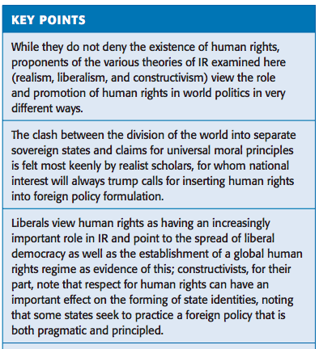
(summary below)

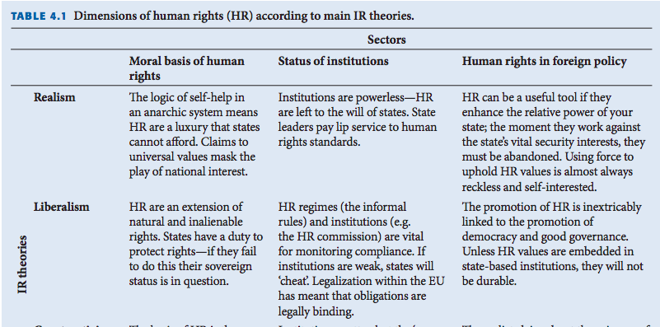

Identify a few key points that will provide you a good summary of the differences between realism and liberalism. Use your own words here.

Realism | Liberalism

Adapted from: https://socialsciences.exeter.ac.uk/politics/research/readingroom/Dunne-goodhart-chap04.pdf

