The Inquiry: Who Gets to Have Their Own Country?

Directions: First read the first two definitions that explain two terms that come up throughout. Start listening to The Inquiry podcast, “Who Gets to Have Their Own Country?” from 8/2017, once you get to “Part 1…” and use this worksheet while you listen to hear some definitions and explanations of the concepts discussed.

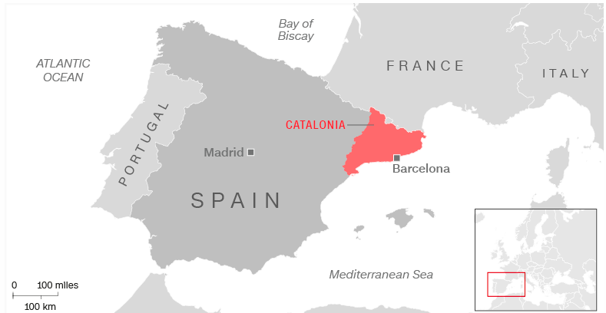
Autonomous/Autonomy: Having autonomy means a group of people has some independent control over what happens to them and to their land but these people do not have absolute sovereignty over their territory.

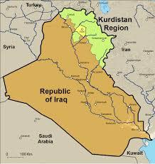

Referendum: A popular vote among citizens to decide on what should happen on a particular issue. Whether UK should leave the EU was a referendum. Colorado legalizing recreational use of marijuana was also done by a referendum. Regions that want to establish an independent nation state often use referendums to make their case for the legitimacy of their claims for independence.

(Start listening) Part I: A people’s prerogative

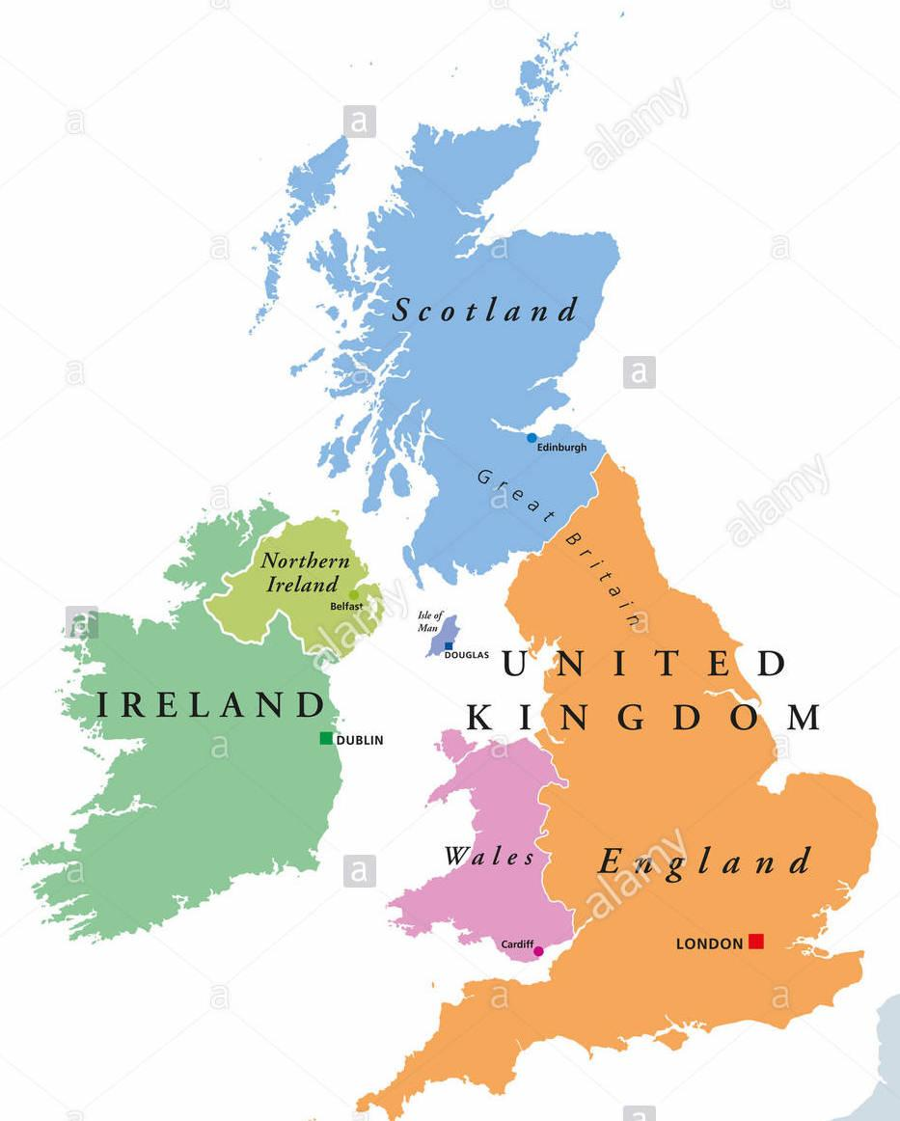
In the past, how did countries become independent or add new territory?

Jurisdiction: having the legitimate power to make legal decisions and judgments

Self-determination: the concept that a group of people determines its own statehood and forms its own allegiances and government.

Uti possidetis (Latin for "as you possess under law") is a principle of international law which provides that newly-formed sovereign states should retain the internal borders that their preceding dependent area had before their independence. Ex. When Algeria became independent from France, which had colonized it, Algeria became an independent nation state and retained the same borders it had under France. New nations were not expected to be then carved out of Algeria even if the people inside of Algeria wanted it.

Nationalist: a person who strongly identifies with their nation-state and focuses on the interests of that nation-state. A Catalonian nationalist may support the creation of an independent Catalonia from Spain.
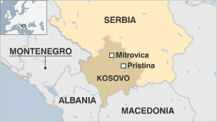

Part II: The Curious Case of Kosovo

“An understanding in the international community that the borders of states will be sacrosanct. That there will be respect for the territorial integrity of states.”

Define “Territorial integrity”:

Why do concepts of self-determination and territorial integrity disagree with each other?

Why did Kosovo’s independence cause controversy based on the way other nation states had been formed?

Unilaterally: Decided or acted upon by one group by itself without permission from other interested groups.

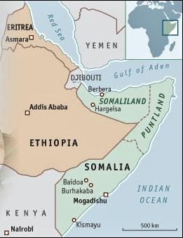
Part III: “Limboland”

What is Somaliland’s argument for being recognized as a legitimate nation-state?

What stops it from actually being considered a legitimate state?

What are the benefits of being a fully recognized nation-state in the international system?

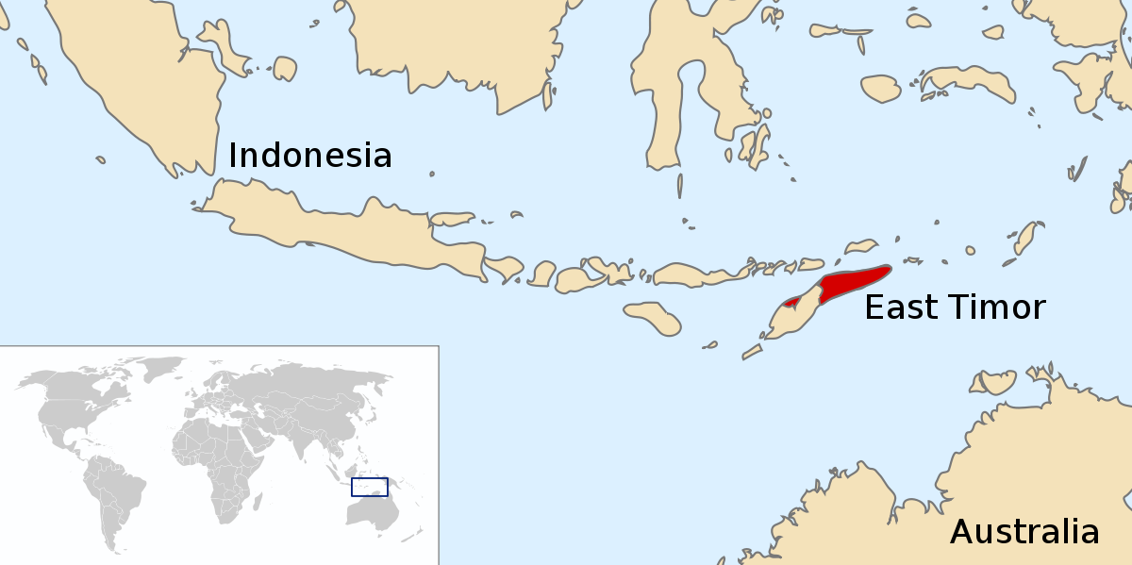
Part IV: The Rule of Great Powers

What is the role of “great powers” in deciding who gets to be a country? How do those great powers exercise that power?

Questions. Was anything unclear or do you have further questions we should explore about the topic here?

Respond

Do you think the current system for determining who gets their own nation state and who doesn’t is fair? Explain using specific ideas and evidence from the podcast we listened to today. Please be thoughtful in your response.

