From the news

Suez Canal Blocked

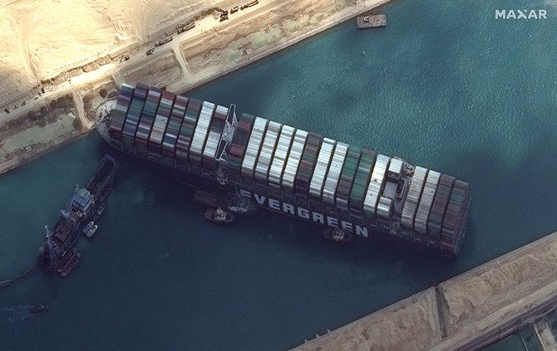

Summary

“What to Know About the Suez Canal and the Cargo Ship That Was Stuck There”

https://www.nytimes.com/2021/03/25/world/middleeast/suez-canal-container-ship.html

“Implications of Suez Canal Blockage on Global Trade”

https://globaledge.msu.edu/blog/post/56998/implications-of-suez-canal-blockage-on-g

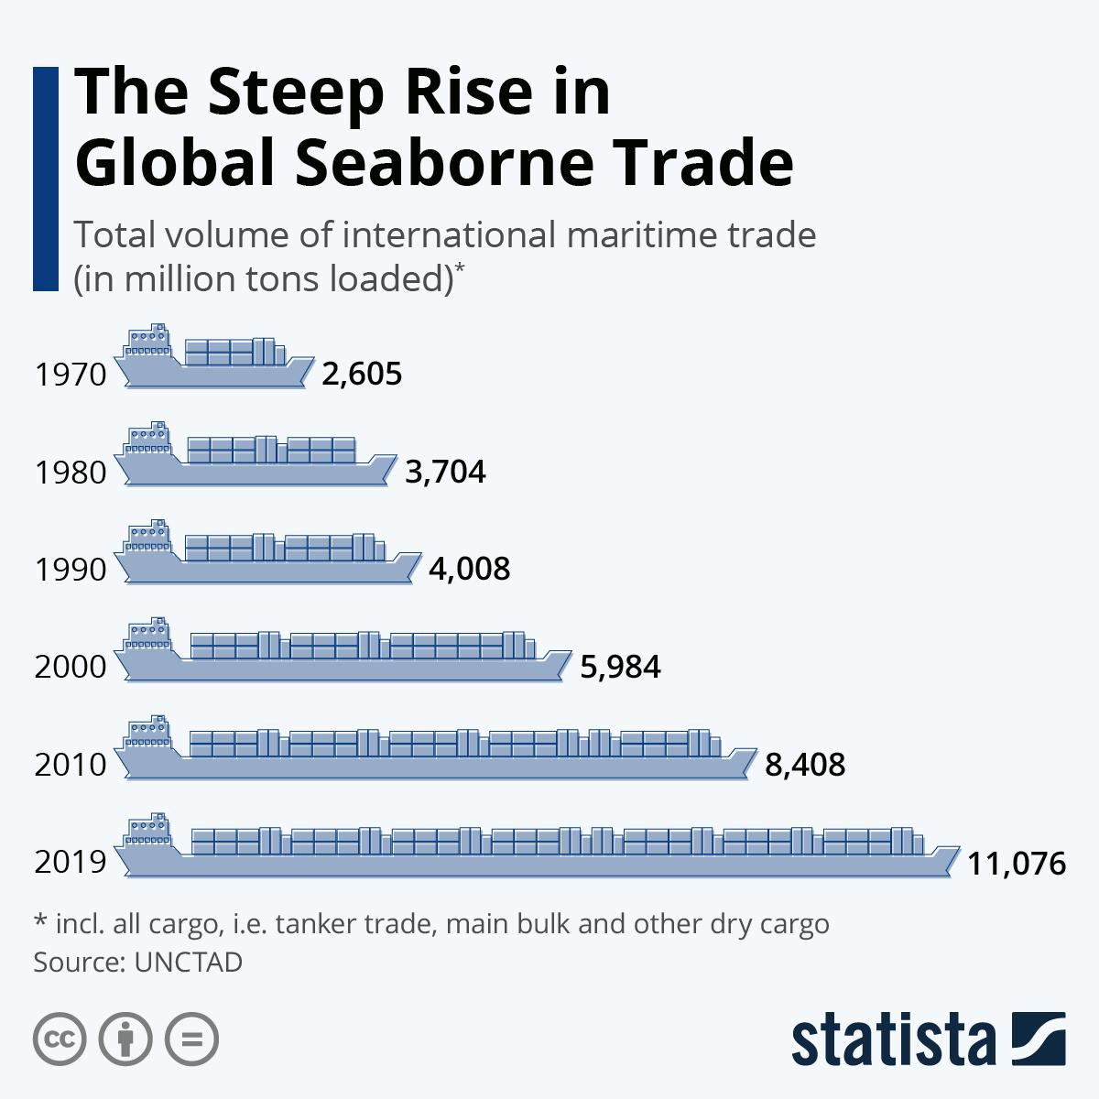
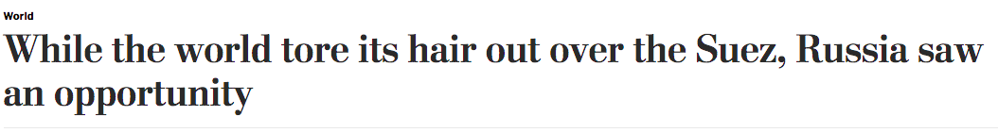

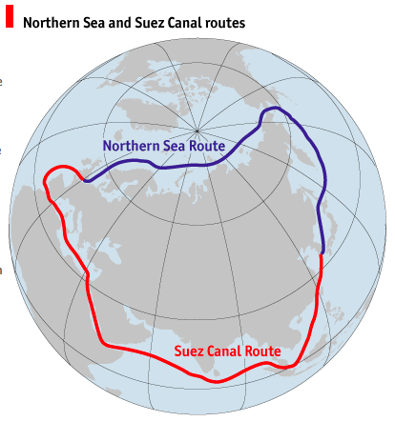

Mini Case Study #2: The International Criminal Court

Key Question: How effective is the international institutional approach to protecting human rights?

(Mini Case study #1 was the European Court of Human Rights)

Do Now: Assume the perspective of a realist. Why would you want your nation to join an international human rights court? Why not?

The Rome Statute and International Criminal Court (ICC)

Someone who did Rome Statute want to tell us about the ICC?

What is the ICC?

The International Criminal Court, established in 2002, seeks to hold to account those guilty of some of the world’s worst crimes. Champions of the court say it deters would-be war criminals, bolsters the rule of law, and offers justice to victims of atrocities. But, since its inception, the court has faced considerable setbacks. It has been unable to gain the support of major powers, including the United States, China, and Russia.

Background

After World War II, there were two tribunals (courts created for a specific, limited purpose) to try German and Japanese leaders for war crimes. The cause of an international court or tribunals took a long pause during the Cold War but In the 1990s, there were two tribunals to try leaders from the former Yuglslavia and Rwanda for war crimes and crimes against humanity. This created momentum to create a more permanent court to be able to try individuals and

Remember that in order for human rights to be meaningful, there needs to be a mechanism to enforce and protect those rights. The ICC is the most ambitious attempt at creating such a place with an international jurisdiction (area in which you have official power).

Which countries are members of the court?

There are 123 countries party to the Rome Statute. Some forty countries never signed the treaty, including China, Ethiopia, India, Indonesia, Iraq, North Korea, Saudi Arabia, and Turkey. Several dozen others signed the statute, but their legislatures never ratified it. These include Egypt, Iran, Israel, Russia, Sudan, Syria, and the United States.

Note that there is also an International Court of Justice (ICJ) but this is to resolve disputes between countries. Individuals cannot be charged for crimes here. The ICC is also not part of the UN and exists independent of the UN system.

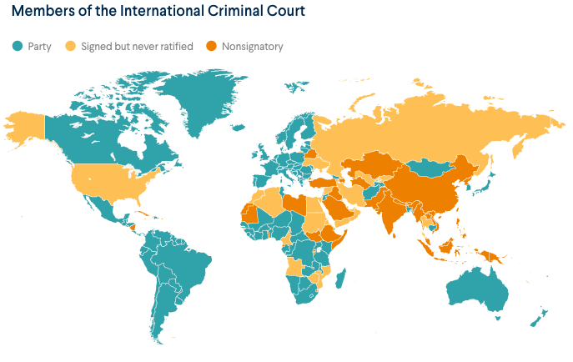

Two countries have withdrawn from the ICC. Burundi left in 2017, following the court’s decision to investigate the government’s crackdown on opposition protests. Philippine President Rodrigo Duterte pulled out in 2019, after the court launched an inquiry into his government’s war on drugs, saying domestic courts are sufficient to enforce the rule of law.

The court has jurisdiction over four categories of crimes under international law:

- genocide, or the intent to destroy in whole or in part a national, ethnic, racial, or religious group;
- war crimes, or grave breaches of the laws of war, which include the Geneva Conventions’ prohibitions on torture, the use of child soldiers, and attacks on civilian targets, such as hospitals or schools;
- crimes against humanity, or violations committed as part of large-scale attacks against civilian populations, including murder, rape, imprisonment, slavery, and torture; and
- crimes of aggression, or the use or threat of armed force by a state against the territorial integrity, sovereignty, or political independence of another state, or violations of the UN Charter.

The ICC is intended to complement rather than replace national courts. It can only act when national courts have been found unable or unwilling to try a case. The ICC is considered a court of last resort. The expectation is that existing courts inside of countries are the primary vehicles to deliver justice. The ICC is only used in exceptional cases.

Ex. American Contractors in Iraq

Employees of Blackwater Security Consulting, now known as Academi, shot at Iraqi civilians, killing 17 and injuring 20 in Nisour Square, Baghdad on Sept. 16, 2007 as they were escorting a US embassy convoy.

The incident caused five investigations. The FBI found that at least 14 of the 17 Iraqis killed were shot without any cause, including 9- and 11-year-old boys.

"Seven years ago, these Blackwater contractors unleashed powerful sniper fire, machine guns and grenade launchers on innocent men, women and children," Ronald Machen, the US Attorney for the District of Columbia, said in his 2014 statement.

Four Blackwater employees were convicted and sentenced to prison. All of this was done within the US court system and not in any international court.

In 2020, President Trump pardoned these and other contractors and soldiers convicted of war crimes.
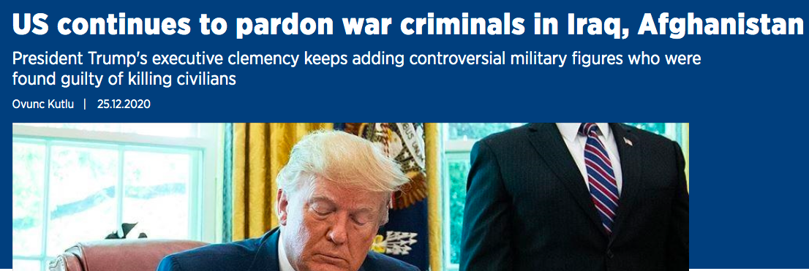
https://www.aa.com.tr/en/americas/us-continues-to-pardon-war-criminals-in-iraq-afghanistan/2088191

International Criminal Court Cases

(image can be found here)

In breakout rooms, discuss and take notes on the following questions:

What is the relationship between the ICC and national sovereignty?

Membership can undermine national sovereignty, leaders and citizens can potentially be put on trial by an external court.

ICC being a central institution for deciding what is and isn’t a war crime, human rights abuse gives it power and takes away power from nation states,

ICC is a court of last resort so countries still have sovereignty and control except in exceptional cases.

States can still back out, countries have choice whether to participate

What is the nature of the court’s legitimacy? What would strengthen its legitimacy? Undermine it?

Many nation states have signed on (123), if countries abide by it, follow its rulings, its findings, participate in it.

More members, powerful ones, if they joined would add legitimacy to it.

If countries were to back out of the ICC would undermine it, if powerful countries, like the US denounce or undermine it it would undermine its legitimacy. Smaller countries backing out would undermine its legitimacy.
Not a lot of consequence for joining, adding consequences would add to its legitimacy.

The Court - Inside the International Criminal Court (8 minutes)

This video should provide a good review of the ICC. Please take notes on anything important that you come across and any questions.

https://www.youtube.com/watch?v=PR8qPyCrrsM

Notes on video:

Any questions?

Adapted from: https://www.cfr.org/backgrounder/role-international-criminal-court

