Evaluating Political Cartoons on Brexit

Introduction: In 2016, voters in the United Kingdom (UK) chose to leave the European Union (EU), a process known as Brexit. Since that time, politicians have tried to negotiate a settlement agreement between the UK and EU that would lay out the terms of the UK’s exit. British Prime Minister Theresa May negotiated a withdrawal agreement with the EU but resigned after failing to get Parliament to approve it. Her successor, Boris Johnson, promised to carry out Brexit even if it means leaving the EU with no formal separation agreement (a No-Deal Brexit). This complex process inspires political cartoonists to offer commentary and analysis about issues related to Brexit.

Cartoonists use a variety of techniques to convey their ideas. These include:

Labels: Cartoonists often identify or name certain things in their cartoons with words so that it is apparent what they represent.
Symbolism: Cartoonists may use simple objects to represent larger ideas or concepts. Analogy: Cartoonists may compare a simple image or concept to a more complex situation in order to help the viewer understand the situation in a different way.
Irony: Cartoonists may express an opinion on a topic by highlighting the difference between the way things are and the way things should, or are expected, to be.
Exaggeration: Cartoonists may exaggerate objects, people, or ideas to make a point. Stereotype: Cartoonists may use a stereotype or generalization about a group of people (even though it is not true about everyone in that group).

Instructions: Work with your group to analyze cartoons has assigned to you. You will be asked to identify the techniques each cartoonist used. The following questions will help guide your thinking.

- If the cartoonist used labels, what things in the cartoon are labeled? Why do you think the cartoonist chose to label those things?
- If the cartoonist used symbolism, what things in the cartoon are symbols? What do they stand for?
- If the cartoonist used an analogy, what two ideas or situations are compared? How does this comparison help the viewer see the complex situation in a different way?
- If the cartoonist used irony, what does the cartoonist show about the way things are? How does the cartoonist think things should be?
- If the cartoonist used exaggeration, what objects, people, or ideas are exaggerated? What point is made by exaggerating/ distorting them?
- If the cartoonist used stereotypes, what stereotypes are presented? How do these add to the message of the cartoon?

Let’s work through one together. Try to observe the following cartoon and apply the concepts discussed above. This cartoon is from December 2019

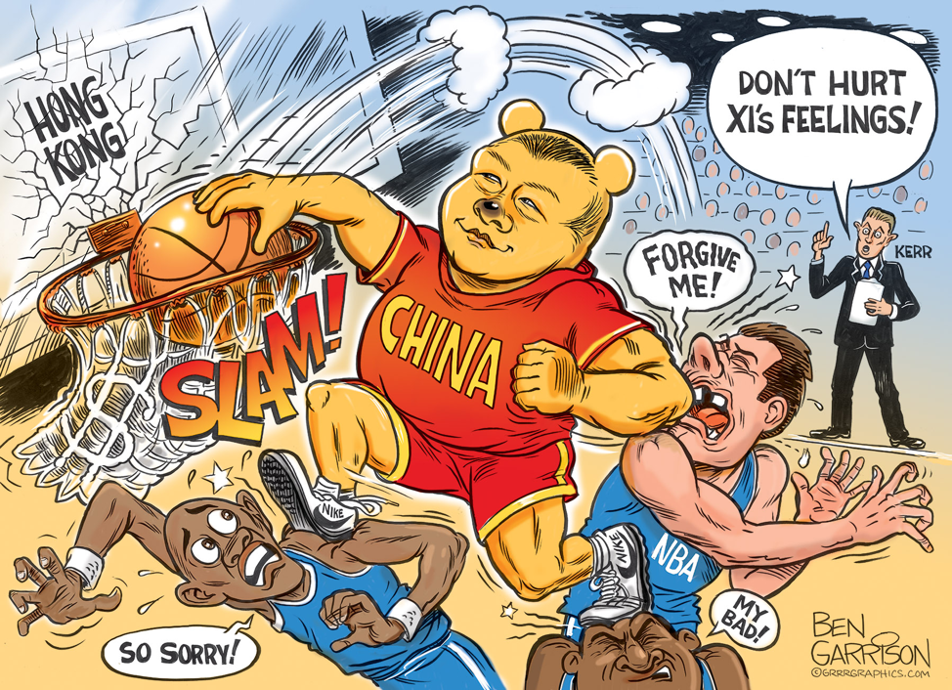

Notes on the cartoon above

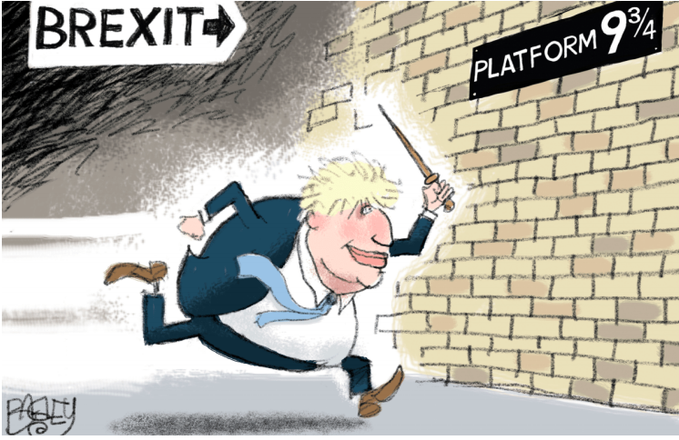

Brexit Cartoon #1 (above)

1. Observation. Describe the objects or people in the cartoon.

2. Technique: Identify at least two techniques that the cartoonist used and explain what ideas are conveyed through each technique.

3. Message: What is the message of the cartoon? Make specific reference to the people and situations in the cartoon.

Cartoon #2

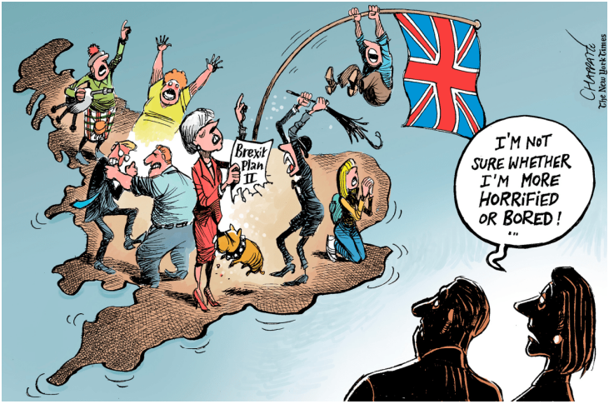
1. Observation. Describe the objects or people in the cartoon.

2. Technique: Identify at least two techniques that the cartoonist used and explain what ideas are conveyed through each technique.

3. Message: What is the message of the cartoon? Make specific reference to the people and situations in the cartoon.

Cartoon #3

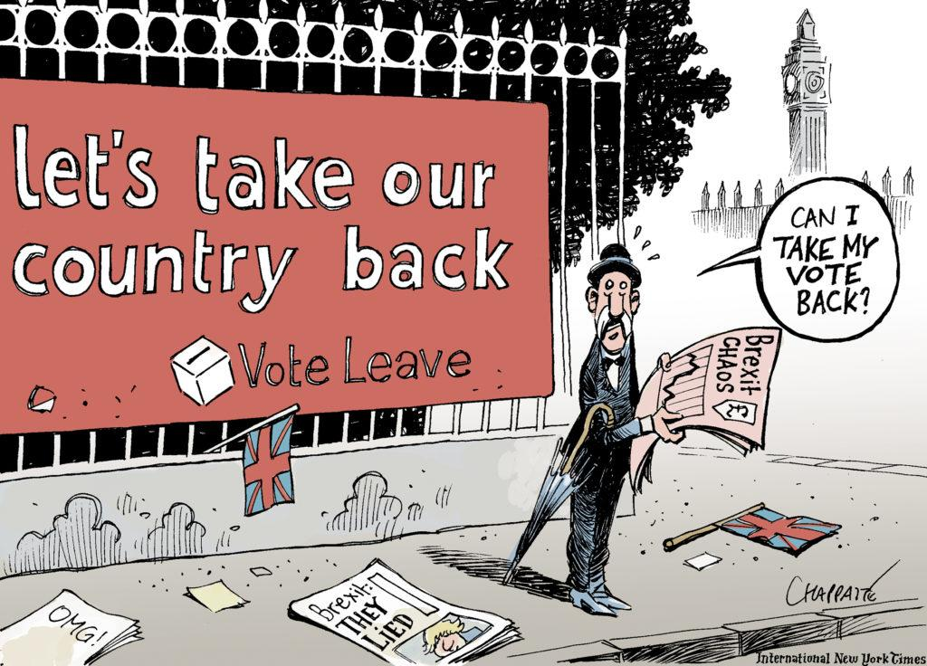

1. Observation. Describe the objects or people in the cartoon.

2. Technique: Identify at least two techniques that the cartoonist used and explain what ideas are conveyed through each technique.

3. Message: What is the message of the cartoon? Make specific reference to the people and situations in the cartoon.

Cartoon #4

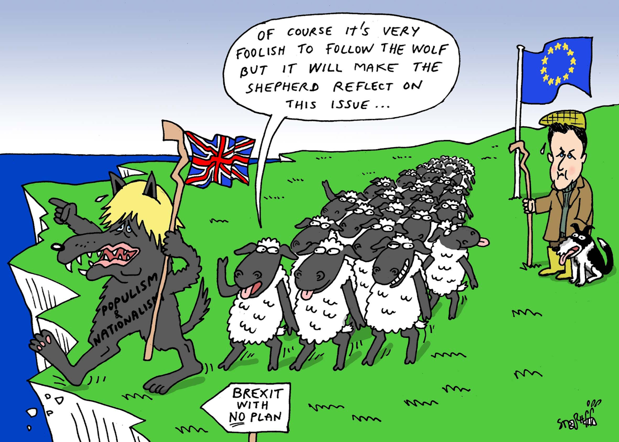

1. Observation. Describe the objects or people in the cartoon.

2. Technique: Identify at least two techniques that the cartoonist used and explain what ideas are conveyed through each technique.

3. Message: What is the message of the cartoon? Make specific reference to the people and situations in the cartoon.

Adapted from: https://www.choices.edu/teaching-news-lesson/political-cartoon-analysis-understanding-brexit/

