IB Exam Changes

Standard Level IB exam changes

Old | New for May 2022
Political Engagement Activity  May 2022 Exam Paper 1  May 2022 Exam Paper 2 (2 questions) | Political Engagement Activity  May 2022 Exam Paper 2 (2 questions)

Higher Level IB exam changes

Old
- Political Engagement Activity  - Two 10 minute research presentations on Global Political Challenges  - May 2022 Exam Paper 1  - May 2022 Exam Paper 2 (3 questions) | - Political Engagement Activity  - One 10 minute research presentation on Global Political Challenges  - May 2022 Exam Paper 2 (2 questions)

Essay checklist

Please look back over your essay and make sure you’ve done each of the following. If there is anything missing or incorrectly done, I’m allowing you to resubmit your work on turnitin.

- Total essay is 1200-2000 words
- Includes a bibliography or works cited page
- Includes internal citations that refer to actual source articles we read in class not to class google docs
- Key terms are defined
- Each paragraph clearly addresses the assigned task
- Each paragraph has a clearly worded topic sentence
- Each paragraph includes a description and discussion of a specific case study to justify arguments
- Essay addresses the assigned task from multiple perspectives (ex. counterclaim)

Non state Actor: Social/Protest movements

We’ve covered various actors in global politics including nation-states, IGOs, NGOs, and MNCs. We’ll look at this one final actor today and tomorrow. There are still many more actors that we haven’t addressed but we will explore later on in the course.

Read the following

Social/Protest Movements (adapted)

Social movements can be described most simply as collective attempts to promote or resist change in a society or group. The degree of change advocated and the level at which changes are pursued vary across all types of social movements, whether religious, political, or student. Some movements clamor for sweeping, revolutionary transformations, whereas others pursue specific moderate reforms. The level at which changes are sought varies from global and national alterations of social structures to attitudinal, spiritual, and lifestyle changes.

Types of movements

Revolutionary movements such as the Bolshevik, Palestinian, and Irish Republican movements seek fundamental structural changes. These movements pursue radical changes in a society's basic institutions or, in some cases, major changes in the world order. Because these groups challenged the legitimacy of existing authorities, powerful elites typically use every means, including violence, to repress revolutionary movements.

Reform movements, in contrast, attempt to modify structural relations without threatening existing institutions. Consequently, while some elites oppose any reforms, they are usually more tolerant of reform movements than they are of revolutionary ones. Some reform movements, such as the peace, women's, and environmental movements, are general in scope and often blend a plethora of political and lifestyle objectives. Peace movements, for example, not only pursue a variety of political objectives (e.g., preventing and stopping wars, opposing Specific weapons, promoting disarmament, changing foreign policy, establishing conflict resolution institutions) but also strive to persuade individuals to change their attitudes and live more peaceful everyday lives.

Social Movement Organizations

The activities of movements and their participants are coordinated by social movement organizations (SMOs). Most general reform movements spawn numerous SMOs. For instance, by 1984, the US Nuclear Disarmament movement included some 3,000 independent SMOs as well as another 1,000 local chapters of national organizations. Specific reform movements, by contrast, tend to generate fewer SMOs. Regardless, SMOs are formal groups that can be thought of as the command posts of movements. They acquire and deploy resources, mobilize adherence, and plan movement strategy.

Movement outcomes

To evaluate the outcomes of a movement, researchers examine its explicit and implicit goals, the direction of those goals, and the intended and unintended outcomes of attempting to reach those goals. For example, while the women's movement has ostensibly been geared toward enacting and changing policy, there is also an underlying goal of raising the consciousness of society concerning women's issues (e.g., Women's Health, reproductive rights, violence against women, employment). Movement success may be evaluated with respect to a variety of dimensions, including a movement's ability to mobilize people to act the diffusion of ideas across many cultures or countries, changes in a specific culture and individual sensibilities, and social policy changes.

Protests around the world

This site tracks major protests around the world. Take a deeper look when you get a chance.

https://carnegieendowment.org/publications/interactive/protest-tracker#

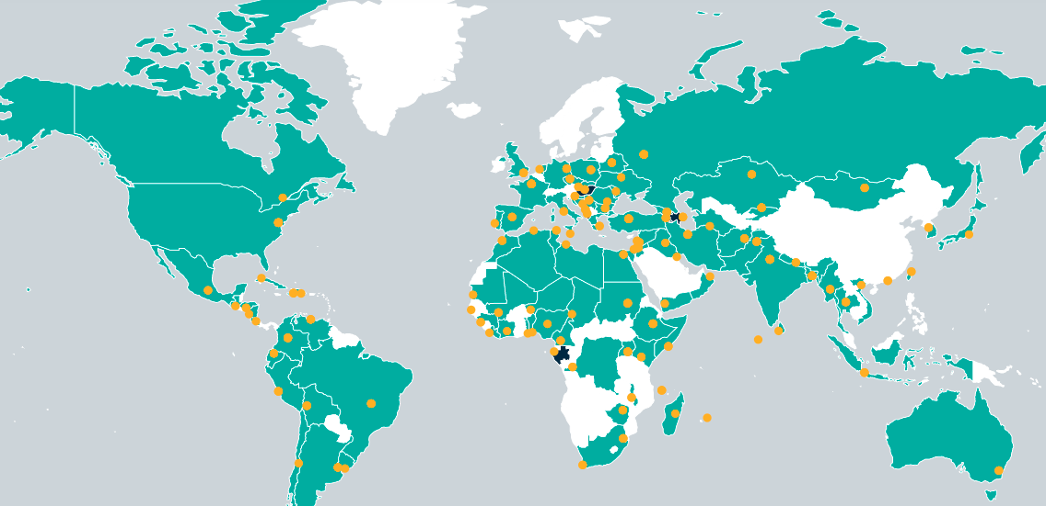

Black Lives Matter (BLM)

Take a few minutes to look over the following links and address the questions that follow.

https://blacklivesmatter.com/

https://www.adl.org/education/educator-resources/lesson-plans/black-lives-matter-from-hashtag-to-movement

https://www.nytimes.com/interactive/2020/07/03/us/george-floyd-protests-crowd-size.html

Respond based on the sources above and your own knowledge:

What are the general and/or specific goals of this movement? How might they connect with the course concepts of power, legitimacy, sovereignty, and interdependence?

movement was created and popularized around racial injustice, criminal justice reform, police brutality, white supremacy

Trying to undermine legitimacy of the former president, republican party

Exert power by pushing for criminal prosecution of former officials, undermine their platform

Size of their protests adds power and legitimacy to political opponents.

Want to increase power of certain politicians, messages, ideas (ex. Cori Bush)

Question the legitimacy of police power and approaches.

Can partner with other NGOs, social movements, protest groups, to further their message and exert more power.

Acceptance, interactions, partnerships with other groups give the group legitimacy.

To what extent has this organization accomplished its goals? Explain.

Protest movement group work

See the attached doc. Each of you will be in a group of four and will choose from among the following protests.

- India (farmer protests) (Source 1)
- Lebanon (anti government protests) (Source 1)
- Myanmar (anti military coup protests) (Source 1, Source 2)
- Nigeria (end SARS protest) (Source 1)

Find your name on the attached doc. Your Zoom breakout room will correspond to your group number. With your group members, decide who is doing which protest movement.

https://docs.google.com/document/d/1Mf5TDfCIamTUwz8f9RxD8b0wUIMFb_WRSDbvfF82BuM/edit

IMPORTANT NOTE!!!

During seminar time, we often don’t come during the half period when we are supposed to. Normally this is fine but for tomorrow, if you’re groups 1-8, please come the first half of the period: 1:30-2:00. If you’re groups 9-16, please come the second half of the period: 2:00-2:30. If this is a problem please let me know and we can rearrange.

Use the links above to read about the protests. You may need to consult an additional source to fill in some gaps in your understanding.

Answer the following questions about your protest movement. Be ready to teach your group members about your movement tomorrow during seminar time.

1. Briefly summarize the situation in your chosen country. What is the relevant background, why are people protesting, what are their goals?

2. What have the protests accomplished? To what extent have they been successful?

3. Relevant concepts (power, sovereignty, legitimacy, interdependence). Explain.

Beaford, Robert D, Timothy B. Gongaware, and Danny L. Valadez. “Social Movements.” In Encyclopedia of Sociology

