Do Now: Let’s a few minutes to summarize some points from the unit on the EU and Brexit.

Why did the UK vote to leave the European Union?

Being a part of the EU came with too many restrictions (economic and political).

These restrictions prevented the UK from flourishing economically

Being a member of the EU limits some national sovereignty. Internal borders inside the EU are somewhat erased, people can move around and work and live where they want. Many people from poorer countries moved to work in the UK, people in the UK didn’t like immigrants taking their jobs.

Free trade and free access is a reciprocal relationship. You can sell to other countries’ markets but they can access yours. Other EU companies could fish in UK waters which bothered many Britons that control of their resources lay in Brussels rather than at home

The EU collects money from each member state and then spends it around the EU. Richer countries gave more than they got.

In order to create a proper integrated market across 27 countries there were a lot of regulations to make sure that all countries agreed and complied with the same rules.

The UK was not allowed to negotiate its own trade deals the EU had to do it for the whole block all at once.

Why would the EU want to make any exit deal “painful” for the UK?

Don’t want others to leave also, not easy.

What does Brexit tell us about larger trends in global politics? What conflicts are there? Reversing trends? Emerging problems?

More and more nations seem to be interested in acting independently rather than in larger groups. The world is changing it may be easier to steer without a lot of restrictions.

Unilateralism is increasingly popular over multilateralism

Populations within countries are more divided along similar lines. Winners and losers from globalization oppose each other. Those who benefit from a rapidly changing globalized world, the elites are opposed.

Nationalism and populism are increasingly present

Tribalism has increased, social media has exacerbated divisions, entrenched opinions, extremism.

Simplicity has replaced complexity when deciding courses of action.

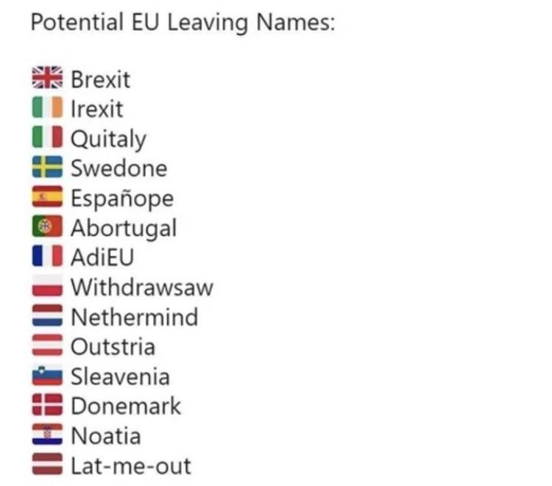

What are the advantages of a “single market”? Let’s look at the case of big tech. Why does Europe have so few giant tech companies?

I’ll be using some images from this article:

https://www.baekdal.com/thoughts/why-usbased-tech-companies-are-winning-over-europe/

Scotland and the UK

Remember that the UK is the union of four separate countries. Scotland is one of them.

Voting Yes or No on Independence

In 2007, the SNP won an upset victory in the Scottish parliamentary elections, ending some 50 years of Labour Party dominance; SNP leader Alex Salmond was elected first minister of Scotland, the top government post. He won a second term in 2011 and was able to use his party’s historic mandate to secure approval for a referendum on independence for Scotland. In 2012, Salmond and British Prime Minister David Cameron signed an agreement to hold that referendum in 2014. The question on the ballot: “Should Scotland be an independent country?”

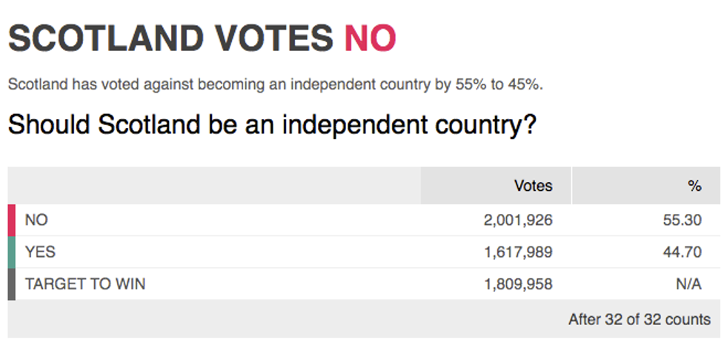

Brexit Vote 2016

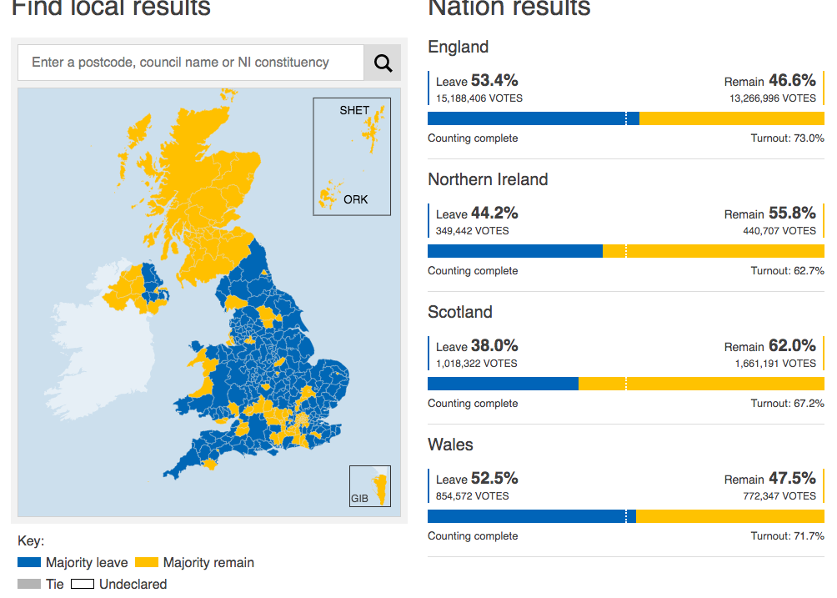

Homework

Please read the following article. It summarizes the Brexit deal and content from the whole unit well.

https://www.nytimes.com/article/brexit-uk-eu-explained.html?name=styln-brexit&region=TOP_BANNER&block=storyline_menu_recirc&action=click&pgtype=Article&impression_id=e872de51-4ea3-11eb-88c4-d14c367a7b02&variant=show

