Do Now: Prisoner’s dilemma

Here’s the situation: You and an accomplice (not a friend) have committed a crime and the following day, each of you is picked up by the police for questioning. You are placed in separate rooms and cannot communicate with each other. They have some evidence to convict each of you but a confession would make their case a lot stronger.

A clever prosecutor makes the following offer to each you and your accomplice:

“You may choose to confess or remain silent. If you confess and your accomplice remains silent I will drop all charges against you and use your testimony to ensure that your accomplice does serious time. Likewise, if your accomplice confesses while you remain silent, they will go free while you do the time. If you both confess I get two convictions, but I'll see to it that you both get early parole. If you both remain silent, I'll have to settle for token sentences on firearms possession charges. If you wish to confess, you must leave a note with the jailer before my return tomorrow morning.”

What do you do?

Say nothing? Or congress and betray your accomplice? Maybe you’re loyal but your accomplice isn’t...

Here are all the possible outcomes and the prison sentences that come with each.

 | Your accomplice stays silent (cooperate) | Your accomplice confesses (betrays you)
You stay silent (cooperate) | Each of you serves 1 year in prison | You serve 5 years  Your accomplice goes free
You confess (betray your accomplice) | You go free  Accomplice gets 5 years | You both serve 3 years

In breakout rooms, you will be paired with one other person. You two are playing the roles of the criminals in this situation. Do not speak or negotiate with each other. Once you’re both present in the room each of you has to type into the chat “silent” or “confess” but do so at the same time.
Record the outcomes below.

We will do this with three different partners. I will close rooms quickly and recreate with new partners. Once again, don’t talk about what happened or your strategy. At the same time, type in (or say) “silent” or “confess.”

Partner # | Outcome: # of years you serve
1
2
3

What conclusions can we come to from this activity?

This is similar to the concept of tragedy of the commons that we learned about in Economics last year. Or at least you should have.

Here’s an example of this type of thinking in the real world:

The North Atlantic Treaty Organization (NATO)

NATO is a political and military organization composed of 30 different nation states from North America and Europe (and Turkey, depends on whether you consider Turkey part of Europe or not). The core purpose is to promote the concept of interdependence and the global political challenge collective security.

You can read more about it here: https://www.nato.int/nato-welcome/index.html

Originally, NATO was created to counter the military threat of the Soviet Union and the spread of communism in Europe. Despite the fact that communism no longer exists in Europe, NATO still exists and has continued to add new members (by the way, this has really annoyed Russia and is a large reason for Russian antagonism toward the US and western Europe).
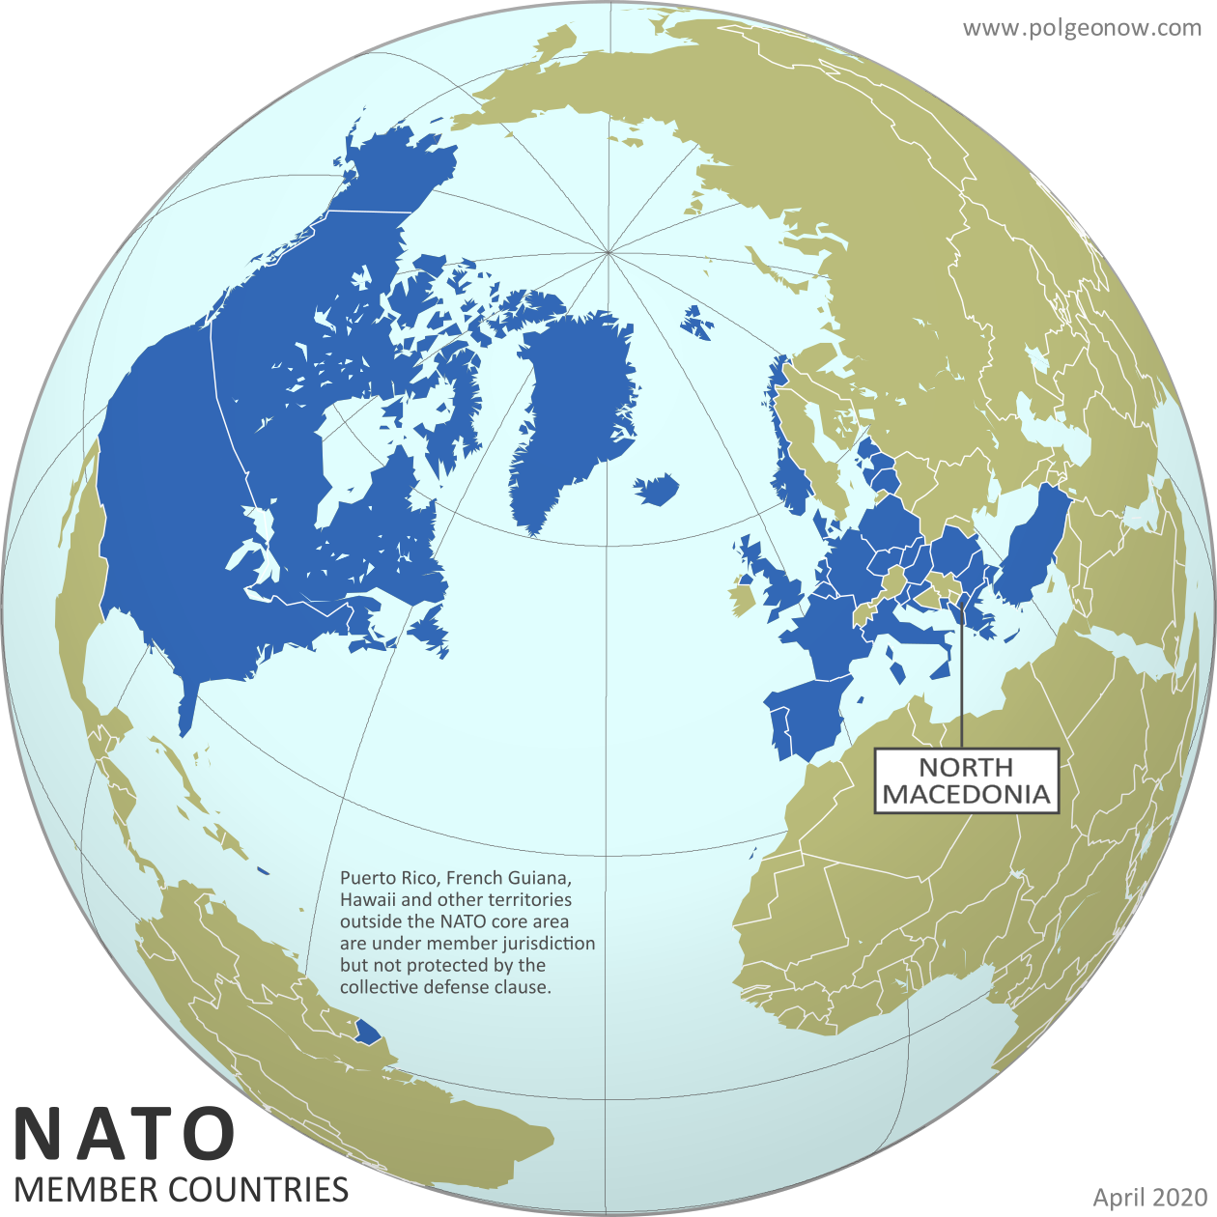
Being a member of NATO means that you will come to the defense of any other member that is attacked and they will come to your defense if you are attacked. An attack on one member is considered an attack on all members.

Treaty members pledge to spend 2% of their GDP on national defense (guns, tanks, fighter jets, soldiers, etc.) which makes sense. You want each member to do their part if they are going to benefit from the spending from other members. How many countries actually do this?

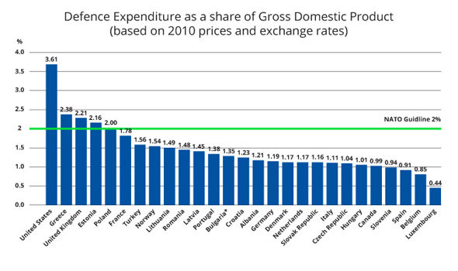

Here is a more updated version of that statistic

https://www.statista.com/statistics/584088/defense-expenditures-of-nato-countries/

Why do so many countries not meet their expected military budgets? Think about the work we’ve done so far today.

All of this is an introduction to an approach to global politics: Realism.

Earlier we learned about liberalism.

There are two dimensions to liberalism: domestic and international.

Domestic liberalism focuses on promoting rule of law, limited government, representative democracy, etc.

Liberals also wanted to apply their assumptions about human nature to the international sphere as well and, after WWII, pushed for greater cooperation internationally, reliance on IGOs and multilateralism in problem solving internationally.

We read more about this back in the Brexit unit. Reading attached here (at the bottom):

This international approach contrasts with tha t of realists.

Watch the linked video. You’ll have to stop it frequently to take notes but watch and complete the attached chart to compare and contrast realism and liberalism as approaches to global politics.

https://youtu.be/Hl43BizGd5c

Take notes on any beliefs, characteristics, actions, or assumptions either philosophy holds

Liberalism | Realism

Homework
Directions: Please read and annotate the following. Answer the questions that follow

The World Wants You to Think Like a Realist

From Europe to Iran to North Korea, the world doesn't make sense anymore — unless you put all your illusions aside.

Stephen M. Walt May 30, 2018, 1:35 PM

Instead of relying on realism, both Republicans and Democrats tend to view foreign policy through the lens of liberal idealism. Rather than see world politics as an arena where security is scarce and major powers are forced to contend whether they wish to or not, America’s foreign-policy experts are quick to divide the world into virtuous allies (usually democracies) and evil adversaries (always some sort of dictatorship) and to assume that when things go badly, it is because a wicked foreign leader (Saddam Hussein, Ali Khamenei, Vladimir Putin, Muammar al-Qaddafi, etc.) is greedy, aggressive, or irrational. When friendly states object to something the (virtuous) United States is doing, U.S. leaders tend to assume that critics just don’t understand their noble aims or are jealous of America’s success.

It is still highly useful to think like a realist. Let me explain why.

Realism has a long history and many variants, but its core rests on a straightforward set of ideas. As the name implies, realism tries to explain world politics as they really are, rather than describe how they ought to be. For realists, power is the centerpiece of political life: Although other factors sometimes play a role, the key to understanding politics lies in focusing on who has power and what they are doing with it.

For realists, states are the key actors in the international system. There is no central authority that can protect states from one another, so each state must rely upon its own resources and strategies to survive. Security is a perennial concern — even for powerful states — and states tend to worry a lot about who is weaker or stronger and what power trends appear to be. Cooperation is far from impossible in such a world — indeed, at times cooperating with others is essential to survival — but it is always somewhat fragile.

If you do think like a realist — at least part of the time — many confusing aspects of world politics become easier to understand. If you think like a realist, for example, you’ll understand why China’s rise is a critical event and likely to be a source of conflict with the United States (and others). In a world where states have to protect themselves, the two most powerful states will eye each other cautiously and compete to make sure that they don’t fall behind or become dangerously vulnerable to the other. Even when war is avoided, intense security competition is likely to result.

If you think like a realist, the crisis in Ukraine (Russia invaded and took part of Ukraine’s territory) looks rather different than the typical Western version of events. Western accounts typically blame Putin for most of the trouble, but realists understand that major powers are always sensitive about their borders and are likely to react defensively if other great powers start encroaching on these regions. Ever heard of the Monroe Doctrine? In the case of Ukraine, the United States and its European allies had been expanding NATO (the military alliance that includes the United States and much of Western Europe, initially created to counter the rise of communism in Europe after World War II) steadily eastward (violating pledges made to Soviet leaders when Germany reunified) and ignoring repeated warnings from Moscow. By 2013, the United States and European Union were making a significant effort to pull Ukraine into closer alignment with the West and openly interfering in Ukraine’s domestic political processes. Because the Obama administration did not think like realists, however, it was blindsided when Putin seized Crimea and derailed the EU/U.S. effort. Putin’s response was neither legal nor legitimate nor admirable, but it wasn’t surprising either. It is equally unsurprising that these events alarmed the Europeans and prompted NATO to shore up its defenses in Eastern Europe, precisely as a realist would expect.

If you think like a realist, you might not be quite so outraged by the support that Iran and Syria gave the anti-American insurgency in Iraq after 2003. You might not like it, but you wouldn’t find their conduct surprising. Their response was classic balance of power behavior because the United States had just overthrown Saddam Hussein and the Bush administration had made it clear that Syria and Iran were next on its hit list. It made good strategic sense for Damascus [capital of Syria] and Tehran [capital of Iran] to do whatever they could to keep the United States bogged down in Iraq so that Washington couldn’t reload the shotgun and come after them. Americans have every reason to be upset by what these states did, but if more U.S. officials thought like realists, they would have expected it from the get-go.

And if you think like a realist, it is obvious why North Korea has gone to enormous lengths to acquire a nuclear deterrent (prevention and protection from war and aggression from others) and obvious why a country such as Iran was interested in becoming a nuclear weapons state as well.

Last but not least, if you think like a realist, you’re likely to be skeptical about the ambitious schemes that idealists keep dreaming up to bring an end to conflict, injustice, inequality, and other bad things. Striving to build a safer and more peaceful world is admirable, but realism reminds us that the ambitious efforts to remake world politics always create unintended consequences and rarely deliver the promised results. It also reminds that even allies fear unchecked power and will have misgivings whenever the United States tries to run the world. If you think like a realist, in short, you are more likely to act with a degree of prudence, and you’ll be less likely to see opponents as purely evil (or see one’s own country as wholly virtuous) and less likely to embark on open-ended moral crusades. Ironically, if more people thought like realists, the prospects for peace would go up.

Respond:

Based on the reading, make a list of the various realist actions nation states have taken.

Please make a list of key ideas realists believe in that the author writes about here

