Step 1: Watch 1.5 minute video explaining how dams and hydroelectric power work. The article and conflict make more sense when you watch this.
https://www.youtube.com/watch?v=PvJHjnELVSM

Step 2: Read and annotate the following article. Answer the questions that follow.

“Africa’s largest dam powers dreams of prosperity in Ethiopia —and fears of hunger in Egypt”

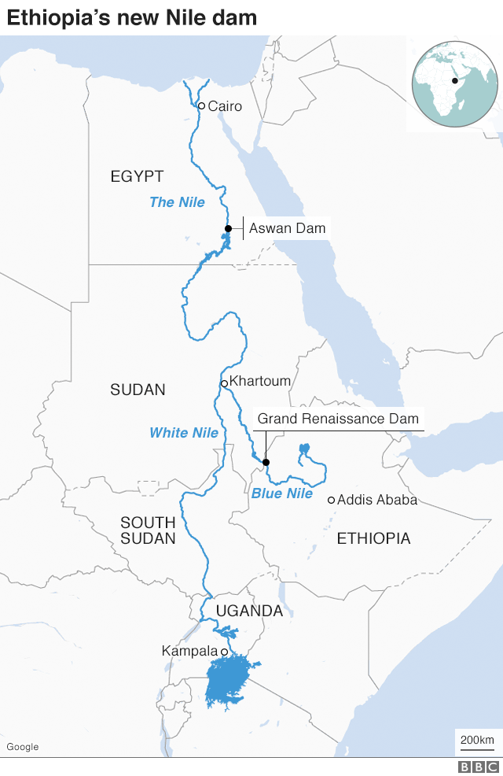
Once completed, the Grand Ethiopian Renaissance Dam (GERD) will be nearly twice as tall as the Statue of Liberty and as wide as the Brooklyn Bridge is long. The reservoir (the lake the dam creates) behind it is roughly the size of London. Sitting on the Blue Nile, the main tributary of the Nile river, the dam is the largest hydro-electric project in Africa. Soon it will produce 6,000 megawatts of electricity, more than double Ethiopia’s output today. With a little co-operation between Ethiopia and its downstream neighbours, Egypt and Sudan, the dam could be a great benefit for the whole region.

Yet so far it has produced only acrimony (anger and bitterness). Egypt, which depends on the Nile for 90% of its fresh water, sees the dam as an existential threat. Shortly after construction began in 2011, officials in Cairo (the capital of Egypt) considered sabotage; a former president even considered bombing it. Last month Ethiopia accused Egypt of sponsoring cyber-attacks to disrupt the project.

“Mothers who’ve given birth in the dark, girls who fetch wood for fire instead of going to school — we’ve waited so many years for this — centuries,” said Filsan Abdi, the 28-year-old minister for women and children. “When we say that Ethiopia will be a beacon of prosperity, well, it starts here.”

Thousands of miles downriver in the Nile Delta, on a farm near the edge of the Sahara desert, Mohamed Abdelkhaleq looked over what was once a field green with rice.

Rice had given him prosperity: a three-story house that provides a home for his eight children and 20 grandchildren. Over two centuries in the rice-growing business, his family had acquired such wealth that they would hire helicopters to plant the seeds and spread pesticides.

“We planted as much rice as we wanted,” he recalled with a wistful smile. Now he and others in the village of Kafr Ziyada grow only enough to feed their families.

Growing water shortages triggered by climate change and population growth have altered their life of growing rice, a water-intensive crop. Two years ago, Egypt reduced the area used for rice production by more than a half, from 1.76 million acres to 750,000, in an effort to save 3 billion cubic meters of water. At the time, the country’s irrigation minister insisted that the measures were unrelated to concerns over the Ethiopia dam.

But now, as the dam fills (remember from the video, the dam creates a reservoir, a man-made lake, and for the dam to begin working, it has to first fill up like a bathtub, reducing the flow of the river), farmers fear that even the rice they subsist on is under threat. Rice farming remains heavily restricted, and Abdelkhaleq has already had to pay a $600 fine for over-planting. Irrigation Ministry officials enforce a rule that limits farmers to four days of water at a time from canals, followed by at least two weeks without, the strictest rationing in years, farmers say.

“They are rationing the water because the Nile’s waters are already down,” said Ali Mohamed, 42, Abdelkhaleq’s son. “It’s lower this year, and every year is less and less.”

He blamed the dam, but Mostafa al-Naggari, head of the rice committee of Egypt’s Agriculture Export Council, said the current rice production restrictions are primarily driven by the need to satisfy the growing population’s demand for water and meet national development goals.

Egypt’s politicians and pundits have jumped at the chance to portray Ethiopia as the cause of this crisis, accusing Addis Ababa of negotiating in bad faith on filling the reservoir and in turn threatening to plunge millions of Egyptians into darkness and poverty. That rhetoric is popularized on talk shows in hyper-nationalist terms.

“This is our right,” said Ahmed Mousa, one influential TV personality. “No one treats Egypt this way.”

Whether the dam will contribute to water shortages in Egypt is largely a function of the eventual water-sharing agreement that Egypt, Sudan and Ethiopia sign.

“It all comes down to how much water Ethiopia will agree to release during and after a drought,” said Kevin Wheeler, a hydrologist at Oxford University who has co-written multiple papers on the dam. “During the onset of a drought, Ethiopia will decide whether to continue releasing water at the same rate, thus continuing to generate power and provide downstream countries with water, or else fill its reservoir to ensure longer-term energy production.”

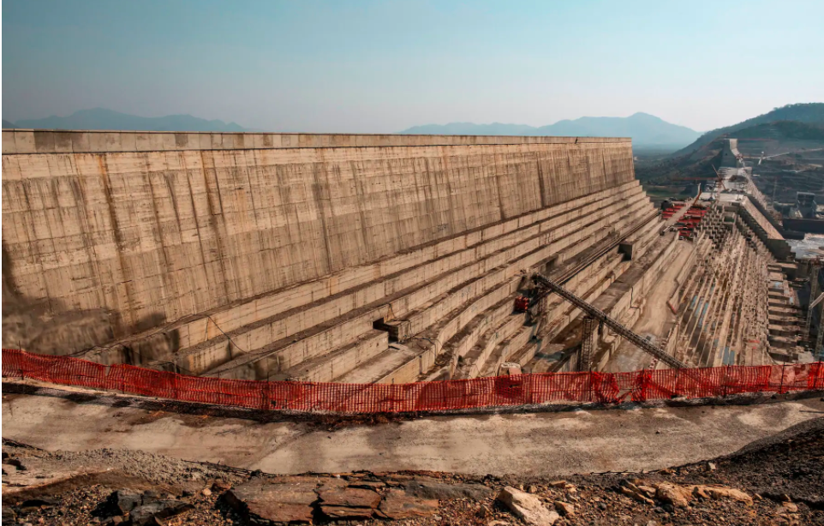

At the beginning of the year, when Ethiopia’s water minister was asked in a press conference who would control the dam once complete, he looked surprised before responding with a curt, “It’s my dam.” Ethiopians across social media adopted his response as a mantra and hashtag, urging their government to move forward with the project. Some have gone further, saying that the dam should be filled regardless of downstream countries’ positions: One Twitter user wrote, for example, “There is no need of negotiations with crafty Egypt.”

Egyptians online retorted with pleas using the hashtag #Nile4All and threats such as “I proudly volunteer to join my Egyptian army to demolish Ethiopia and its dam,” using hashtags such as #EgyptNileRights.

At their core, all the online attacks, hacks, and discord are driven by the same force: nationalism. For both countries—Egypt since the 2011 fall of Mubarak and Ethiopia since the 2012 death of strongman Prime Minister Meles Zenawi—national identity has been in flux.

Egypt’s Sisi has anchored his legitimacy on a nationalistic platform. At its core has been an emphasis on national security, rounded out by megaprojects such as the Suez Canal expansion and the construction of a new administrative capital city. But at the core of Egyptian identity is the Nile, so bolstering nationalism means defending the Nile, too. And officials have encouraged this outlook: One sleekly produced video shared on Facebook by the Ministry of Immigration and Egyptian Expatriates Affairs warned, “More than 40 million Egyptians are facing the threat of drought and thirst.… The cause of water shortage is Ethiopia building a dam five times bigger than its needs.”

Meanwhile, in Ethiopia, Prime Minister Abiy Ahmed has been unable to manage competing nationalist sentiments growing among different ethnic groups. Still, the dam provided a unifying issue around which Ethiopians of all ethnic backgrounds could rally. “We do have a lot of divisions—ideological, ethnic, tribal, religious,” said Chala, the Ethiopian professor. “But even though we have these bitter divisions, Ethiopians have overwhelmingly supported this Nile dam especially on social media.”

But nationalism creates problems. The thousands of Ethiopian refugees, asylum seekers, and migrants living in Egypt are now facing greater pressure and harassment from Egyptian citizens and authorities since the dam tensions started to heat up, said Hamdy al-Azazy, an Egyptian migrant rights activist currently in Germany. And in Ethiopia, it has meant that any domestic criticism of the dam from an environmentalist point of view—namely, that it could disrupt ecosystems and biodiversity, even within Ethiopia—is met with derision.

And for both countries, surging nationalist sentiment means that it’s harder for officials to agree to, and for the public to accept, compromise. Ethiopia, Egypt, and the quieter Sudan have actually already agreed on most items when it comes to the dam; the main sticking points now are related to dispute resolution, drought contingency plans, and future upstream projects. And yet, much of the online rhetoric remains maximalist, even rejecting items that have already been unanimously decided—such as the existence of an Ethiopian Nile dam in any form—raising the possibility that the online tensions and attacks may not subside anytime soon.

Respond:

1. Discuss the role that sovereignty has in creating this conflict. You can also connect the issue of borders here as well.

2. Discuss the role that this conflict demonstrates on the concept of legitimacy. This concept is connected in multiple ways so take some time to consider it from a few different perspectives.

Adapted from “Dam Bluster: Egypt, Ethiopia and Sudan must learn how to share the Nile river” https://www.economist.com/leaders/2020/07/02/egypt-ethiopia-and-sudan-must-learn-how-to-share-the-nile-river
Adapted from: “The Ethiopian-Egyptian Water War Has Begun” https://foreignpolicy.com/2020/09/22/the-ethiopian-egyptian-water-war-has-begun/
Adapted from “Africa’s largest dam powers dreams of prosperity in Ethiopia —and fears of hunger in Egypt” https://www.washingtonpost.com/world/interactive/2020/grand-ethiopian-renaissance-dam-egypt-nile/

