Do Now: Evaluate the meaning of the cartoon below. Do you agree with its point?

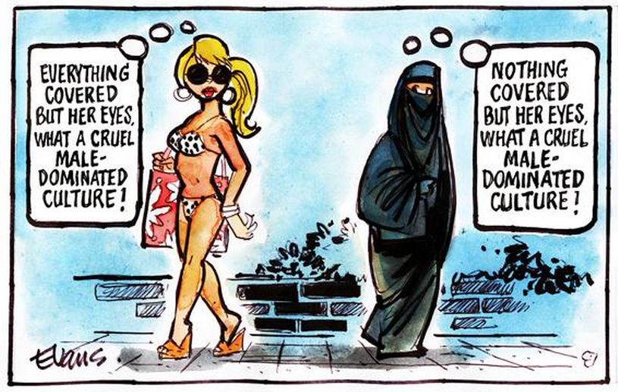

French police make woman remove clothing on Nice beach following burkini ban

Tue 23 Aug 2016

Photographs have emerged of armed French police confronting a woman on a beach and making her remove some of her clothing as part of a controversial ban on the burkini.

Her ticket, seen by French news agency AFP, read that she was not wearing “an outfit respecting good morals and secularism”.

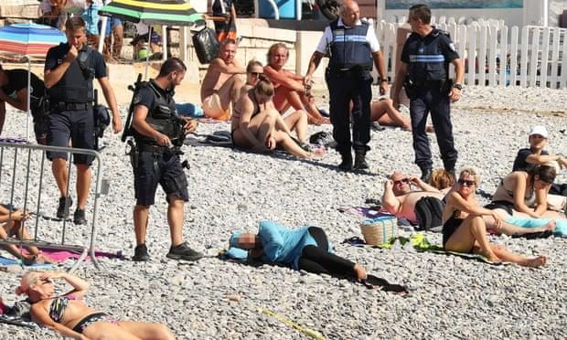

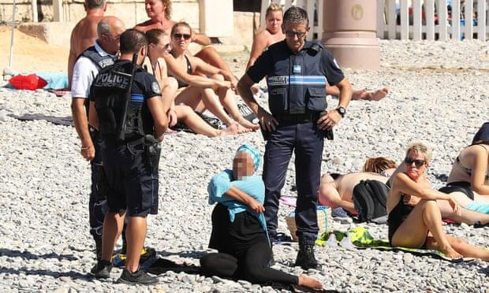
https://www.theguardian.com/world/2016/aug/24/french-police-make-woman-remove-burkini-on-nice-beach

FGM Quick Review

- What does the term “female genital mutilation” mean? Why does it exist?

- How does the practice of FGM connect to the concepts of universalism and relativism?

- (from yesterday’s work) Why might it be difficult to expect this practice to end by passing laws banning it?

Levels of Analysis and FGM

This practice exists within specific communities and at the local level. The practice has been addressed at those levels and it has also been engaged and addressed at the international and national levels.

World Health Organization (remind me again what the WHO does and what it is capable of?)

Building on work from previous decades, in 1997, WHO issued a joint statement against the practice of FGM together with the United Nations Children’s Fund (UNICEF) and the United Nations Population Fund (UNFPA).

In 2008, the World Health Assembly passed resolution WHA61.16 on the elimination of FGM, emphasizing the need for concerted action in all sectors - health, education, finance, justice and women's affairs.

WHO efforts to eliminate female genital mutilation focus on:

- strengthening the health sector response: developing and implementing guidelines, tools, training and policy to ensure that health care providers can provide medical care and counselling to girls and women living with FGM and communicate for prevention of the practice;
- building evidence: generating knowledge about the causes, consequences and costs of the practice, including why health care providers carry out the practice, how to abandon the practice, and how to care for those who have experienced FGM;
- increasing advocacy: developing publications and advocacy tools for international, regional and local efforts to end FGM, including tools for policy makers and advocates to estimate the health burden of FGM and the potential public health benefits and cost savings of preventing FGM.

Respond: Summarize the role of IGOs like the WHO and the UN in dealing with issues like FGM? What might the limitations of this approach be?

Watch: Female Genital Mutilation (FGM) Survivor Tells Her Story (2 minutes)

https://www.youtube.com/watch?v=jlyj9hgdbrQ&feature=youtu.be

The woman whose story was depicted in the video above spoke to my Global Politics class last year (remotely). She is an activist against the practice of FGM who also works for the US State Department. She had a lot of great insights on many of the ways it is being addressed around the world. She does an excellent job addressing issues of relativism, language, local vs. international engagement, among other topics.

Not required to watch but really interesting.

https://drive.google.com/file/d/1OZ-Aa4rY0YrZr1L5vrJ7A0GhnWHKmwD2/view?usp=sharing

Who supports FGM? Why?

Directions: Please read and annotate the following two readings. Answer the questions that follow.

Why do these women in Kenya support female genital mutilation?

Stopping female genital mutilation has been a global priority for years.
But the BBC's Anne Soy has been speaking to a group of women in Kenya who support FGM, as it's often referred to. She attended a meeting that was attended by over a thousand women from eight different clans belonging to the Maasai tribe in Kenya.

"They said that no one consulted them even when the country was coming up with laws that prohibited FGM, and so they felt that they were being discriminated against and they needed their voices heard," Soy says. In 2001, Kenya passed a law to criminalize FGM, especially for girls under 18. It went into effect in 2011.

The meeting of the Maasai women was part of a series of gatherings that came about after a court case was brought against parents of a girl who was circumcised and died as a result. The women told Soy that the practice has been handed down to them from previous generations and they see no reason for it to be stopped. They also argue that men are circumcised too — a practice that has been encouraged because it may help reduce the number of HIV/AIDS cases. Soy says for the Maasai women, FGM is an important rite of passage.

“It marks the point when a girl stops being a girl and becomes a woman. In their eyes, anyone who is not circumcised is not a woman and not fit to carry out certain traditions," she says.

Soy points to a study that was carried out in 2009 and showed that 7 out of 10 Maasai girls undergo FGM. She says the few Maasai women who have abandoned the practice have been shunned in the community.

Soy says when she first thought about reporting on this story, she was afraid — because she comes from an ethnic community that traditionally has practiced FGM. "I know from my own culture that a woman who is not circumcised is seen as a child in front of a woman who has been circumcised. I thought that would be a barrier," she says.

But she was finally able to find women who were willing to talk about the issue.
"Most of the people who still want to carry on with this practice are illiterate. They feel left out. Representatives come from Nairobi to their villages and tell them that this has been decided on and they have to stop this practice. They feel like they haven't been consulted," Soy says.
The Woman Who Wants to Legalize Female Genital Cutting
In 2011, Kenya’s Parliament criminalized FGC (Female Genital Cutting) and anyone who enabled it: parents who arranged it for their daughters, neighbors who failed to report it, anyone who had FCG tools, and even anyone who used “derogatory and abusive language” towards an uncut woman.
Many people argue that the law is imperfect, mostly because it’s driven FGC underground. Though the elaborate ceremonies that used to accompany the rite of passage — easy, conspicuous targets for police raids — have all but disappeared, FGC is still practiced in private. Its overall prevalence has dropped in Kenya from 37 percent in 1998 to 21 percent in 2014, but it is still widely practiced in certain areas; over 90 percent of women in Somali, Kuria, and Maasai communities have been cut.
Today, many affluent Kenyan families send their daughters to hospitals or clinics to be illegally cut with sterile tools and local anesthesia instead of being cut by traditional circumcisers in the village, a trend in FGC known as medicalization.
“This happens a lot more than we realize, more than the general Kenyan public realizes,” says Sofia Rajab-Leteipan, an attorney who is representing Equality Now, one of the parties opposing Kamau in court. Kenya has some of the highest rates of medicalization in the world. She says it is still risky since medical professionals are not trained in circumcision and often “guesswork” their way through the cut.
Dr. Tatu Kamau, is “that woman who wants to legalize female genital cutting.” Once a thoroughly unextraordinary physician working as an administrator at Kenya’s Ministry of Health, almost overnight she became famous — and hated — in the global health world. Kamau argues that, once FGC is legalized, medical professionals can be trained properly and deliver the highest standard of healthcare for women who choose to be cut in medical facilities.
Practiced for centuries, it’s only been campaigned against for two decades. For much of this time, those campaigns have been led by Western organizations, particularly Western feminists.
How do human rights square, however, with cultural preservation? Over the last decades, many men have used FGC as a means to defend their culture from outside influence — including anti-colonial leader Jomo Kenyatta, who went on to become Kenya’s first president in 1963. In his book Facing Mount Kenya, he held up FGC as a pillar of a traditional past that should be protected, embraced even, against Western missionaries’ efforts to eradicate it in the name of progress.
Kamau’s filed a petition to overturn Kenya’s Prohibition of Female Genital Mutilation Act, a landmark bill passed in 2011. The petition echoes his arguments: she states that “all cultural beliefs are equally valid and that truth itself is relative, depending on the cultural environment.”
She has also adopted the language of western feminism. After all, some say, shouldn’t feminists believe women have a right to make informed decisions about their bodies? Is it patronizing to insist that brown and black women be jailed for FGC while white women in the West can get vaginoplasty, or cosmetic surgery for the vulva? She had now pushed the conversation to a more ethically complicated matter: adult women’s right to do whatever they choose with their bodies. “Once you reach adulthood, there should be no reason why you cannot make the decision now,” Kamau told KTN. “If women can decide to drink, to smoke, women can join the army, women can do all sorts of things which might bring them harm or injury, and yet they’re allowed to make that decision…for this decision of female circumcision, a woman can make that decision, yes.”

Respond: Briefly summarize the arguments in favor of FGC discussed in the previous two articles. Make explicit connections to the concept of cultural rights and relativism.

Watch: Advocate: 'Female genital mutilation' horrors exaggerated (8 minutes)

Interview with Fuambai Ahmadu, an anthropologist and defender of what she calls female genital circumcision.

https://www.youtube.com/watch?v=ob3Wf0PKtBM

Respond: What are Ahmadu’s main arguments in favor of allowing female genital circumcision?

Take a position: Should we respect the practice of FGM/FGC as a cultural right? Or should this practice be banned as a violation of human rights? Write a paragraph to respond here.

Optional listens:

Is Zero Tolerance the Right Approach for FGM?
For more than two decades, the United Nations has led a fierce campaign against ‘Female Genital Mutilation’. And yet it still happens to millions of girls every year.

https://www.bbc.co.uk/programmes/w3csvsyj

Should FGM have a place in the 21st century? A discussion with FGM activists Fuambai Ahmadu and Nimco Ali

https://www.bbc.co.uk/sounds/play/p03djj5j

Adapted from https://www.pri.org/stories/2014-07-02/why-do-these-women-kenya-support-female-genital-mutilation
Adapted from: https://brightthemag.com/legalize-female-genital-cutting-fgm-kenya-health-f5335243b4e2

