Do Now:

Take 5 minutes and look at the two maps below.

- Give each map a name that describes what the map shows.

- What does the second map tell us about our world and how it is organized? Try to think deeply about this question.

Map 1
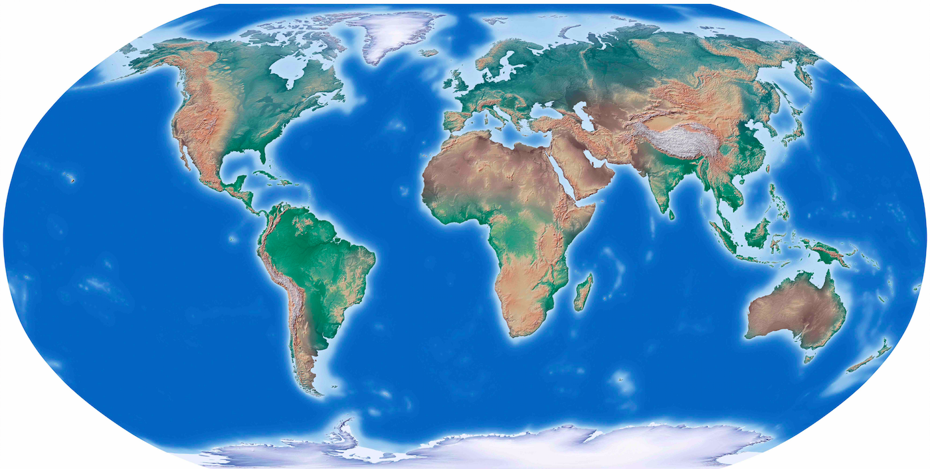

Map 2

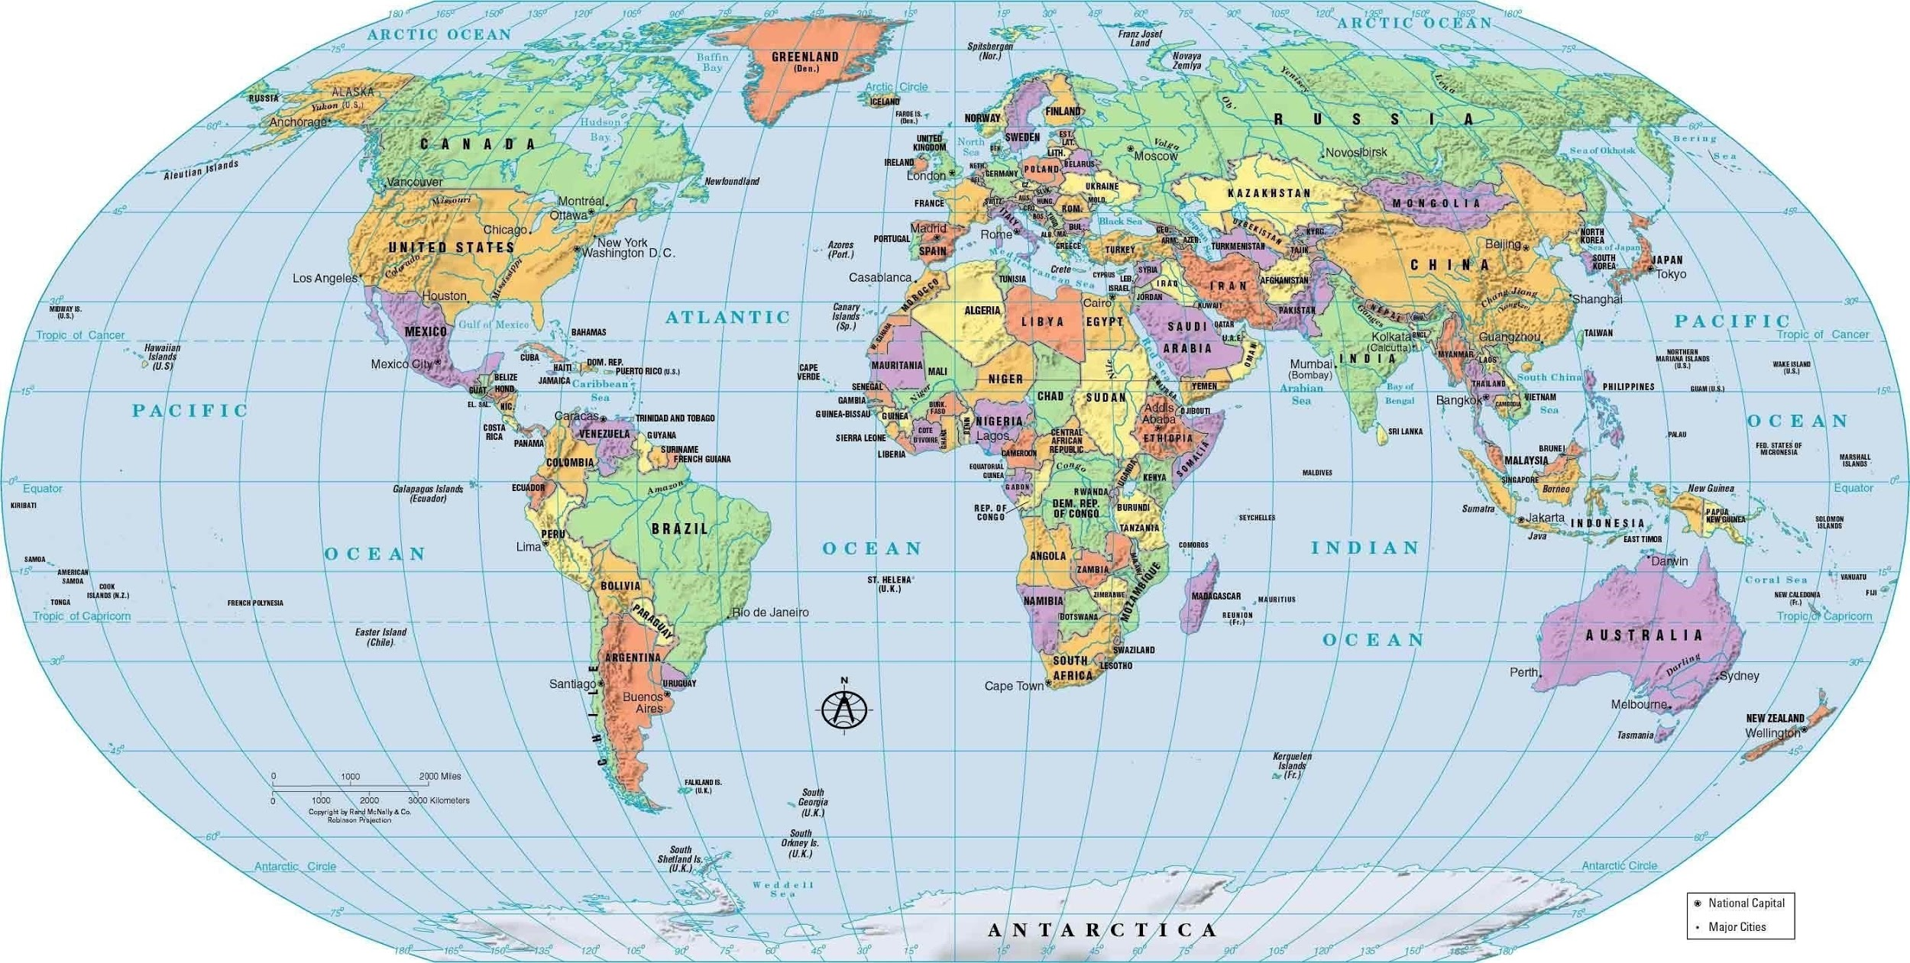
Once done I will put you into groups to share responses.

Further Group Discussion (wait until you are prompted to start on these)

- What does each border line on the map mean?

- What can we assume exists inside of each of those boundary lines?

- What changes when you cross one of those borders?

- What do you think is true about the people who live inside of any of those boundary lines?

Individual Wrap Up

So that I can get to learn a bit more about you:

One topic in global politics I would love to learn about is:

One thing I should know about you as a student/person?

How are you feeling at the conclusion of our first live class?

Homework Reading

Directions: Read over the following document. Annotate by highlighting text and placing a comment in the margins by clicking on the + sign that appears on the right.

The Difference Between a Nation, State, and Nation-State

1. What is a nation?

A nation is a group of people who see themselves as a unified unit who share cultural or historical qualities. People who consider themselves members of the Japanese nation may share common respect for their royal family, speak the same language, have common religious beliefs, ethics, and have common historical beliefs (or even myths).

A nation’s existence, definition, and members can change dramatically based on circumstances. In other words, what defines membership in a nation can change over time. Leaders that are described as “nationalist” often push their own ideas about what qualities define a particular nation, often including some people and excluding others. Pre-World WarII Germany provides a meaningful historical example of rampant nationalism that tried to define who was German and who wasn’t along racial and religious lines. Often times there is an effort to create new myths or rewrite history in order to justify current beliefs.

Nations in some ways can be thought of as “imagined communities” that are bound together by notions of unity that can focus on religion, ethnic identity, language, or cultural practice. It is an imagined community. It is imagined because the member of even the smallest nation will never know most of their fellow members, meet them, or even hear of them, yet in their minds each lives with imagined common bonds.

What is important to note is that not all nations of people have their own countries or nation-states. These people can be described as stateless nations.

- Kurdish people (Iraq, Syria, Turkey, Iran)
- Palestinian People (Israel, Lebanon, Jordan)
- Tibetan People (China)
- The Indian Nations of the United States

These people may have common historical circumstances, languages, religions, or cultures but what makes them a “nation” is that there is a common belief among those people that unites them that separates them from other people. When we hear the term “nationalist movement,” what is often happening is an effort to promote a national identity and get people to see themselves differently.

What’s also important is that some countries have multiple “nations” of people inside of them. That means that inside the border you see on the map are multiple languages, ethnicities, religions, or cultures. Kenya for example, has more than 70 ethnic groups. The largest, the Kikuyu, are only 20% of the people. People can see themselves as having multiple identities, however, and being part of an ethnic group does not mean you cannot also see yourself as a member of the larger geographic nation you live inside of.

2. What is a state?

When you hear this term, don’t think about a U.S. state like Mississippi (which for some reason ranks last in every measurement of everything but I digress). A state is a territory with its own government that has control over territory and people. We will explore this concept in greater detail soon.

3. What is a nation-state?

When you use the term “country” you are often talking about a nation-state. On a world map, we see mostly nation-states. Nation-states have control and power inside their own territory. They can make laws for their people. They also have the ability to interact with other nation-states outside of their own and they are treated as equals when dealing with other countries. This ability to interact with others and control their own territory is called sovereignty. This is a key concept in our course and we will spend a lot of time talking about it.

Non-Sovereign States

There are many entities that have most qualities of nation-states but are officially not considered to be sovereign. Many have their own histories, and some even have their own languages. Some examples include:

- Bermuda
- Greenland
- Taiwan

Wrap Up Question

Look back at the second map (the political map) that we studied earlier. Based on our discussion today and the reading above, in your own words, why is the world more complicated than this map shows? Respond in a few sentences.

Adapted from https://www.e-education.psu.edu/geog128/node/534
This paragraph adapted from Imagined Communities by Benedict Anderson
Adapted from : https://www.thoughtco.com/country-state-and-nation-1433559

