Interesting infographic

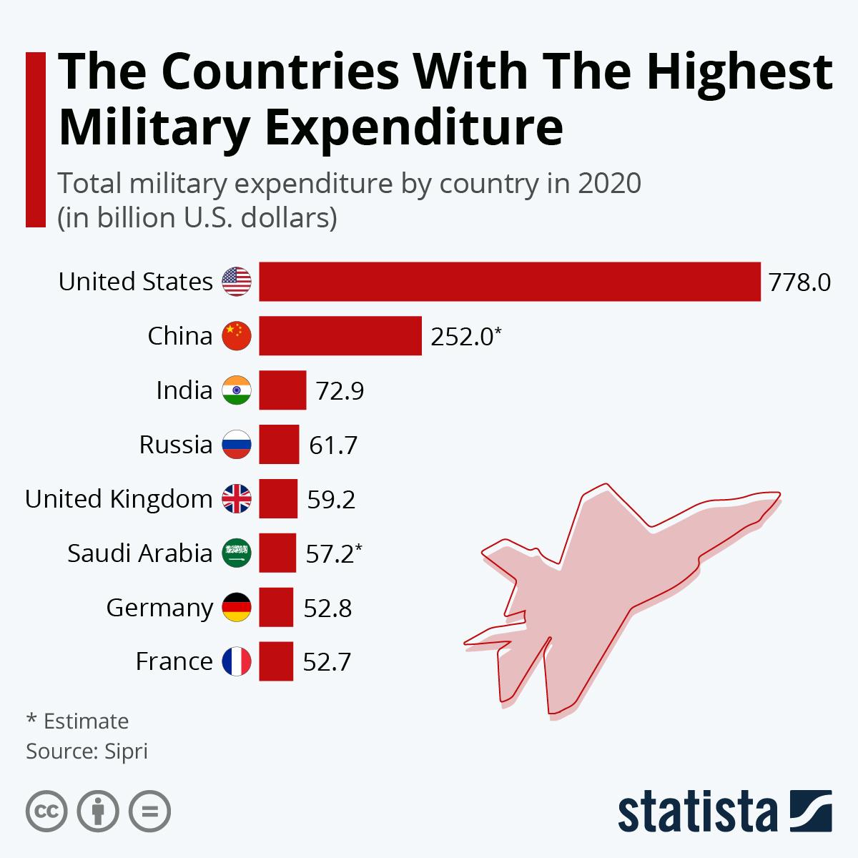

Asian values

Directions: Please read and annotate.

The idea that Asian culture and beliefs may constitute an alternative to western ones gained momentum during the 1980s and 1990s, fuelled by the emergence of Japan as an economic superpower and the success of the so-called Asian ‘tiger’ economies – Hong Kong, South Korea, Thailand and Singapore. This position was outlined most clearly by the Bangkok Declaration of 1993, when Asian state representatives from Iran to Mongolia, meeting in preparation for the World Conference on Human Rights in Vienna, issued a bold statement in favour of what they called ‘Asian values’. While not rejecting the idea of universal human rights, Asian values drew attention to supposed differences between western and Asian value systems as part of an argument in favour of taking culture difference into account in formulating human rights. Particularly keen advocates of this view included Mahathir Mohamad and Lee Kuan Yew, at that time the prime ministers, respectively, of Malaysia and Singapore. From this perspective, human rights had traditionally been constructed on the basis of culturally-biased western assumptions. Individualism had been emphasized over the interests of the community; rights had been given preference over duties; and civic and political freedoms had been extolled above socio-economic well-being. The recognition of Asian values sought to rectify this. At their heart, was a vision of social harmony and cooperation grounded in loyalty and respect for all forms of authority – towards parents within the family, teachers at school and the govern-
ment within society as a whole. Allied to a keen work ethic and thrift, these values were seen as a recipe for social stability and economic success.

The idea of Asian values was dealt a damaging blow by the Asian financial crisis of 1997–98. This occurred not only because it cast doubt over the image of ‘rising Asia’, but also, and more seriously, because so-called Asian values were sometimes held to be responsible for the crisis in the first place. In this view, Asian economies had faltered because of a failure fully to embrace market principles such as entrepreneurialism, competition and ‘rugged’ individualism, and this failure had stemmed from aspects of Asian culture, particularly an emphasis on deference, authority, duty and loyalty. Nevertheless, the rise of China and, to a lesser extent, India has revived interest in the idea of Asian values, although in its modern form it tends to be orientated more specifically around the alleged strengths of Chinese civilization and particularly of Confucianism (defined below). However, the general notion of Asian values has also attracted criticism. For some, it simply serves as an excuse for the survival of authoritarian rule and absence of liberal-democratic reform in many parts of Asia. The key Asian value, from this perspective, is political passivity, an unwillingness to question authority based on a trade-off between economic well-being and political freedom. The notion of an ‘Asian civilization’ from which a distinctive set of values can be seen to derive has also been criticized, in line with wider concerns about the ‘tectonic’ model of civilizations. Not only does Asian culture encompass a wide range of national traditions and a mixture of religions (Islam, Hinduism, Buddhism, Christianity and so on), but its national traditions are often highly diverse as well. For example, so-called ‘Chinese civilization’ is not defined by Confucianism but rather by the competing influences of Confucianism, Buddhism and Daoism overlaid, in the modern period, by a Maoist version of Marxism-Leninism.

Confucianism

Confucianism is a system of ethics formulated by Confucius (551–479 BCE) and his disciples that was primarily outlined in The Analects. Confucian thought has concerned itself with the twin themes of human relations and the cultivation of the self. The emphasis on ren (humanity or love) has usually been interpreted as implying support for traditional ideas and values, notably filial piety, respect, loyalty and benevolence. The stress on junzi (the virtuous person) suggests a capacity for human development and potential for perfection realized in particular through education. Confucianism has been seen, with Taoism and Buddhism, as one of the three major Chinese systems of thought, although many take Confucian ideas to be coextensive with Chinese civilization itself.

How has China responded to criticism of its human rights record?

Here is an interesting statement from the Chinese ambassador to South Africa titled, “US Selective and Politicized Human Rights Practices Against the Will of People”

It’s interesting how he responds by focusing on economic development rather than on political rights. Some argue that political rights are meaningless without economic development, a view the ambassador agrees with. Here is a quote from the piece:

“China believes that safeguarding people's rights to subsistence and development particularly the five basic rights, namely the right to work, the right to eat, the right to live, the right to hospital and the right to school, are the most important human rights that every government must take the responsibility to ensure.”

http://za.china-embassy.org/eng/sgxw/t1684553.htm

Adapted from Global Politics by Andrew Heywood p. 195-196

