Do Now: From your own knowledge, what were the circumstances of founding of the United Nations (UN)? What particular events demonstrated the need for the creation of the UN?

This was created after World War II, hopefully create a place to settle disputes peacefully. This was after a very destructive world war. Wanted to promote peace and security, promote transparency and communication. Goal was to promote development, living standards.
This was the second attempt (League of Nations).
Basis was the UN Charter, there is formalized structure
Legitimacy and effectiveness were based on world wide participation, even among the losers of the war.
Wanted to promote interdependence and lessen the effects of nationalism.
Key institution promoting international liberalism.

Why would there be a motivation for the United Nations to create a statement or framework around human rights?

Genocide, Holocaust, ethnic cleansing are central parts of this war in Europe and Asia. These are the worst examples of human rights abuses.

War crimes are rampant through this war.

Nuremberg Trials 1945-1946

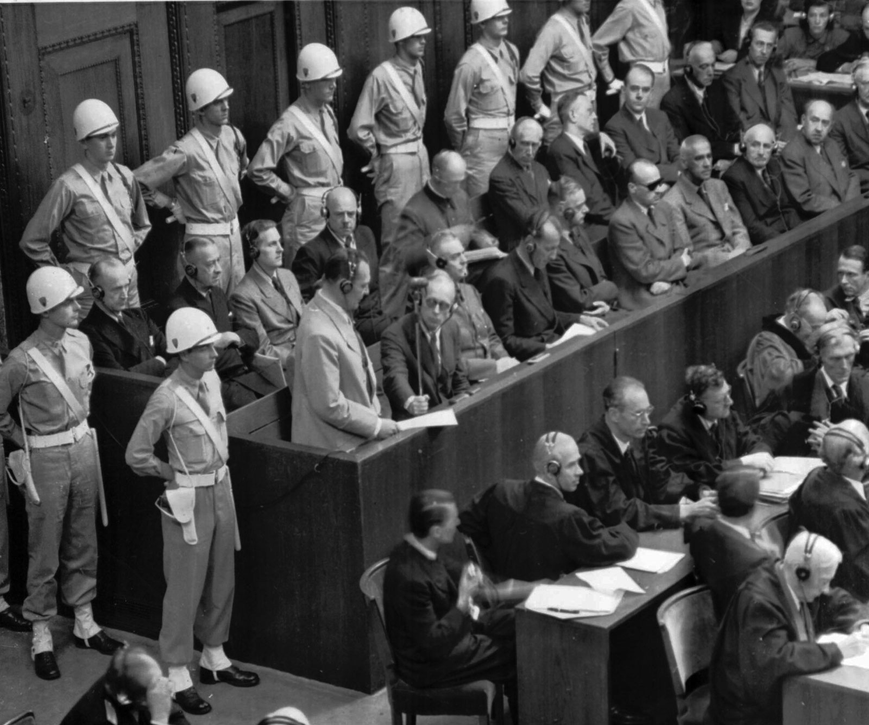

Tokyo War Crimes Tribunal 1946-1948

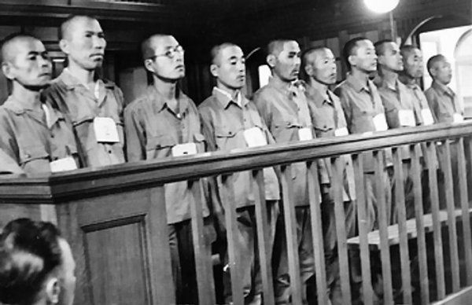

Tribunal: a special court created to deal with a narrow, specific purpose.

War Crimes Tribunals

- Nuremberg trials (German Nazis and political leaders)
- Tokyo trials (Japanese war criminals and political leaders)

These trials established the idea that there are actions that nation states can take that are outside of the bounds of acceptable, legal, international behavior. There should be international laws and agreements to rein these states in, and that there should and could be punishment afterwards for violations of human rights outside the boundaries of war.

War itself is not a human rights violation in this mindset but certain conduct during a war could be considered a war crime or violation of human rights.

Universal Declaration of Human Rights 1948

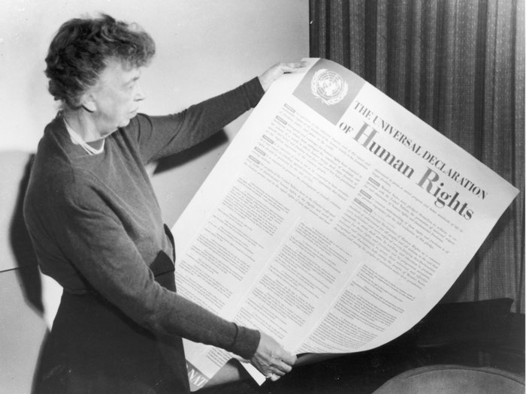

Declaration vs. Treaty/Convention/Covenant:

A declaration is a statement that nation states can adopt that recognizes the belief in certain principles. These are not legally binding.

Treaties/Conventions/Covenants are legally binding agreements that countries formally adopt through a process of ratification. These become the basis of international laws that countries consent to.

Who crafted the Universal Declaration of Human Rights?
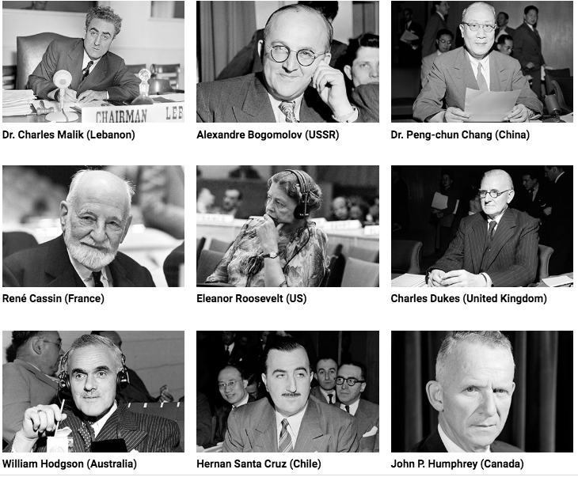

How did countries vote?

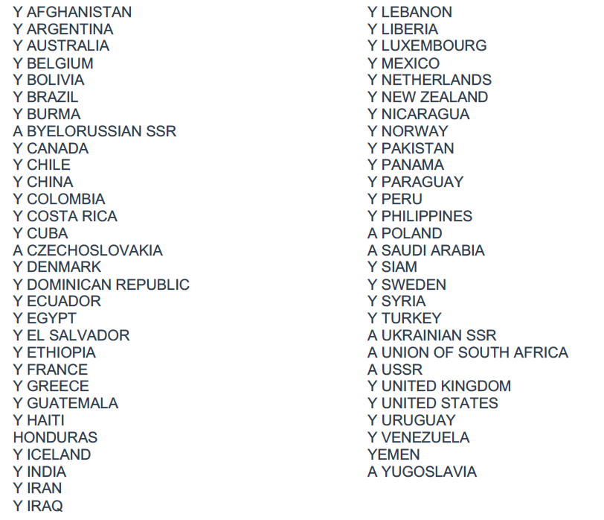

For more on why countries voted the way they did you can read here

Preamble of the Universal Declaration of Human Rights

While not a treaty itself, the Declaration was explicitly adopted for the purpose of defining the meaning of the words "fundamental freedoms" and "human rights" appearing in the United Nations Charter, which is binding on all member states, including members who joined after 1948.

Whereas recognition of the inherent dignity and of the equal and inalienable rights of all members of the human family is the foundation of freedom, justice and peace in the world,

Whereas disregard and contempt for human rights have resulted in barbarous acts which have outraged the conscience of mankind, and the advent of a world in which human beings shall enjoy freedom of speech and belief and freedom from fear and want has been proclaimed as the highest aspiration of the common people,

Whereas it is essential, if man is not to be compelled to have recourse, as a last resort, to rebellion against tyranny and oppression, that human rights should be protected by the rule of law,

Whereas it is essential to promote the development of friendly relations between nations,

Whereas the peoples of the United Nations have in the Charter reaffirmed their faith in fundamental human rights, in the dignity and worth of the human person and in the equal rights of men and women and have determined to promote social progress and better standards of life in larger freedom,

Whereas Member States have pledged themselves to achieve, in cooperation with the United Nations, the promotion of universal respect for and observance of human rights and fundamental freedoms,

Whereas a common understanding of these rights and freedoms is of the greatest importance for the full realization of this pledge,

Now, Therefore THE GENERAL ASSEMBLY proclaims THIS UNIVERSAL DECLARATION OF HUMAN RIGHTS as a common standard of achievement for all peoples and all nations, to the end that every individual and every organ of society, keeping this Declaration constantly in mind, shall strive by teaching and education to promote respect for these rights and freedoms and by progressive measures, national and international, to secure their universal and effective recognition and observance, both among the peoples of Member States themselves and among the peoples of territories under their jurisdiction.

Thoughts, impressions, questions based on the preamble?

