Do Now: Earlier in the year we said that the term power, broadly, meant the ability to influence others, to accomplish your own goals.

A few classes ago, we identified a large list of non-state actors that exert power in global politics including multinational corporations, terrorist groups, religious groups, NGOs among others.

Groups like the Red Cross, Doctors without Borders (MSF), Amnesty International, and Habitat for Humanity are examples of NGOs.

Read over the headlines below.

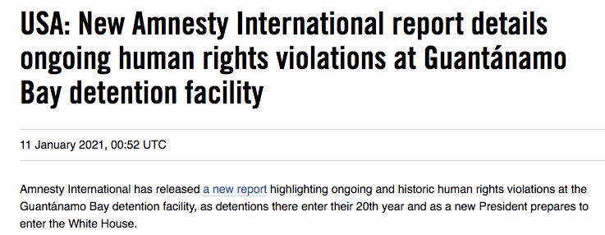

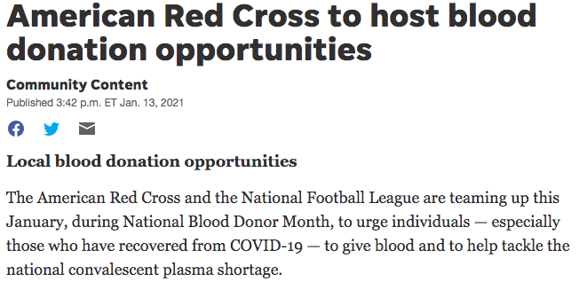

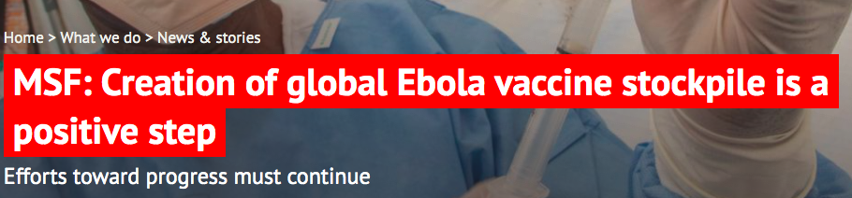

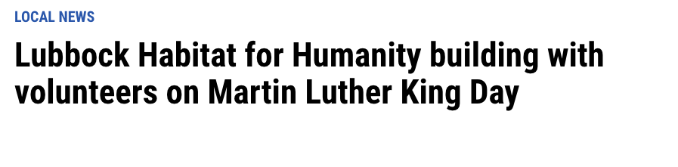

Respond: Based on the headlines and your own knowledge of the organizations, what common characteristics are there? What do you think the definition of a nongovernmental organization is?

Nonprofit organizations whose job is to benefit a certain cause. Can have a professional staff or rely on volunteers, can organize people’s efforts toward solving certain problems.
May try to fill in needs that are not met by governments either because of a lack of expertise, money, or lack of will.
These are supposed to be nonpartisan.
`
(As a class) What is the definition of an NGO?

A non-governmental organization (NGO) is any non-profit, voluntary citizens' group which is organized on a local, national or international level. Task-oriented and driven by people with a common interest, NGOs perform a variety of service and humanitarian functions, bring citizen concerns to Governments, advocate and monitor policies and encourage political participation through provision of information. Some are organized around specific issues, such as human rights, environment or health. They provide analysis and expertise.

Review: How do we evaluate the legitimacy of different actors?

Legitimacy refers to an actor or action being considered generally acceptable.

Actor | What makes them legitimate?
Nation-States | - Recognition from other nation states  - Authority accepted by the citizens of the country  - Able to exert effective control inside of their borders  - In democratic governments, free and fair elections, respecting the rule of law, respecting individual rights and liberties.  - In monarchies, birthright bestows legitimacy on rulers.  - In dictatorships or one party states, the ability to maintain control of the military/armed forces or promote safety and stability or promote economic growth.
Multinational Corporations | - Respecting the laws of the nation they operate in.  - Effectively serving the interests of consumers.  - Effectively serving the interests of their share holders.  - In the case of social media platforms, fairly applying their own terms of service, protecting users from threats of violence, etc.
Nongovernmental Organizations (NGOs) | - Transparency: how clearly do you communicate what it is you’re doing with the money you raise.  - To what extent are you successful in accomplishing the goals you set out.  - What are your goals? Do people care about them?  - How much money goes toward the cause itself?  - How many volunteers do you have? How many people want to participate in the work you do? How much do people want to contribute to your work?  - Getting the message out about their cause and raising awareness.  - Maintaining neutral stand on political issues.

Jigsaw Work on NGOs.

Each of you will be assigned a different article about particular NGOs in the world. Tomorrow, we will work in groups to share what we learned and come to conclusions about the nature of NGOs and the power they exert in global politics.

Article 1a and 1b: Attard-Eisenberg
Article 2: Frenette-Kiskinis
Article 3: Kluger-Russack
Article 4: Sachs-Zollo

Directions: Based on the article you are assigned:

1. Provide a basic summary of what is happening including: what is/are the key NGO or key NGOs involved here? What is their purpose?

2. What does this story tell us about the power of NGOs in general?

3. What does this story tell us about the relationship between NGOs and sovereignty?

#1a: French NGOs accuse Samsung of using child labour in Chinese plants

11 JANUARY 2018 - 18:39 AGENCY STAFF

Paris — Two French campaign groups filed a legal case against Samsung in France on Thursday, alleging the Korean electronics giant was responsible for the use of child labour in its Chinese plants, and other abuses.

Using a new French law that makes a company potentially liable for working conditions elsewhere in the world, the nongovernmental organizations (NGOs) Peuples Solidaires and Sherpa lodged a complaint in Paris against Samsung’s French subsidiary and international parent company.

Using research from the China Labor Watch group, the French campaigners alleged that children had been found in Chinese plants producing Samsung products, and that other staff faced severe health problems.

They took aim at Samsung’s stated objective of becoming one of the most ethnical companies in the world.

"We are asking the justice system to sanction the unacceptable gap between its ethical commitments and the reality in its factories as described by Chinese NGOs on the ground," the French groups said in a statement. Peuples Solidaires and Sherpa targeted Samsung unsuccessfully with a complaint in 2014, which was thrown out of court, but are banking on new tougher legislation passed in 2017.

#1b: NGOs lose court case to halt Norway Arctic oil exploration

A Norwegian court has found that Arctic oil exploration licenses do not violate the country's constitution. Environmentalists have been ordered to pay the state's court costs. It is unclear if the groups will appeal.

A lawsuit brought by environmental groups has been struck down by an Oslo court. The suit, brought by Greenpeace and the group Nature and Youth, alleged that Norwegian licenses granted in 2016 to 13 companies including Statoil, Chevron, ConocoPhillips and Lukoil to explore for oil in the Barents Sea violated Norway's constitution.

Norway is the largest oil producing and exporting nation in Western Europe. Although Arctic oil makes up a small portion of the country's output, experts suspect that the region holds great potential and could eventually replace older fields in the North Sea and the Norwegian Sea. After ruling in favor of the Norwegian government, the court ordered the NGOs to pay the government's legal costs, which totaled 580,000 Norwegian crowns ($71,687/ 59,334 euros).

The NGOs claimed that the licensing violated citizens' constitutional rights to a healthy living environment. Government lawyers, in turn, argued that the suit had been a publicity stunt that would have cost jobs had it been upheld. It is unclear whether the NGOs will appeal the ruling.

#2 NGO expelled from Darfur considered ICC cooperation
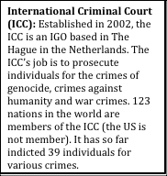
UNITED NATIONS (Reuters) - A humanitarian aid group expelled [forced out] by Sudan said on Monday it had considered cooperating with the International Criminal Court investigation of crimes in Darfur but promptly dismissed the idea.

The International Rescue Committee is one of 13 foreign humanitarian non-governmental organizations (NGO) that were expelled by Sudan’s government for allegedly cooperating with the court in its investigation of President Omar Hassan al-Bashir.

Since 2003 the United Nations has been using NGOs as part of a massive humanitarian aid effort it oversees for internally displaced persons in Sudan’s conflict-torn western Darfur region. It provides food and other aid for some 4.7 million people and says its operations are neutral and impartial.

U.N. humanitarian affairs chief John Holmes told reporters on Monday that NGOs had to decide for themselves whether or not to cooperate with the ICC. But he said the world body encouraged aid groups to follow the U.N. example and subscribe to principles of “neutrality, independence and impartiality.”

The NGOs say that they have refused to assist the ICC because it would undermine their humanitarian goals.

Earlier this month the Hague-based ICC issued an arrest warrant for Bashir after its judges indicted him on seven counts of war crimes and crimes against humanity.
Sudan’s U.N. Ambassador Abdalmahmoud Abdalhaleem singled out the New York-based IRC, established in 1933 at the suggestion of Albert Einstein to help Germans under the Nazis, as one of the top collaborators with the criminal court.

Not only has the group helped the court’s prosecutor Luis Moreno Ocampo but it signed a “memorandum of understanding” with the ICC to solidify its cooperation, he said.

‘IMMEDIATE REJECTION’

IRC spokeswoman Melissa Winkler denied the organization had signed any agreement with the Hague court but acknowledged that the organization had weighed a proposal to assist the ICC.

In a July 2005 internal memorandum, seen by Reuters, an IRC protection programs coordinator named Joseph Aguettant, who later headed IRC operations in Chad, wrote to IRC management outlining guidelines for cooperating with the court.

He said cooperation could be justified because the ICC’s work would help Sudan’s people and bring criminals to justice.

“The draft document was reviewed by IRC senior management and rejected as IRC policy,” Winkler said. “The policy that was later adopted specifically directs IRC staff members not to communicate in any way with the ICC and not to support ICC investigations.”

In a later email, Winkler played down the review of the unsolicited proposal, saying the group’s management never seriously entertained cooperation with the ICC. They read the memo “and immediately rejected its suggestions,” Winkler said.

Sudan got the memo and “has inappropriately used excerpts of it as a basis for accusing the IRC of providing information to the ICC,” she said. “The claim is baseless and false.”

Other well-known NGOs expelled from Darfur include the French aid organization Medicins Sans Frontieres (Doctors Without Borders), Britain’s Oxfam and U.S.-based CARE.

Accusations against them by Sudan’s U.N. envoy Abdalhaleem ranged from assisting the ICC investigation to “first-class espionage.” He declined to specify charges against the NGOs and has declined to produce evidence he says he has against them.

Like the IRC, the other groups denied straying from a purely humanitarian mandate in distributing aid in Darfur.

The U.N. has said expulsion of the NGOs would cripple aid activities in Darfur. Bashir said on Monday that he wants all foreign aid groups to halt activities in Sudan within a year.

#3 As Pakistan cracks down on NGOs, civil society questions next steps

By Sabrina Toppa // 10 January 2018
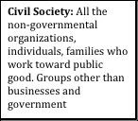
LAHORE, Pakistan — When Iftikhar Nizami, the former country director of ActionAid in Pakistan, received a government notice to shut down his NGO’s operations in December, he was stunned. In 2005, the South Africa-based organization distributed critical emergency relief during a major earthquake in Kashmir, prompting the government to issue a letter praising its humanitarian and development assistance. Now the government was striking a different tone altogether. “If there was more communication and discussion beforehand, it would’ve been very helpful,” Nizami said of the decision. “I am sure there are misunderstandings.”

“We are very transparent: We are following international regulations, we do audits from companies, we share all of the information with the government. We follow all the directives,” Nizami stressed. Nevertheless, ActionAid is one of more than 20 international NGOs that the Pakistani government has expelled from the country in December — giving them until January 25 to wind down their operations. The list of organizations affected — which includes Marie Stopes, World Vision, the Danish Refugee Council, Plan International, and Open Society Foundations — has left the entire civil society sector reeling and questioning the way forward in an uncertain environment. The affected areas of operation are wide reaching, ranging from INGOs that provide services to Afghan refugees in Pakistan to organizations helping Pakistani women access contraception.

“It is unfortunate that the process has taken this direction,” said Nargis Khan, the policy and communications adviser for the Pakistan Humanitarian Forum, a network representing 63 NGOs, including 11 of the organizations asked to leave. “These NGOs are working in the areas where there are no services,” Khan added. Those 11 organizations alone employed 6,000 local Pakistani staff and had allotted approximately $124 million in aid to serve 8.7 million people throughout Pakistan in 2018. “This is funding lost to Pakistan,” Khan pointed out.

The expulsion of foreign NGOs comes at a time when United States aid to Pakistan has been cut, and many segments of Pakistan’s civil society are increasingly under assault. As Pakistan loses key security-related funding from the U.S., it does not appear to be changing its tone toward foreign NGOs providing economic and development assistance.

Civil society remains under threat: In recent months, the country has witnessed everything from the abduction of liberal social media users to the enforced disappearance of activists and university students. For activists, the government’s latest move has intensified fears that the government is broadening the scope of who it sees as a threat. “It adversely affects the entire democratic climate in Pakistan,” said Saroop Ijaz, a lawyer with Human Rights Watch in Pakistan. “It’s clearly part of a larger pattern which reflects a shrinking space for freedom of expression and association,” Ijaz added.

In the last few years, INGOs (International NGOs) have come under increased scrutiny. In 2015, new regulations brought all foreign NGOs under the purview of the ministry of interior, which has the power to reject NGO registrations or arbitrarily rescind permissions to work in the country for broad, vague reasons: “NGOs working against Pakistan’s strategic, security, economic, or other interests will have their registration cancelled,” then-Interior Minister Chaudhry Nisar Ali Khan warned in 2015.

“Making the ministry of interior the relevant ministry was a formal acknowledgment Pakistan would view the INGO issue through a security lens,” Human Rights Watch’s Ijaz told Devex. In 2011, Save the Children aroused the ire of the Pakistani government when a Central Intelligence Agency-recruited doctor running a fake vaccination program claimed he worked for the international aid group. While the organization denied any involvement, it was subsequently ejected from the country.

“The government’s strategy is very dangerous and tricky,” said Zar Ali Khan Afridi, whose NGO Society for Rights and Development was closed in 2016, following a deadly attack on its Peshawar office. “[The government] first attacked local NGOs, creating issues and restricting work,” he said. “They do not allow our people to work in [the federally-administered tribal areas],” he said. “They have completely banned us. They consider us state enemies, which is shocking. They suspect us. This is not a positive approach.” Afridi said local NGOs suffered intimidation long before the government began to harass international NGOs.

“The present government is a weak government and thinks various NGOs, especially NGOs which are working with the cooperation of foreign partners, are not working in the interest of Pakistan,” said Mehdi Hasan, chairman of Pakistan’s Human Rights Commission. “They are afraid to give NGOs the freedom to work.”

Indeed, in the most sensitive areas of operation in Pakistan, INGOs have already been kicked out. This past fall, Médecins Sans Frontières — which spent more than $27 million in Pakistan in 2016 — shuttered its last two medical operations in the federally-administered tribal areas. The failure of the government to grant a No Objection Certificate, a legal document providing permission to run a project, came as a surprise even to MSF staff, who had been operating in the tribal areas for 14 years and received only two weeks notice to clear its medical operations in Bajaur Agency.

While there is a clear hope that INGOs will be able to reverse the government’s decision and regain the right to work, if the government holds firm, the long-term ramifications would be significant. “This will negatively impact communities and civil society, and the future work of international missions. This isn’t about INGOs alone, this is about the wider humanitarian and development community in Pakistan,” Khan said.

#4 Israel imposes travel ban on 20 foreign NGOs over boycott movement

British groups War on Want and Palestine Solidarity Campaign among those whose staff are barred from visiting Israel

The prominent British campaign group War on Want has been listed as one of 20 foreign NGOs whose representatives are banned from visiting Israel over their support of the pro-Palestinian boycott, sanctions and divestment (BDS) movement.
The publication of the list, which also includes a well-known Jewish anti-occupation group and a Nobel peace prize-winning US Quaker group, had been threatened for months by Israel.

The organisations were singled out by Israel’s rightwing strategic affairs and public security minister, Gilad Erdan, for advocating boycotts of Israel over its treatment of Palestinians.

Erdan said on Sunday that the groups “operate consistently and continuously” against Israel using a “campaign of incitement and lies”.

Human rights groups condemned the move as an assault on free speech. A number of individuals have been refused entry into Israel in recent months, including a prominent African theologian and official of the World Council of Churches.
While most of the organisations listed by Erdan are local branches of the BDS movement around the world, others include Jewish Voice for Peace, which has 13,000 members, the US group Code Pink and the American Friends Service Committee, which won the peace prize in 1947.

As well as War on Want, the list names a second British group, the Palestine Solidarity Campaign, of which Jeremy Corbyn is a patron.

Erdan said Israel had “shifted from defence to offence” with the publication of the list. “The boycott organisations need to know that the state of Israel will act against them and not allow [them] to enter its territory to harm its citizens,” he said. “No country would have allowed critics coming to harm the country to enter it.”

The interior minister, Arye Dery, whose ministry is responsible for barring those listed, said: “These people are trying to exploit the law and our hospitality to act against Israel and to defame the country. I will act against this by every means.”
The travel ban is the latest in a series of populist moves by the Israeli government, the most rightwing coalition in the country’s history. The prime minister, Benjamin Netanyahu, has said he intends to remove 40,000 African migrants from Israel and expressed support for making it easier to carry out the death sentence on people convicted of terrorism.

Rebecca Vilkomerson, the executive director of Jewish Voice for Peace, criticised the publication of the list, saying it was “disconcerting but not surprising given the further erosion of democratic norms and rising anxiety about the power of BDS as a tool to demand freedom.”

She wrote on Facebook: “As someone with considerable family in Israel, this policy will be a personal hardship. But I am also heartened by this indicator of the BDS movement’s growing strength, and hope that it will bring the day closer when just as I go to visit my friends and family in Israel, so will Palestinian friends and colleagues be able to return home.”

Hassan Jabareen, of the Legal Centre for Arab Minority Rights in Israel, said the travel ban was draconian and arbitrary. “This ban is an overt violation of the constitutional rights of Israeli citizens and the rights guaranteed to Palestinian residents of the OPT [Occupied Palestinian Territories] under international humanitarian and human rights law. This move is reminiscent of South Africa’s apartheid regime which also prepared blacklists in order to punish people and prevent the entry of those opposed to its racist policies.”

In November Israel denied entry to a US employee of Amnesty International as part of its anti-boycott offensive under the same rules. Amnesty is not on the list of 20 groups published on Sunday.

