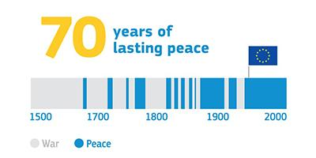

Do Now: In breakout rooms, please discuss the following and collect your responses on the following chart. Use your homework to help complete this.

What are the costs and benefits of joining the European Union?

Benefits of European Union Membership | Costs of European Union Membership

Why free trade? Why free movement of people? Why common currency?

Imagine for a second, that each state in the United States:
- Had a different currency
- Required people to have permission to travel to other states with border stops and security at all crossings
- Required permission from the state to move to there
- Required permission from the other state to work there
- Taxed anything made in another state that was sold in your state

What might the consequences be?

- Chaotic, would undermine economic integration
- People would travel less between states conflict between states especially those with shared borders
- Divisiveness, more than now, there are differences already between states this would exacerbate those
- Increased rivalry
- Maybe different parts of the US would secede
- More cultural differences between regions and states
- Less innovation, trickle of ideas and technologies
- Harder for people to move to work would make it mess with economic growth and innovation.
- If each state always did its own thing then hard to coordinate important.

Let’s be clear, in the United States, we have a nation state that is both politically integrated (under the same national government) and economically integrated (same currency, free movement of people, interstate commerce is open and free). People can move around freely and without permission. People can live where they want, work where they want, produce goods where they want and sell where they want without permission or limitations. States cannot tax goods made in other states. Yes each state can have different policies around job licensing and tax rates within that state but those are limited.

The European Union started out as an economic union but has evolved into a political union as well.

What are the core foundations of European Union member states?

Not anyone can be a member. Members have to maintain certain fiscal discipline including budget limitations but they also must share core liberal democratic beliefs. States that don’t meet those standards can be punished by the EU.

From the E.U.’s website:

The EU values are common to the EU countries in a society in which inclusion, tolerance, justice, solidarity and non-discrimination prevail. These values are an integral part of our European way of life:

- Human dignity
- Freedom
- Democracy
- Equality
- Rule of law
  - Law and justice are upheld by an independent judiciary.
- Human Rights

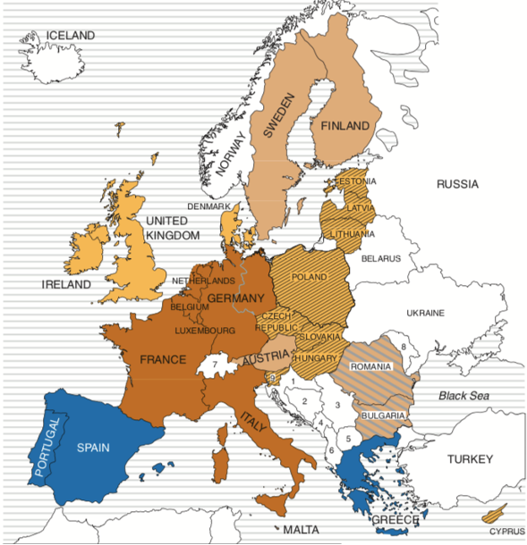
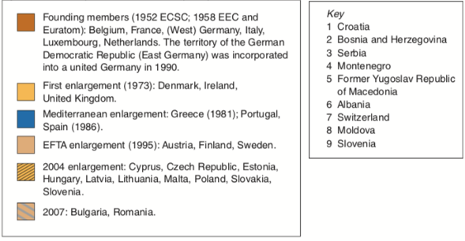

Internal Sovereignty in the European Union

Internal sovereignty EU members maintain | Internal sovereignty EU members give up
- Can still make laws around domestic issues like education, health care, taxes, spending.  - Basic things like roads, or bridges  - Can maintain currency if they don’t adopt the Euro | - Internal structures of government have to continue to be in line with the EU’s liberal democratic principles.  - Have to maintain certain budgetary controls (can’t run huge deficits, etc.) if they use the Euro  - Have to give up certain domestic laws around certain practices for goods that get traded around the EU, agricultural, packaging laws  - Give up currency control if they adopt the Euro.

External Sovereignty in the European Union

External sovereignty EU members maintain | External sovereignty EU members give up
Each nation has its own military and military strategy.  Maintain their own foreign relations and foreign policies. | Don’t have absolute control over borders and who comes and goes.  Cannot represent themselves individually for trade or economic deals

