Review questions from last class:

1. “Some U.S. conservatives made clear their own unease with the Declaration, seeing its assertion of broad economic rights as a step toward socialism. The Soviets had the opposite objection to the Declaration, arguing that it favored individual over collective rights and undermined national sovereignty.”

What does this mean?

2. How might a Human Rights Treaty be seen as an “agent for western colonialism”? What might nations be worried about this in 1948?

How can we uphold human rights?

For human rights to be a meaningful concept, what else needs to happen? Let’s brainstorm specific things that need to exist for human rights to have weight and be upheld.

Codification: Specific documents, treaties, that countries agree to and adopt.
Enforcement: there has to be a way to punish transgressions, violations
Monitoring: there has to be a way to keep track of what’s going on in the world.
Promotion: people need to be aware and education about these ideas

Note: There is a significant difference between declarations and conventions/covenants. The latter are legally binding and ratified by states.

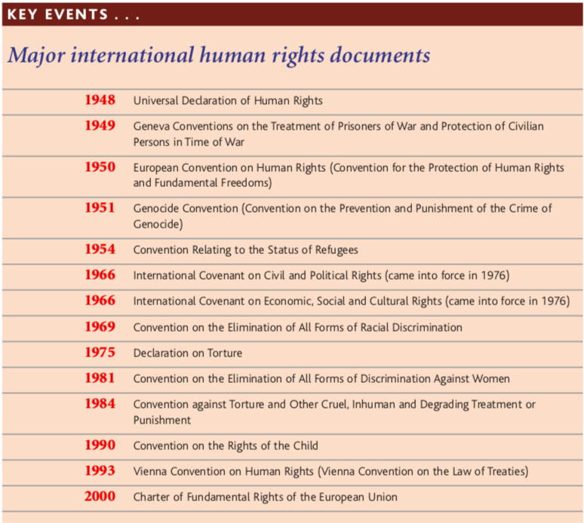

Expanding human rights work: Codification

We’ll be looking into different treaties and expansions of international human rights. Each person in your group will be responsible for researching a different agreement/expansion. You can choose your own group or be assigned. The work you do will be individual but you’ll be responsible for sharing and discussing your research.

