Do Now: Currently President Trump is challenging election results in several different states. He is challenging the voting process and results in state and federal courts. His campaign has lost almost every legal challenge. It’s important to note that all of these actions, whether you like them or not, are legal. They are within the boundaries of what our laws allow.

- What would happen if President Trump could simply fire any judge who disagreed with him and replace them with someone who agreed with him?

- What if President Trump were to campaign on changing the structure of the court system to be loyal to the President rather than independent and then was reelected. Would that be okay to do since it was democratically done?

Liberal Democratic Governments

The key takeaways here are that we don’t simply have a “democracy” where people rule and can do whatever they want. There are limits on the power of “the people” to take actions and laws.

In a liberal democracy, those limits include:

- Individual rights and liberties. No matter how popular or democratic an action is, it cannot be allowed in a liberal democracy if it violates individual rights and freedoms.
- Limited Government: No matter how popular the actions, governments cannot do anything they want. Government actions are limited by powers given in constitutions and laws that are written down and passed by legitimate representative bodies.
- Rule of law: Everyone must follow the law. No matter how popular a person is or how important it is to ignore laws, they must be followed. Laws must change according to the process laid out.

In order to achieve these, certain systems have been created in liberal democracies:

- Separation of powers: independent branches that have separate powers that can limit each other.
- Independent Judiciary: Judges should be separate from other branches and not be subject to pressure or power from elected officials. This allows them the ability to enforce laws and protect people against the power of elected officials and majorities of people who may want to act against them.

The EU is not just an economic union but a political one as well. There are expectations of each government to maintain these liberal democratic values. It’s important that it is not enough simply to have an elected government or to be democratic, there are other expectations as well.

What happens if a government takes actions that go against those expectations?

What can the European Union do if a country breaks the rules or defies its expectations?

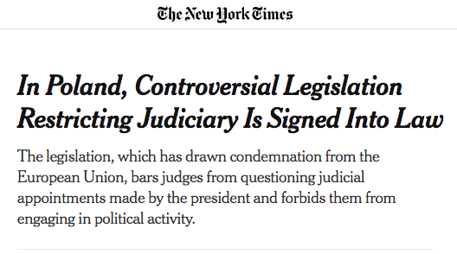

2/4/2020

WARSAW — President Andrzej Duda of Poland signed into law on Tuesday much-criticized legislation that gives politicians the power to fine and fire judges whose actions and decisions they consider harmful.

The legislation has drawn condemnation from the European Union and international human rights organizations as well as from Poland’s opposition and some of its judges. They say it violates the basic democratic values of judicial independence and the system of checks and balances and puts judges under political control.

https://www.nytimes.com/2020/11/16/world/europe/eu-stimulus-poland-hungary.html

After taking office in 2015, PiS assumed direct control of the National Council of the Judiciary, a formerly independent body that oversees the appointment, promotion and discipline of all Polish judges. This allowed the government to fill a newly created judicial disciplinary chamber with party loyalists who have since proceeded to launch disciplinary proceedings against any judge who questions the new regime.

Judges involved in politically sensitive cases, or who have expressed opposition to challenges to judicial independence are frequently threatened with disciplinary proceedings and even criminal charges, and in many cases are subjected to state-led campaigns of intimidation.

https://www.theguardian.com/world/2020/jan/24/declaration-of-war-polish-row-over-judicial-independence-escalates

European Union Budget

Each country pays the same proportion of its national income to the EU budget, so richer countries pay more and poorer ones less. Some countries, such as the UK, pay less because they receive a rebate.

The EU spends the money on a wide range of projects, but about three quarters of the budget every year goes to two main areas: agriculture and development of poorer areas of the EU.

So, poorer countries and those with a lot of farms get more.

Below is a table of which countries pay more than they get back from the EU in direct payments (blue) and those that receive more than they pay (red).

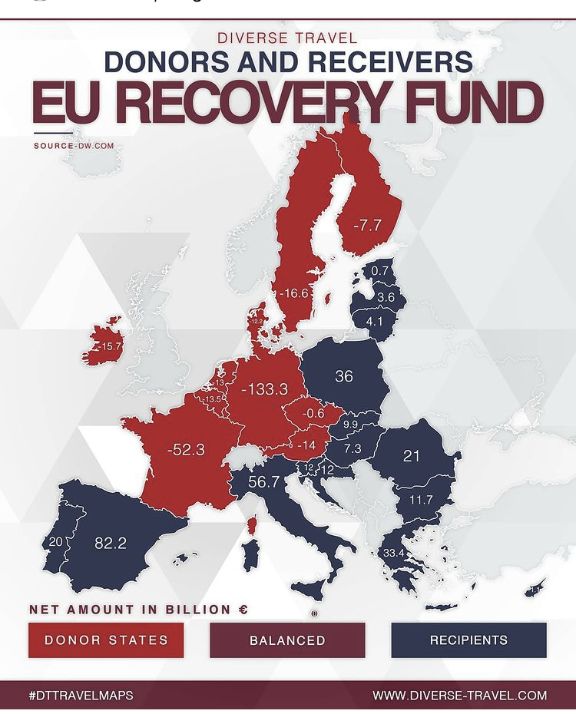
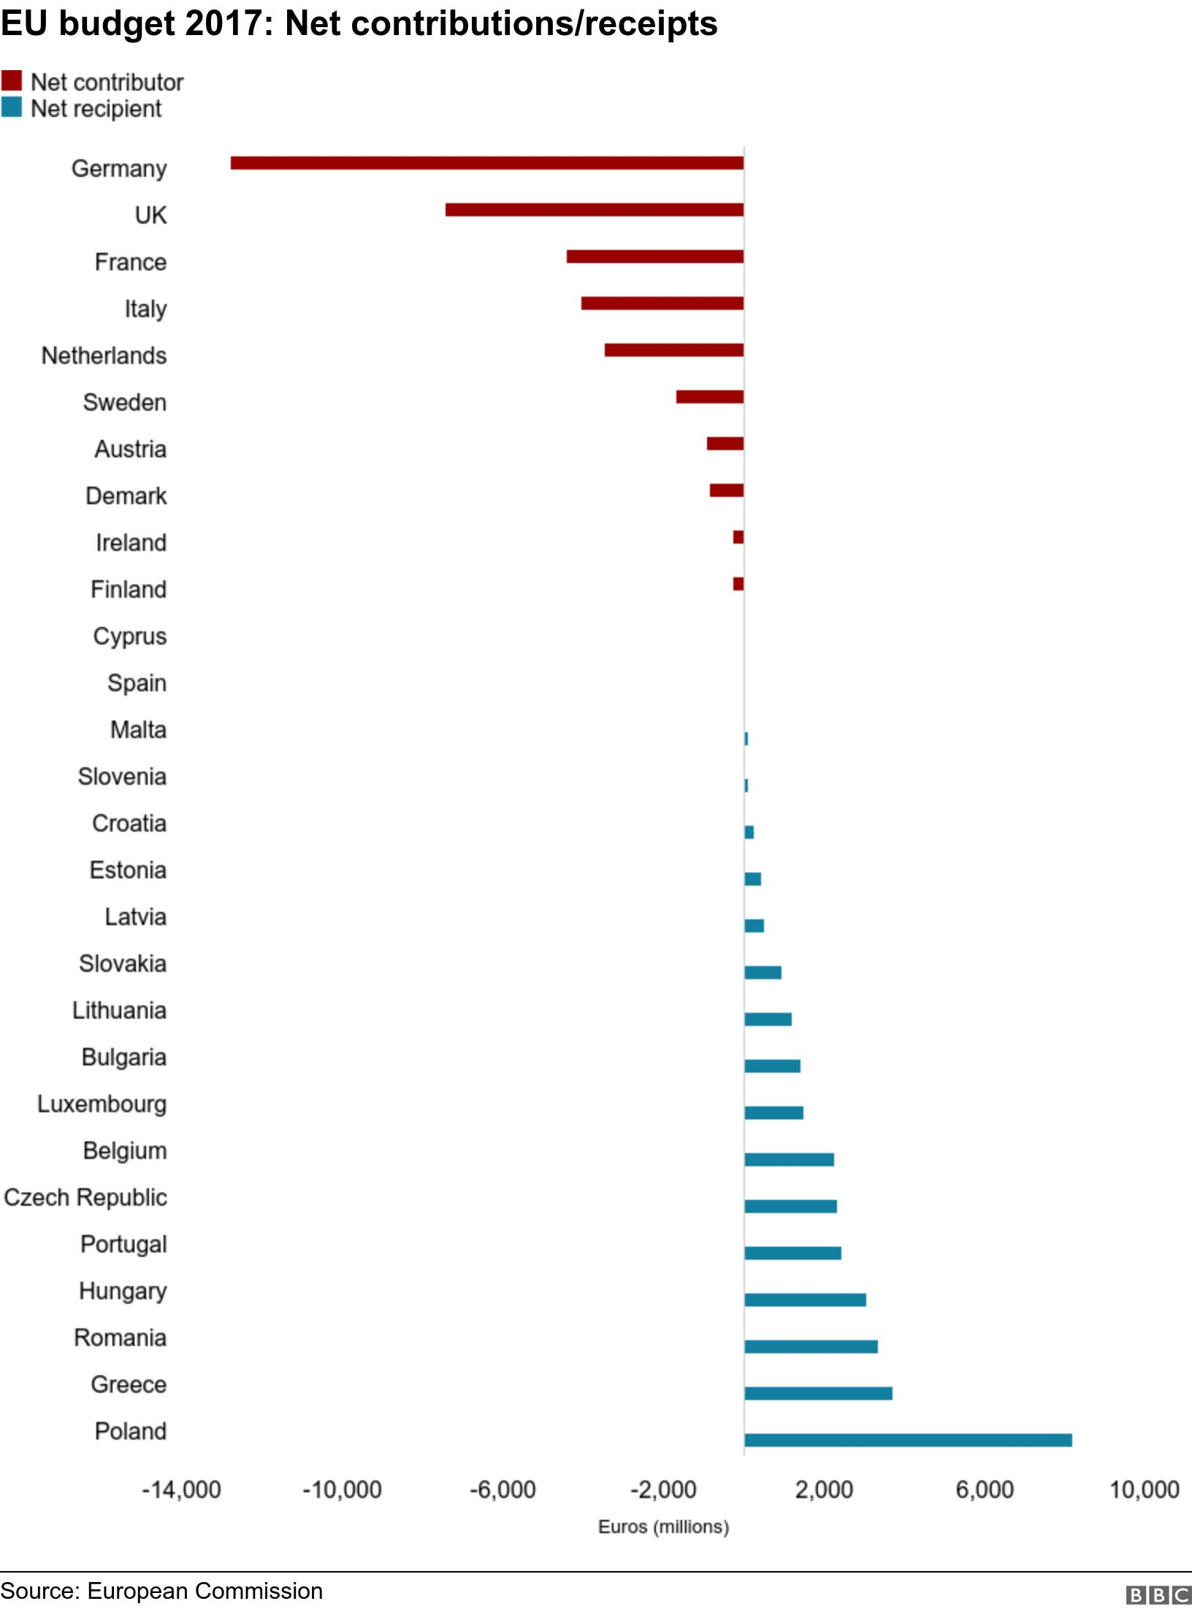
Click here for full article

EU Issues rule of law report and ties EU budget money to rule of law principles

Democracy is suffering in several European nations, including Hungary and Poland, according to a European Commission audit on the rule of law published in September.

The new report, the product of months of work that put all 27 E.U. nations under scrutiny, reflected concerns that the European Union has failed to combat democratic backsliding among some of its members, though it has long prided itself as a bastion of liberal values.

The release of the report coincided with a preliminary agreement by European diplomats to tie access to E.U. funds to respecting the rule of law. Defenders of principles such as an independent judiciary and a free press have accused the European Union of enabling illiberal leaders by failing to cut off the money that props them up.

The European Union was founded as a club of democracies, but it has struggled to intervene over the past decade as leaders in Hungary and Poland backed away from democratic commitments.

How have Poland and Hungary responded?

EU budget blocked by Hungary and Poland over rule of law issue

11/16/2020

The two eastern European countries said they would veto the spending bill because the funding was made conditional on upholding rule-of-law standards, such as an independent judiciary, which the two governments have weakened as they defiantly tear down separation of powers at home.

Polish Justice Minister Zbigniew Ziobro said the rule of law issue was "just a pretext".

"It is really an institutional, political enslavement, a radical limitation of sovereignty," he said.

The leaders of Hungary and Poland consider the proposal, to tie European Union aid to external rule of law standards, to be a violation of their national sovereignty.

But Austrian Chancellor Sebastian Kurz, addressing a conference shortly after the budget was blocked, said that "upholding the principles of the rule of law is an absolute necessity" because the sums being handed out by the EU to member states were so vast.

Polish Prime Minister, Mateusz Morawiecki, said that Poland didn’t sign up for this type of EU.

This isn’t the first time eastern European countries have gone against the European Union’s wishes

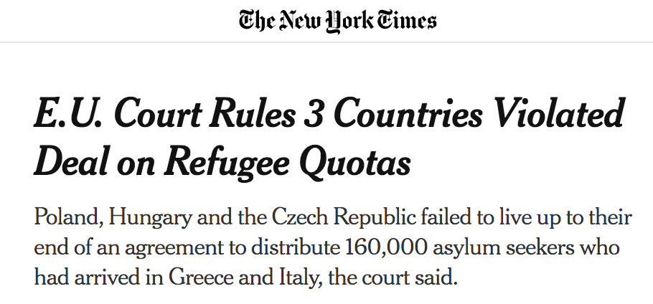

4/2/2020

The European Court of Justice ruled on Thursday that Poland, Hungary and the Czech Republic had violated their obligations by refusing to take in their fair share of asylum seekers at the height of the refugee crisis in 2015.

The court’s ruling, which is final, said that the three Eastern European countries had failed to live up to their end of a European Union agreement to distribute 160,000 asylum seekers who had made their way to Greece and Italy, which are on the European external borders. The countries were struggling at the time to cope with the large numbers arriving from war zones and fleeing poverty.

The crisis threatened to upend the core of the European Union, fueled the rise of the far right and moved many countries’ governments to the more conservative end of the spectrum.

The three countries’ refusal to participate in the relocation scheme, an emergency measure put in place to help Greece and Italy and intended to make the distribution of new arrivals more equitable, was viewed by some other European Union countries as particularly offensive.

It marked a bloc of resistance to communally agreed policies — especially in relocating and hosting migrants and refugees in Eastern Europe — and created a new fault line in European Union politics.

The relocation program lapsed in 2017, so there’s no practical way to make Poland, Hungary and the Czech Republic take in more asylum seekers now. It is up to the European Commission to decide what to do next, the court said, referring to the executive arm of the European Union.

The Polish government said in a statement: “The refusal to comply with the relocation mechanism was dictated by the need to protect Poland’s internal security and defend it against uncontrolled migration. The most important goal of government policy is to ensure the safety of our citizens.”

Laying out the violations affecting refugees, the European court, based in Luxembourg, noted that, “Poland indicated that 100 persons could be swiftly relocated to its territory. However, it did not relocate those persons and it did not make any subsequent relocation commitment.”

It said that Hungary did not even indicate a number of people to take in and that the Czech Republic took in only 12 asylum seekers from Greece, even thought it had said it would accept 50.

Germany, in contrast, took in nearly one million asylum seekers, while other major European countries complied with the policy.

Poland expects concessions after it vetoed EU budget

https://www.reuters.com/article/us-eu-budget-poland/poland-expects-concessions-after-it-vetoed-eu-budget-idUSKBN27X0ME

Respond:

First, please go back over today’s work and read over the text and annotate. We worked through these ideas quickly during class time.

1. Why should European Union countries care whether other members are following liberal democratic principles? Why can’t they just let countries in the union do what they want? Think deeply about this question. Think back to what the European Union is and how the countries actually interact with each other along with why the union was formed in the first place.

2. Based on the topics and articles above, discuss the relationship between membership in the European Union and national sovereignty

3. How can the European Union exert power over its member states? Refer to specific aspects from the readings above.

Seminar Questions

What questions do you want to go over or discuss tomorrow during our seminar?

