Facts about tobacco and smoking

Key facts

- Tobacco kills up to half of its users.
- Tobacco kills more than 8 million people each year. More than 7 million of those deaths are the result of direct tobacco use while around 1.2 million are the result of non-smokers being exposed to second-hand smoke.
- Around 80% of the world's 1.1 billion smokers live in low- and middle-income countries.
- Smoking is the direct cause of one of every five deaths in the U.S. That translates to roughly 480,000 deaths annually, 1,300 smoking-related deaths per day, 54 deaths per hour, or almost one death per minute.
- Every cigarette you smoke cuts five to 11 minutes from your life. Over a lifetime, that can reduce your life expectancy by as much as 12 years.
- Around 25 percent of all heart disease deaths and 75 percent of lung disease deaths are directly attributed to smoking irrespective of any other cause.

Leading cause of death, illness and impoverishment

All forms of tobacco are harmful, and there is no safe level of exposure to tobacco. Cigarette smoking is the most common form of tobacco use worldwide. Other tobacco products include waterpipe tobacco, various smokeless tobacco products, cigars, cigarillos, roll-your-own tobacco, pipe tobacco, bidis and kreteks.

The economic costs of tobacco use are substantial and include significant health care costs for treating the diseases caused by tobacco use as well as the lost human capital that results from tobacco-attributable morbidity and mortality.

In some countries children from poor households are employed in tobacco farming to boost family income. Tobacco growing farmers are also exposed to a number of health risks, including the "green tobacco sickness".

Below are some interesting charts and graphs on tobacco use

For a great set of resources and data on tobacco use, check out Our World in Data:
https://ourworldindata.org/smoking

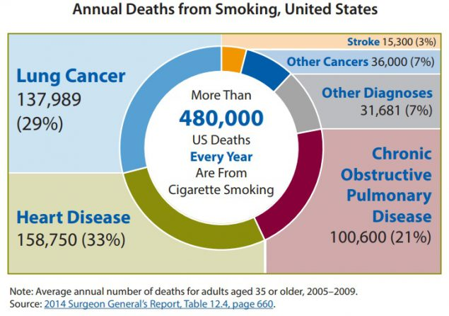

Chart on US cigarette consumption

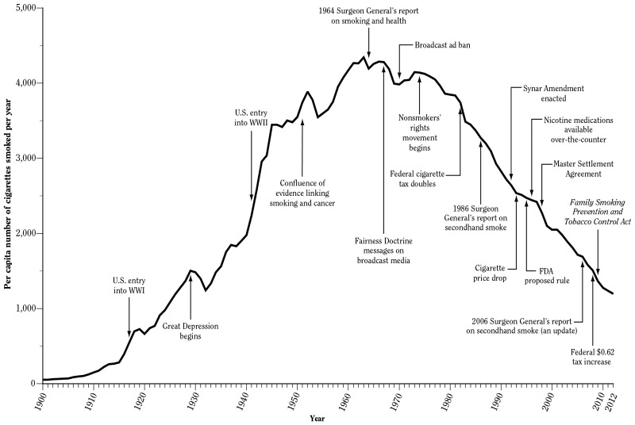

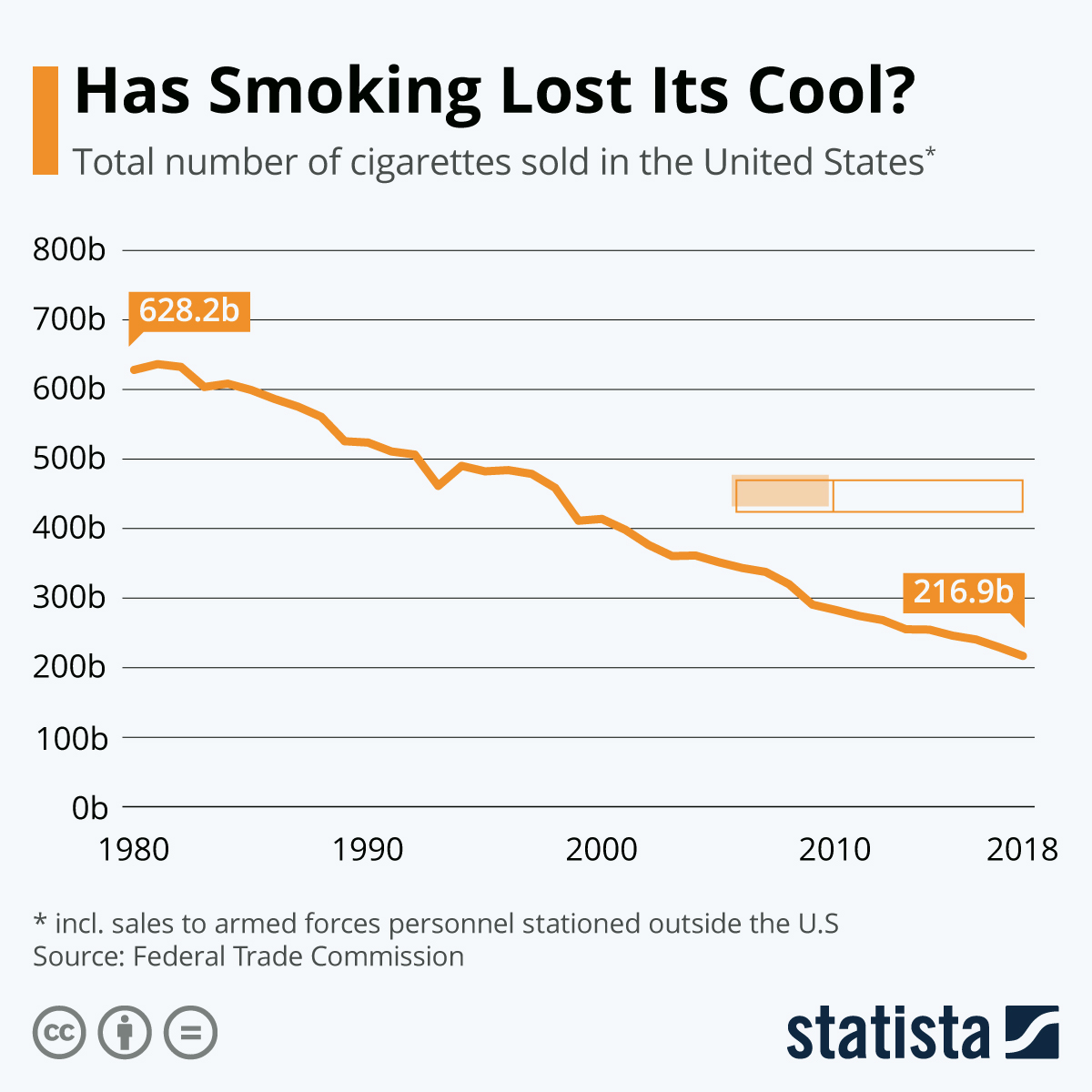

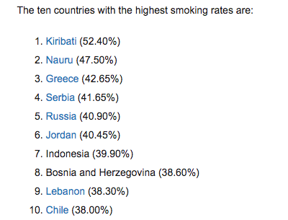

WHO Framework Convention on Tobacco Control

Overview

The WHO Framework Convention*** on Tobacco Control (WHO FCTC) is the first treaty negotiated under the auspices of the World Health Organization. The WHO FCTC is an evidence-based treaty that reaffirms the right of all people to the highest standard of health. The WHO FCTC represents a paradigm shift in developing a regulatory strategy to address addictive substances; in contrast to previous drug control treaties, the WHO FCTC asserts the importance of demand reduction strategies as well as supply issues.

The WHO FCTC was developed in response to the globalization of the tobacco epidemic. The spread of the tobacco epidemic is facilitated through a variety of complex factors with cross-border effects, including trade liberalization and direct foreign investment. Other factors such as global marketing, transnational tobacco advertising, promotion and sponsorship, and the international movement of contraband and counterfeit cigarettes have also contributed to the explosive increase in tobacco use.

The core demand reduction provisions in the WHO FCTC are contained in articles 6-14:

Price and tax measures to reduce the demand for tobacco, and

Non-price measures to reduce the demand for tobacco, namely:
- Protection from exposure to tobacco smoke;
- Regulation of the contents of tobacco products;
- Regulation of tobacco product disclosures;
- Packaging and labelling of tobacco products;
- Education, communication, training and public awareness;
- Tobacco advertising, promotion and sponsorship; and,
- Demand reduction measures concerning tobacco dependence and cessation.

The core supply reduction provisions in the WHO FCTC are contained in articles 15-17:
- Illicit trade in tobacco products;
- Sales to and by minors; and,
- Provision of support for economically viable alternative activities.

The WHO FCTC opened for signature on 16 June to 22 June 2003 in Geneva, and thereafter at the United Nations Headquarters in New York, the Depositary of the treaty, from 30 June 2003 to 29 June 2004. The treaty, which is now closed for signature, has 168 Signatories, including the European Community, which makes it one of the most widely embraced treaties in UN history. Member States that have signed the Convention indicate that they will strive in good faith to ratify, accept, or approve it, and show political commitment not to undermine the objectives set out in it. Countries wishing to become a Party, but that did not sign the Convention by 29 June 2004, may do so by means of accession, which is a one-step process equivalent to ratification.

The Convention entered into force on 27 February 2005 - 90 days after it had been acceded to, ratified, accepted, or approved by 40 States.

***Quick note on language,

What is an international convention?

An international convention or treaty is an agreement between different countries that is legally binding to the contracting States. Existing international conventions cover different areas, including trade, science, crime, disarmament, transport, and human rights. A convention becomes legally binding to a particular State when that State ratifies it. Signing does not make a convention binding, but it indicates support for the principles of the convention and the country’s intention to ratify it. As contracting States are legally bound to adhere to the principles included in the convention, a monitoring body is often set up to assess State parties’ progress in implementing the convention by considering reports periodically submitted by States. Human rights conventions do not contain any enforcement mechanism to compel States to comply with the principles of the convention or with the recommendations of the monitoring body, and the implementation of these conventions depends on the commitment of each country.

Respond:

Why is tobacco use an issue that the World Health Organization would take action on?

Based on the documents above, discuss and describe the nature of the World Health Organization’s power? How does it exert power? What are its limitations?

Include a discussion of the power exerted by other actors.

Adapted from: https://www.who.int/news-room/fact-sheets/detail/tobacco
From https://www.un.org/esa/socdev/enable/convinfofaq.htm#q1

