Human Rights Review Document

Here is a link to pages on Human Rights from an IB review book. We’ve done some readings out of this. It should be helpful for you as you review.

Here is a link to the summary of our case studies over the two years along with the relevant course concepts

Sample Human Rights Paper 2 Assignments
Our unit assessment was a Paper 2 assignment last year. You can find yours on turnitin with comments. Here are two exemplary ones from your classmates.

Sample 1

Insert link to your assignment

Core Concepts and Definitions

Define these terms in your own words. Some may have complex definitions or contested meanings. Mention examples from our case studies to help you make connections.

Term | Definition, Examples, and other notes
Human Rights
Liberty
Equality
Justice

Key vocabulary and definitions

Define terms listed below. You can, or should, include a link to work we’ve done connected to the terms and concepts.

Here are pages from the IB Guide that can help you define or understand what is meant by these terms. We did not refer to each of these terms explicitly but you can make connections between the work we did and these terms.

Nature and evolution of human rights
- Definitions of human rights
- UN’s Universal Declaration of Human Rights
- Developments in human rights over time and space
3/9, 3/10, 3/11, 3/12, 3/15,

Codification, protection, enforcement?, and monitoring of human rights
- Human Rights laws and treaties
- Protection and enforcement of human rights at different levels
- Monitoring human rights agreements
3/16, 3/17 (Expanding HR Group Work), 3/23

Practice of human rights (connects directly to the case studies below)
- Claims on human rights
- Violations of human rights

Debates surrounding human rights: differing interpretations of justice, liberty, and equality.
- Individual vs. Collective Rights
- Universal Rights vs. Cultural Relativism
- Politicization of human rights
4/8 (Dakota Access Pipeline), 4/12, 4/13, 4/15, 5/4

Realists and Liberals on Human Rights
4/5

Unit Case Studies

Below are the three main case studies we did in this unit, along with one last year which also applies. Go back into your Google Classroom files and add links

Case Study 0: Additional Human Rights Treaties

This topic is listed above but it’s worth taking time to be familiar with at least two additional human rights treaties, covenants, or conventions along with some specific applications (two in addition to the UDHR). Remember that declarations are nonbinding but when a country ratifies a treaty or convention they officially make it part of their country’s laws.

Specific Treaty | Details and Examples

Case Study #1: European Court of Human Rights (ECHR)
From last year’s google classroom: 3/24, 3/25,
***We did a group activity with a few different cases here. These offer great cases on regional approaches to human rights. Identify specific cases like Alexei Navalny in Russia for example***

Main Actors
Key course concepts related to this case
Summary of the case study with specific events and details
Links for relevant google docs from the dates above
Connections to theoretical perspectives

Case Study #2: International Criminal Court (ICC) (created by the Rome Statute 1998)

From last year’s google classroom: 4/6, 4/7

Main Actors
Key course concepts related to this case
Summary of the case study with specific events and details
Links for relevant google docs from the dates above
Connections to theoretical perspectives

Case Study #3: Kamayurá tribe in the Amazon

4/12

Main Actors
Key course concepts related to this case
Summary of the case study with specific events and details
Links for relevant google docs from the dates above
Connections to theoretical perspectives

Case Study #4: Female Genital Mutilation (FGM)
From last year’s google classroom: 4/19, 4/20, 4/21, 4/23
***When doing this, identify specific countries where actions have been taken, laws changed, and attempts made to deal with this issue. When writing about this, don’t simply say things like “in Middle Eastern countries.” Be precise. Mention the case of the young girl from Egypt who died, laws that have changed in Kenya, and the cases from western Africa***

Main Actors
Key course concepts related to this case
Summary of the case study with specific events and details
Links for relevant google docs from the dates above
Connections to theoretical perspectives

Case Study #5: China and the Uyghurs
From last year’s google classroom: 4/26, 4/29, 5/4

Main Actors
Key course concepts related to this case
Summary of the case study with specific events and details
Links for relevant google docs from the dates above
Connections to theoretical perspectives

Last bunch of Paper 2 Exam Questions

Read over these questions and identify the types of questions and concepts you would want to answer. Which would you want to avoid?

Do Answer Questions About | Don’t Answer Questions About

November 2021
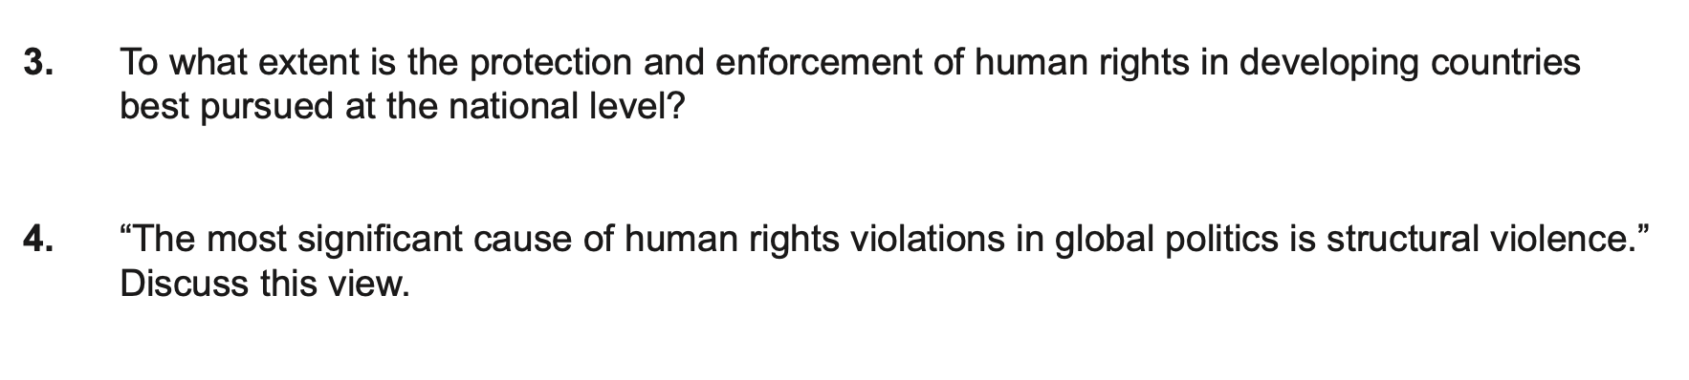

May 2021

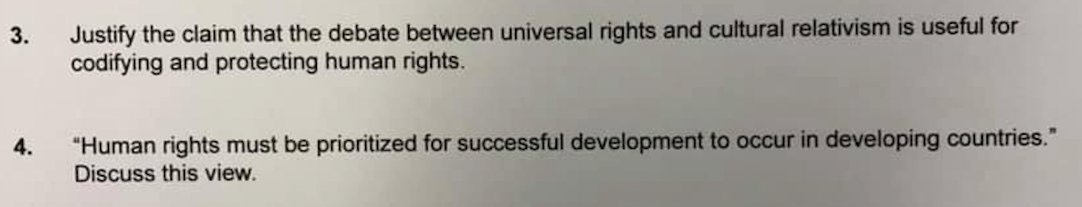

November 2020
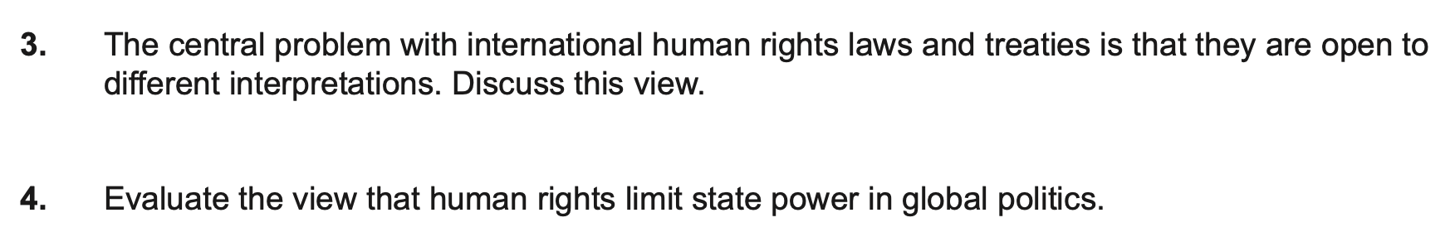

November 2019
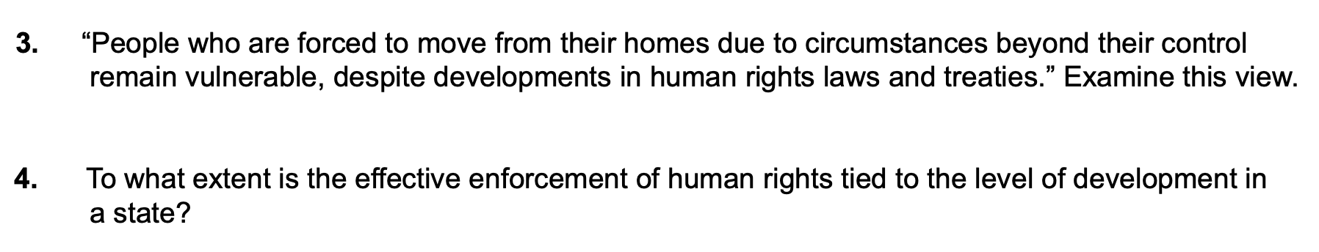

May 2019

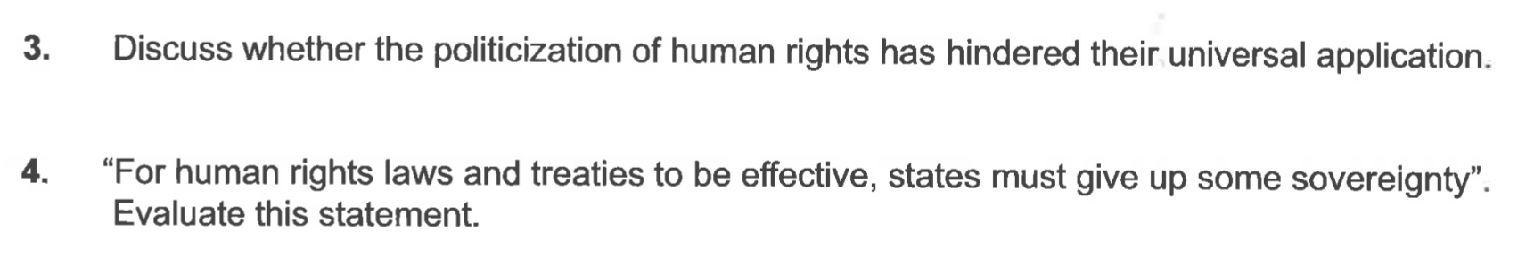

November 2018

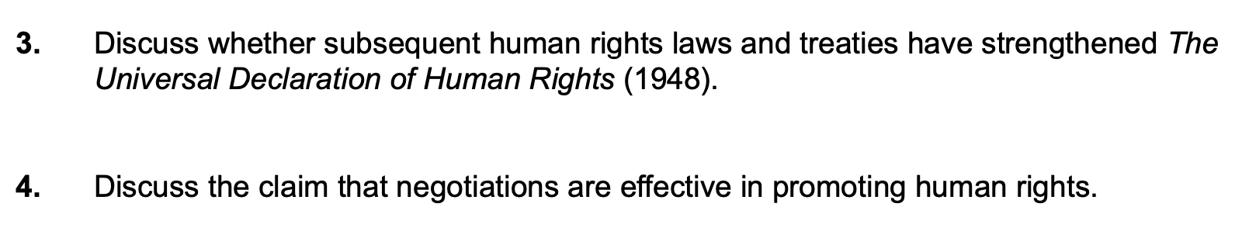

May 2018

