Peace and Conflict Review Document

Here is a link to the Peace and Conflict pages from an IB review book. We’ve done some readings out of this. It should be helpful for you as you review.

Here is a link to the summary of our case studies over the two years along with the relevant course concepts

Core Concepts and Definitions

Define these terms in your own words. Some may have complex definitions or contested meanings. Mention examples from our case studies to help you make connections.

Term | Definition, Examples, and other notes
Peace
Conflict
Violence
Nonviolence

Key vocabulary and definitions

Define terms listed below. You can, or should, include a link to work we’ve done connected to the terms and concepts

What are the different types of conflict? (these are just the ones we studied).
- Territorial conflict
- Identity conflict (including ethnicity)
- Economic/Resource conflict
- Security conflicts
- Interstate vs. Intrastate conflict

What is Just War Theory (example of a justification for violence)?
(12B 3/10, 12D 2/18)

Conflict dynamics, Galtung’s Triangle
What are the key concepts and terms involved in the triangle?
(12B: 2/10, 3/7 12D: 2/10 3/8)
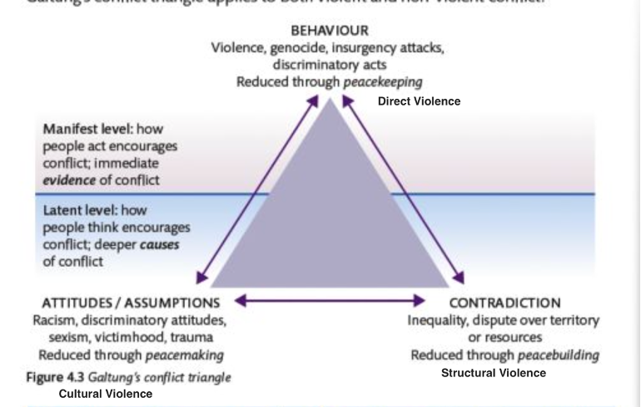

Peacemaking vs. Peacebuilding (look to work on conflict dynamics for help here)
What do these terms mean? What is the difference? What actions are examples of each? Which cases studies fit within each? Refer to specific actions rather than mention overall case studies.

Peacemaking | Peacebuilding

Unit Case Studies

Below are the three main case studies we did in this unit, along with one last year which also applies. Go back into your Google Classroom files and add links

Case Study #1 Ukraine and Russia Red are the more important days
12B: 3/1, 3/2, 3/7, 3/8, 3/9, 3/16 (economic sanctions)
12D: 3/1, 3/2, 3/3, 3/8, 3/9, 3/10, 3/15

Main Actors
Key course concepts related to this case
Summary of the case study with specific events and details
Links for relevant google docs from the dates above

Case Study #2 South China Sea
12B: 3/23, 3/24
12D: 3/24

Main Actors
Key course concepts related to this case
Summary of the case study with specific events and details
Links for relevant google docs from the dates above

Case Study #3 Rwanda
12B: 3/30 (Case Study #3), 4/4 (Rwanda final reading)
12D: 3/31, 4/5

Main Actors
Key course concepts related to this case
Summary of the case study with specific events and details
Links for relevant google docs from the dates above

Case Study #4 Iran-US Relations (we did this in unit 1 last year but it fits with Peace and Conflict as well)

From last year’s google classroom:

10/27, 10/29, 11/9, 11/12 (Topics 3 and 4 submitted to turnitin), 11/18, Final Assignment Iran Paper 2 (on turnitin)

Main Actors
Key course concepts related to this case
Summary of the case study with specific events and details
Links for relevant google docs from the dates above

Last bunch of Paper 2 Exam Questions

Read over these questions and identify the types of questions and concepts you would want to answer. Which would you want to avoid?

Do Answer Questions About | Don’t Answer Questions About
Positive and Negative Peace  Violent, Nonviolent  Peacebuilding vs. Peacemaking  Causes of Conflict | Just War Theory  Strategic alliances  Humanitarian intervention  Development overlap with Peace and Conflict

November 2021

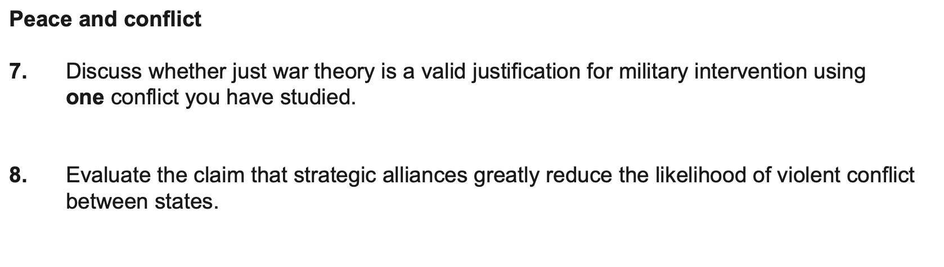

May 2021

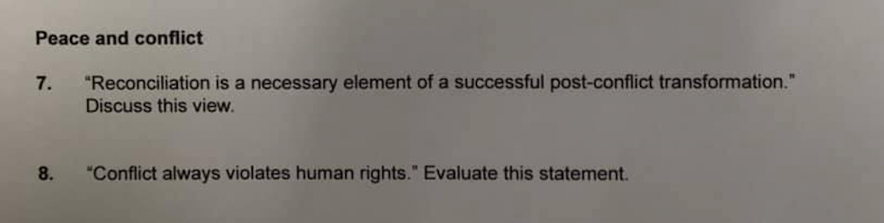

November 2020

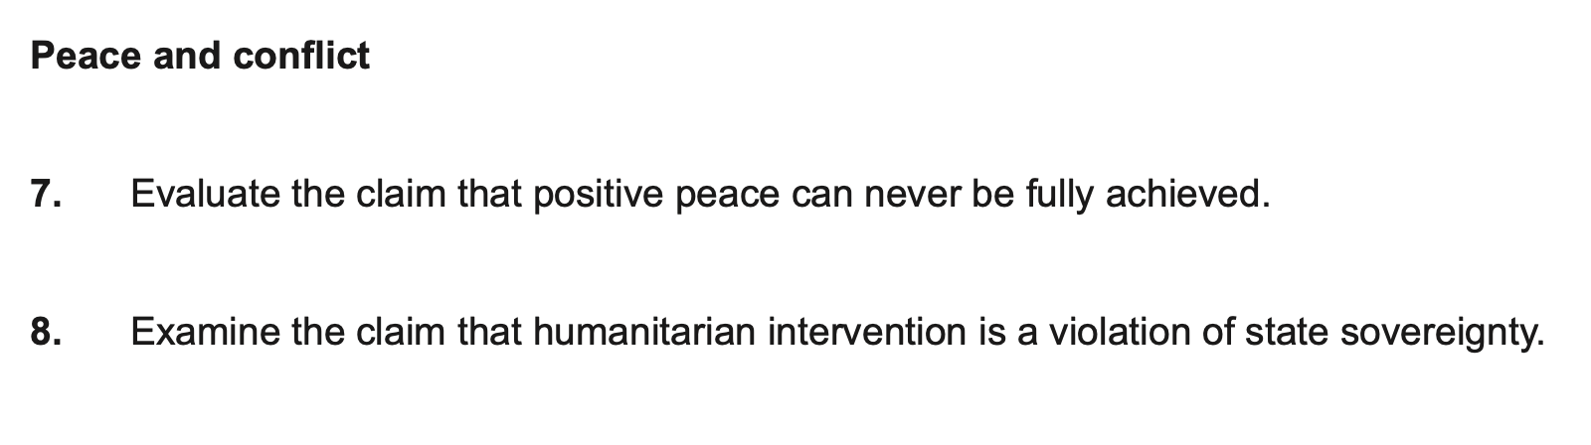

November 2019

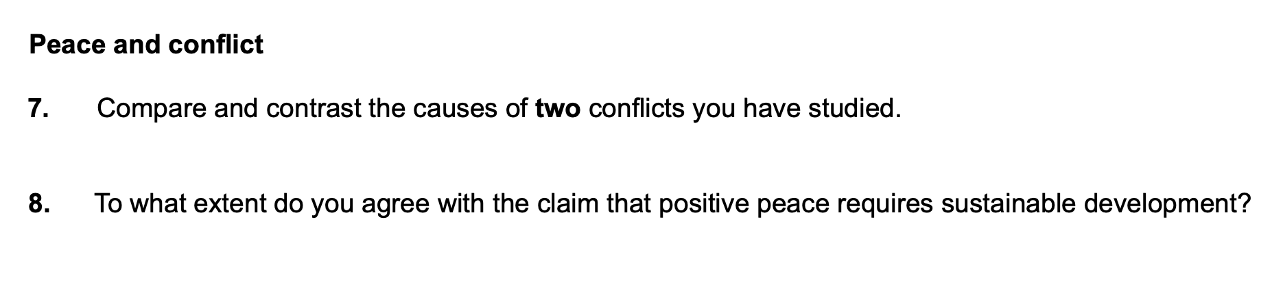

May 2019

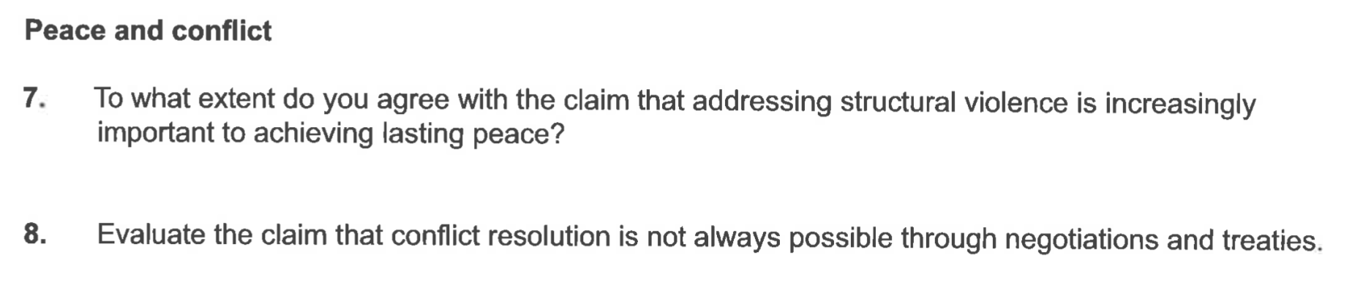

November 2018

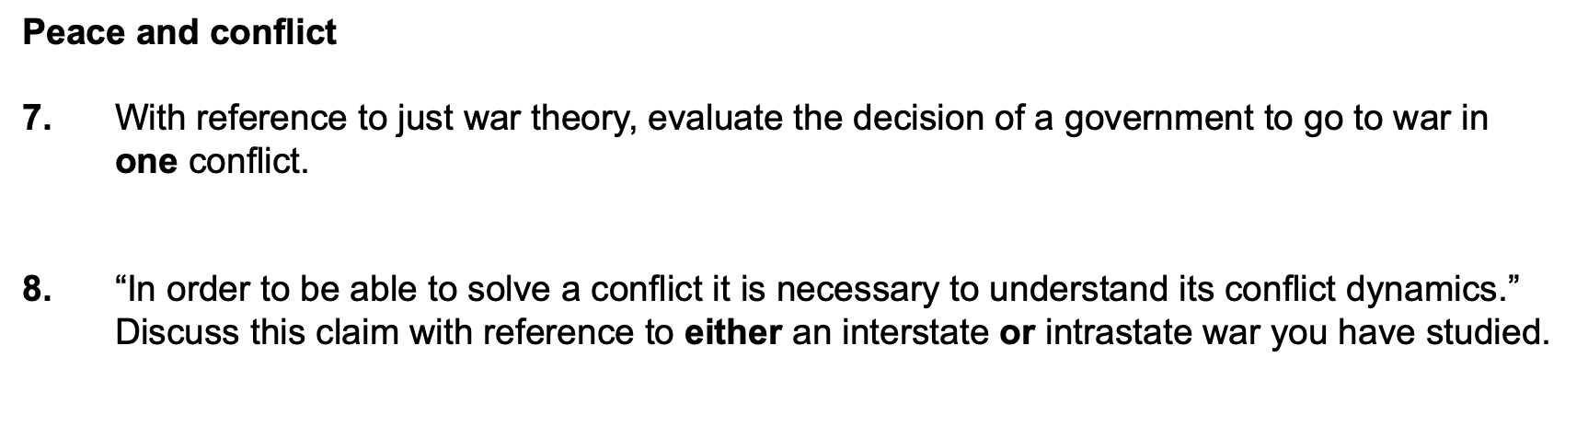

May 2018

