Power, Sovereignty, and International Relations (PSIR) Review Document

Here is a link to pages on PSIR from an IB review book. We’ve done some readings out of this. It should be helpful for you as you review.

Here is a link to the summary of our case studies over the two years along with the relevant course concepts

Sample Paper 2 Assignments

We had three Paper 2 tasks last year for this first unit. The first was about the nature of military power and whether it was diminishing. I am attaching a sample here.

Sample 1

The second was about the nature of sovereignty after our Brexit unit. I’m attaching a sample here

Sample 2

The last was an overall unit assessment that we worked on that combined each of the major case studies from the unit.

Sample 3

You should take time to look over your assignment along with feedback and any notes you prepared to do the assignment.

Core Concepts and Definitions

Define these terms in your own words. Some may have complex definitions or contested meanings. Mention examples from our case studies to help you make connections.

Term | Definition, Examples, and other notes
Power
Sovereignty
Interdependence
Legitimacy

Key vocabulary and definitions

Define terms listed below. You can, or should, include a link to work we’ve done connected to the terms and concepts.

Here are pages from the IB Guide that can help you define or understand what is meant by these terms. We did not refer to each of these terms explicitly but you can make connections between the work we did and these terms.

Nature of power
- Definitions and theories of power
- Types of power

10/21, 10/22, 10/26, 11/9, 11/18, 11/19,

Operation of state power in global politics
- The evolving nature of state sovereignty
- Legitimacy of state power

9/23-10/7

Function and impact of international organizations and non-state actors in global politics
- The UN
  - 11/5
- IGOs (Brexit stuff overlaps here)
  - 1/19,
- NGOs, MNCs, trade unions
  - 1/12, 1/13, 1/14, 1/15
- Social movements, protest movements
  - 2/23, 2/24,

Realism and Liberalism
- 2/25, 2/26,

Levels of analysis
- 3/1, 3/2

Unit Case Studies

Below are the three main case studies we did in this unit, along with one last year which also applies. Go back into your Google Classroom files and add links

Case Study 0: What is a country?

Each of us did our own research assignment around a place whose status as a nation state was in question for one reason or another. Go back and find the work you did. This would be a valuable case study for you to possibly use here.

Main Actors
Key course concepts related to this case
Summary of the case study with specific events and details
Links for relevant google docs from the dates above
Connections to theoretical perspectives

Case Study #0.5: Ethiopia’s Grand Renaissance Dam
This was a one day article we read but provides some good ideas for this exam.

10/20

Case Study #1: Iran-US Relations
From last year’s google classroom: 10/27, 10/29, 11/2, 11/5, 11/9

Main Actors
Key course concepts related to this case
Summary of the case study with specific events and details
Links for relevant google docs from the dates above
Connections to theoretical perspectives

Case Study #2: Brexit

From last year’s google classroom: 11/23, 12/1, 12/2, 12/3, 12/4, 12/7, 12/8, 12/9, 12/10, 12/11, 12/14, 12/17, 12/21, 1/4, 1/5

Main Actors
Key course concepts related to this case
Summary of the case study with specific events and details
Links for relevant google docs from the dates above
Connections to theoretical perspectives

Case Study #3: Uruguay vs. PMI

Here is a link to the episode of This Week Tonight that touched on the case

CLASSROOM DATES: 1/21, 1/25, 1/26, 1/28, 1/29, 1/31 (I believe this was the date I posted an assignment to complete a chart similar to the one below. Use it!),
Main Actors
Key course concepts related to this case
Summary of the case study with specific events and details
Links for relevant google docs from the dates above
Connections to theoretical perspectives

Last bunch of Paper 2 Exam Questions

Read over these questions and identify the types of questions and concepts you would want to answer. Which would you want to avoid?

Do Answer Questions About | Don’t Answer Questions About
Questions about power, sovereignty are good ones  Questions that refer to general categories of actors (NGOs, IGOs, MNCs) are good. | Explicitly about the United Nations  Questions about strikes, protests, demonstrations  Collective security questions  Informal forums

November 2021
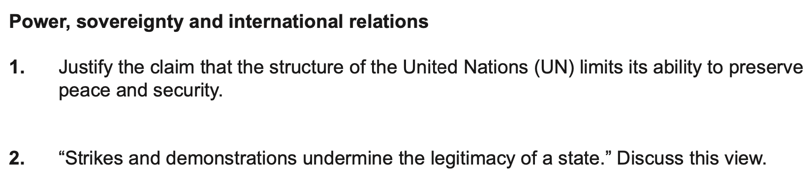

May 2021

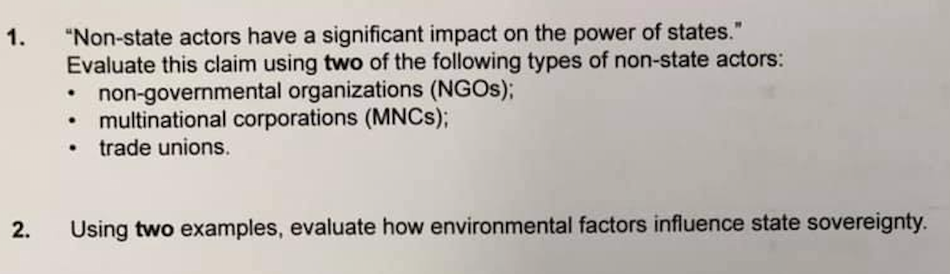

November 2020
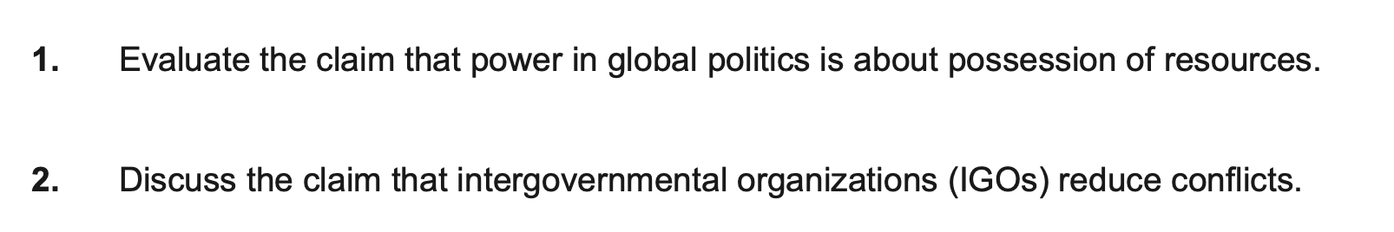

November 2019
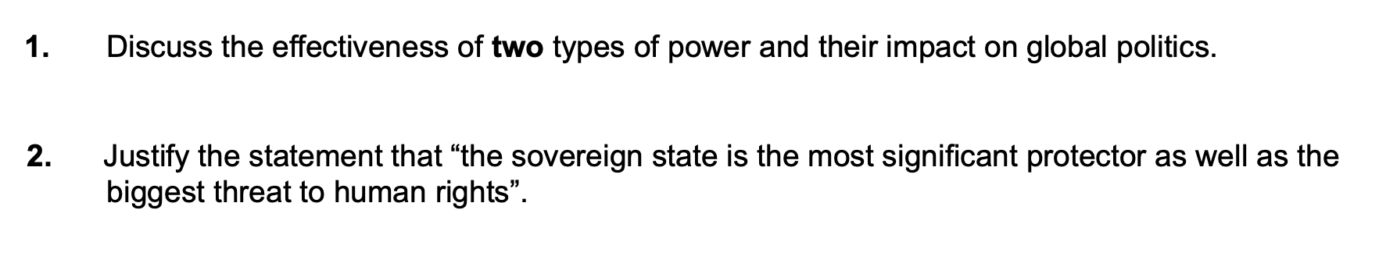

May 2019

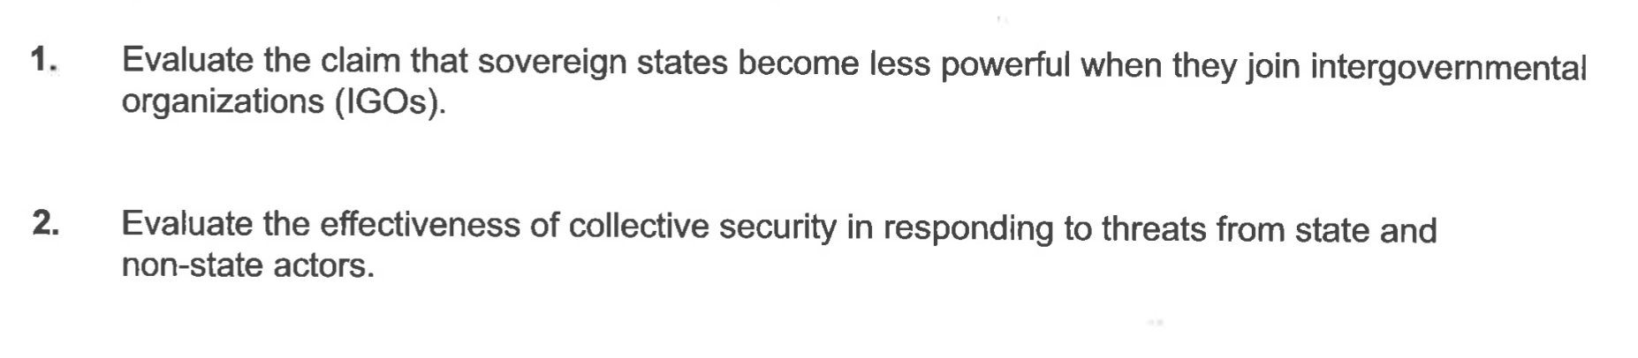

November 2018

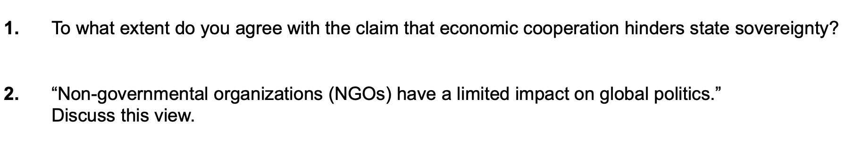

May 2018
